**KENDRIYA VIDYALAYA SANGATHAN**



**REGIONAL OFFICE, RAIPUR**

**STUDY cum SUPPORT MATERIAL**

**CLASS XI**

**PHYSICS**

**2015 – 2016**

**PATRON**

**Smt. P.B. Usha**

DEPUTY COMMISSIONER

KVS RO RAIPUR

**COORDINATOR**

**Sh. R.N. Sendhil Kumar**

PRINCIPAL

K V No.2, BOLANGIR

**PREPARED BY:**

1. **Mr. Y.K. Tiwari, PGT(Phy), K.V. Durg**
2. **Mr. S.K. Mishra, PGT(Phy), K.V. No.2, Raipur**
3. **Mr. V. K. Verma, PGT (Phy), K.V. No.4, Korba**
4. **Mr. B.R. Gajpal , PGT (Phy) , K.V. Bilaspur**
5. **Mr. H. S. Tripathi, PGT (Phy), K.V. Mahasamund**
6. **Mrs. S Khirbat, PGT (Phy), K.V. BMY Bhilai**
7. **Mr. Pankaj Kumar Sinha, PGT (Phy), K.V. Dantewada**

|  |
| --- |
| UNITS /TOPICS COVERED |
| 1. KINEMATICS |
| 1. LAWS OF MOTION |
| 1. WORK ENERGY AND POWER |
| 1. MOTION OF SYSTEM OF PARTICLES AND RIGID BODY |
| 1. GRAVITATION |
| 1. THERMODYNAMICS |
| 1. PROPERTIES OF BULK MATTER |
| 1. KINETIC THEORY OF GASES |
| 1. OSCILLATION AND WAVES |

**KINEMATICS**

**Motion in a straight line**

**IMPORTANT POINTS**

➢ Study of motion of objects along a straight line is known as rectilinear motion.

➢ If a body does not change its position with time it is said to be at rest. If it changes its position with time it is said to be in motion. The position of the object can be specified with reference to a conveniently chosen origin. For motion in a straight line, position to the right of the origin is taken as positive and to the left as negative.

➢ Distance is defined as the total length of the path traversed by an object.

➢ Displacement is the change in position : Δx=x2-x1, Path length is greater than or equal to the magnitude of the displacement between the two positions

➢ An object is said to be in uniform motion in a straight line if its displacement is equal in equal intervals of time. Otherwise the motion is said to be non-uniform.

➢ Average velocity is the ratio of the displacement and time interval in which the displacement occurs.

**V=Δx/Δt**

On an x-t graph, the average velocity over a time interval is the slope of the line connecting the initial and final positions corresponding to that interval.

➢ Average Speed is ratio of the total path length traversed and the corresponding time interval. The average speed of an object is greater than or equal to the magnitude of the average velocity over a given interval of time.

➢ Instantaneous velocity or simply velocity is defined as the limit of the average velocity as the time interval Δt becomes infinitesimally small.

**Vinst=limit V= limit Δx/Δt = dx/dt**

**Δt→0 Δt→0**

The velocity at a particular instant is equal to the slope of the tangent drawn on position –time graph at that instant.

➢ Average acceleration is the change velocity divided by the time interval during which he change occurs.

**a = ΔV/Δt**

➢ Instantaneous acceleration is defined as the limit of the average acceleration as the time interval Δt goes to zero.

**a =lim (a) =lim (ΔV/Δt) = dv/dt**

**Δt→0 Δt→o**

**The acceleration of an object at a particular time is the slope of the velocity- time e curve at that instant of time.For uniform motion, acceleration is zero and x-t graph is a straight line inclined to the time axis. And v-t graph is a straight line parallel to the time axis.For motion with uniformacceleration, x-t graph is a parabola, while the v-t graph is a straight line inclined to the time axis.**

➢ The area under the velocity- time curve between times t1 and *t2 is* equal to the displacement of the object during that interval of time.

➢ For objects in uniformly accelerated rectilinear motion, the five quantities, displacement x, time taken t, initial velocity u, final velocity v and acceleration are related by a setoff simple equations called kinematic equations of motion.

**(i) V= u+ at**

**(ii) X=ut + ½ a t2**

**(iii) v2- u2 = 2 a x**

**Solve the following. Each question carries 1 mark.**

1. Distinguish between scalar and vector quantities.Give an example in support of each.

2. Define speed. How is it different from velocity?

3.Define uniform velocity and variable velocity?

4.Plot the velocity- time graph for a uniform motion. What does the area under

the graphs indicate?

5.Write any two equations of motion of a body moving with uniform acceleration.

6. Plot a velocity- time graph for a body moving with uniform acceleration.

7.Plot position – time graph for a body having uniformly retarded motion

8. What does the speedometer of car indicate?

9. Two cars are running at velocities of 60 km /hr and 45 km/hr respectively. Calculate the relative velocity of car A, if (i) they are both travelling eastwards; and (ii) car A is travelling eastwards and car B is travelling westwards.

10. A body goes from A to B with a velocity of 40 m/sec, and comes back from B to A with a velocity of 60 m/sec.What is the average velocity of the body during the whole journey.

ANSWER-1MARKS

4.



Area under the graph is equal to displacement

5. **(i) V= u+ at**

**(ii) X=ut + ½ a t2**

**(iii) v2- u2 = 2 a x**

**6.**



7.



8.Instantaneous speed

9.(i)VAB=15Km/h eastwards(ii)VAB=105 eastwards

10.Zero

**Answer the following questions each question carries 2 marks**

11. A player throws a ball upwards with an initial speed of 39.2 m/sec.

(a) What is the direction of acceleration during the upward motion?

(b) Find the velocity and acceleration of the ball at the highest point.

(c) Find the height through which the ball rises, and the time after which it returns

to the player’s hands.

12. From the top of a tower 100m height, balls is dropped, and at the same time another ball is projected vertically upwards from the ground with a velocity of 25 m/sec. find when and where the two balls meet. Take g = 9.8 m/sec2

13.The distance travelled by a body is found to be directly proportional to the square of time. Is the body moving with uniform velocity or with uniform acceleration?

14.The displacement (x) of a particle moving in one dimension, under the action of a constant force related to time t by the relation t =√x +3 where x is in meters, and t is in seconds. Find the displacement of the particle when its velocity is zero.

15. Can a body have zero velocity, and finite acceleration?

16. Can a body have constant speed, but a varying velocity?

17.Can a body have constant velocity, but a varying speed?

18. Why is I tthat a parachute descends slowly whereas a stone dropped from the same height falls rapidly?

19.Look at the graphs (a) to (d) in fig carefully and state with reasons which of these cannot possibly represent one dimensional motion of a particle.



20. Fig gives the x-t plot of a particle in one dimensional motion. Three different

equal intervals of time are shown. In which interval is the average speed greatest,

and in which is it the least? Give the sign of average velocity for each interval



21. Suggest a suitable physical situation for each of the following graphs



22. Give the equations of motion of a body falling under gravity. Also give the graphs showing the variation of (i) acceleration of a body with time

(ii) Velocity of a body with time

(iii) Distance with time in case of a freely falling body.

23. Discuss the motion of an object under free-fall.

24. Derive a relation between the position and time for a particle moving with uniform acceleration.

25. Derive a relation for the distance covered in the nth second by a uniformly accelerated body.

26. Show that when a body has uniformly accelerated motion, the distance covered it in a certain interval is equal to the area under the velocity-time graph for that time interval.

27. A body is moving with uniform acceleration its velocity after 5 seconds is 25 m/sec and after 8 seconds is 34 m/sec. Calculate the distance it will cover in the 10th second.

28. The speed of a train increases at a constant rate α from zero, to v, and then remains constant for an interval, and finally decreases to zero at a constant rate β. If t is the total time elapsed,then calculate the maximum velocity attained by the car.

29. A body moving with a uniform acceleration describes 12 m in the 2nd second of its motion and 20m in the 4th second. How much distance will it coverin 4second after after 5th second?

**ANSWER**

11.(a)Downwad(b)velocity=0, acceleration =9.8msec-2 (c)height=78.4 time=8sec

12 time=4sec height 21.6m from the ground.

13.Uniform acceleration

14.displacement is zeo

15.yes when an object is thrown vertically upward at the highest point

16.Yes in case of uniform circular motion

17.No

18.Dur to air resistance

19.All the four graphs are impossible

20Greatest in 3.least in 2: v>0 in 1 and 2 v<0 in 3

21.(a)A ball is at rest on a smooth floor is kicked,it rebounds from a wall with reduced speed and moves to the opposite wall which stops it (b) Aball thrown with some initial velocity rebound from the floor with reduced speed after each hit (c) A uniformly moving cricket ball returned back by hitting with a bat for a very short interval of time.

22.









27. 38.5

28.v=(αβ)t/(α+β)

29.136m

**Description of Motion in Two and Three Dimensions**

**Main Points:**

1.Scalar quantities with magnitudes only. Examples are distance, speed mass and temperature.

2.Vector quantities with magnitude and direction both. Examples are displacement, velocity and acceleration. They obey special rules of vector algebra.

3.A vector ’**A**’ multiplied by a real number**‘λ’ is** also a vector, whose magnitude is**‘λ’**times the magnitude of the vector**‘ A ‘**and whose direction is same or opposite depending upon whether**‘λ’** is positive or negative.

4.Two vectors **A** and **B** may be added graphically using head to tail method or parallelogram method.

5. Vector addition is **commutative:**

**A + B = B + A**

It also obeys the **associative law:**

**(A + B) + C = A + (B +C)**

6.A null or zero vector is a vector with zero magnitude. Since the magnitude is zero, we don’t have to specify its direction. It has the properties:

**A + 0 =A**

**λ0 =0**

**0 .A=0**

7.The subtraction of vector **B** from **A** is defined as the sum of **A** and **–B**:

**A – B = A + (-B)**

8.A vector **A** can be resolved into components along two given vectors a and b lying in the same plane:

**A= λ a + μb** whereλ and μ are real numbers.

9.A unit vector associated with a vector A has magnitude one and is along the vector A :

n ^ = A/ A The unit vectors **i,j,k** are vectors of unit magnitude and point in the direction of x, y, and z- axes respectively in a right handed coordinate system.

10. A vector ‘A’ can be expressed as

A = Ax i + Ay j where Ax , Ay are components along x- and y- axes . If vector A makes an angle Ѳ with the x- axis, then Ax = A cosѲ, Ay = A sinѲ and A = A =√( Ax2 + Ay2), tan Ѳ = Ay/Ax.

11. Vectors can be conveniently added using analytical method. If sum of two vectors‘ A’ and ‘B’ , that lie in x-y plane is ‘R’, then:

R = Rx i + Ry j , where Rx = Ax + B x and Ry = Ay + By

12. The position vector of an object in x-y plane is given by r =x i + y j and the displacement from position r to position r’ is given by

Δr = r’-r

= (x’-x)i + ( y’-y)j

=Δx i + Δy j

13. If an object undergoes a displacement Δr in time Δt, its average velocity is given by

V = Δr/Δt. The velocity of an object at time t is the limiting value of the average velocity as Δt tends to zero..

V= lim Δr/Δt = dr/ dt .It can be written in unit vector notation as

Δt→0

V=vxi + vyj + vz k where Vx = dx/dt, Vy = dy/dt ,Vz= dz/dt

When position of an object is plotted on a coordinate system v is always tangent to the curve representing the path of the object.

14. If the velocity of an object changes from v to v’ in time Δt, then its average acceleration is given by a = (v-v’)/Δt= Δv/Δt

The acceleration a at any time t is the limiting value of a as Δt→ 0

a =lim Δv/Δt = dv/dt

Δt→0

In component form, we have a = ax i + ay j +az k

Where ax = dvx/dt, ay = dvy/dt, az = dvz /dt

15. If an object is moving in a plane with constant acceleration a = a =√(ax2 + ay2)

And its position vector at time t = 0 is r0, then at any other time t, it will be at a point given by

r = r0 + V0t + ½ a t2

and its velocity is given by :

V = V0t + atwhere V0 is the velocity at time t = 0

In component form

X = x0 +V0xt + ½ ax t2

**Y= y0 + V0y t + ½ ay t2**

**Vx = V0x + ax t**

**Vy = V0y + ay t**

Motion in a plane can be treated as superposition of two separate simultaneous one dimensional motions along two perpendicular directions.

16. An object that is in flight after being projected is called a projectile.If an object is projected with an initial velocity **V0** making an angle Ѳ0, with x=axis and if assume its initial position to coincide with the origin of the coordinate system, then the position and velocity of the projectile at time t are given by

**X = (V0cosѲ0)t**

**Y = (V0 sin Ѳ0)t – ½ g t2**

**Vx=V0x = V0 cosѲ0**

**Vy = V0sinѲ0 – gt**

The path of a projectile is parabolic and is given by

**Y= (tan Ѳ0) x – gx2/2(V0Cos Ѳ0)2**

The maximum height that a projectile attains is

**H m= (V0sinѲ0)2/2g**

The time taken to reach this height is

**tm= V0Sin Ѳ0/g**

The horizontal distance travelled by a projectile from its initial position to the position it passes y = 0 during its fall is called the RANGE, R of the projectile. It is:

**R =V0 2Sin 2Ѳ0/g**



17. When an object follows a circular path at constant speed. The motion of the object is called uniform circular motion. The magnitude of its acceleration is ac= v2/R. The direction of ac is always towards the centre of the circle.

The angular speed is the rate of change of angular distance. It is related velocity v by

V =ω R. The acceleration is ac= ω2 R.

➢ If T is the time period of revolution of the object in circular motion and ν is the frequency then we have ω = 2πν, V = 2πνR a= 4π 2ν2 R

➢ Centripetal force is the name given to the force that provides inward radial acceleration to a body in circular motion. We should always look for some material

force like tension, gravitational force, electrical force, friction etc. as the centripetal force.

**Answer the following**

1.When are two vectors equal?

2.What are co-initial and collinear vectors?

3.When are two vectors equal?

4.State the triangle law of vector addition

5.State the parallelogram law of vector addition.

6.Using the parallelogram law of vectors, find the magnitude and direction of the resultant R in the following fig

Discuss cases for (i) Ѳ= 0˚ (ii) Ѳ= 90˚ (iii) Ѳ = 180˚



7. State three important properties of vector addition.

8.What do you mean by the null vector or zero vector.

9.Write properties of zero vector.

10. Define scalar product of two vectors. Give one example.

11. Define vector product of two vectors? Give one example.

12.Express the area of a parallelogram in terms of cross product of two vectors.

13.Define the following terms associated with projectile motion.

(i) Projectile (ii) trajectory (iii) time of flight (IV) maximum height (v) Horizontal Range

14. Give two examples of projectile motion.

15.Write two applications of projectile motion

16.At what angle with the vertical should a projectile be fired so that its range is maximum?

17. A projectile is fired with ‘u’ at an angle of projection Ѳ. Derive

(i) The equation of trajectory

(ii) Expression for the maximum height reached

(iii) Expression for the time of flight

(iv)Expression for the time taken to reach the maximum height.

(v)expression for the horizontal range.

(VI) the other angle of projection for the same horizontal range.

18.Define average angular velocity. Write its units and dimensions.

19.Write the relation between angular velocity (ω), time period (T) and frequency (ν).

20.Write relation between angular acceleration and linear acceleration.

21.Find the min velocity for which the horizontal range is 39.2m

22. Prove that the Max horizontal range is 4 times the max height attained by a projectile.

23. Calculate the magnitude of the vector r = (3i + 4 j + 7 k)

24. Prove that the vectors (i + 2j+ 3 k)and (2i – j) are perpendicular to each other.

25.A string can withstand a tension of 25 N. What is the greatest speed at which a body of mass 1 kg can be whirled in a horizontal circle using a 1m length of the string?

26. A bullet is fired at an angle of 30˚ with the horizontal hits the ground 3 km away. By adjusting its angle of projection, can one hope to hit a target 5 km away? Assume the muzzle speed to be fixed, and neglect air resistance. Take g = 10 msec-2

27.Show that the trajectory of a projectile is a parabola.

28.From the top of a building 19.6 m high, a ball is projected horizontally, after how long does it strikes the ground? If the line joining the point of projection to the point, where it hits the ground makes an angle of 45˚ with the horizontal, what is the initial velocity of the ball?

29. A projectile is fired at an angle Ѳ with the horizontal. Obtain the expressions for (i) the maximum height attained (ii) the time of flight (iii) the horizontal range.

30. What do you mean by centripetal force ? Derive an expression for the centripetal force.

31. An insect trapped in a circular groove of radius 12 cm moves along the groove steadily and completes 7 revolutions in 100 seconds. (a) What is the angular speed, and the linear speed of the motion? (b) Is the acceleration vector a constant vector? What is its magnitude?

32. A cricket ball is thrown at a speed of 28 m/sec in a direction 30˚ above the horizontal. Calculate (a) the maximum height, (b) the time taken by the ball to return to the same level and (c) the distance from the thrower to the point where the ball returns to the same level.

33A particle starts from the origin at *t* = 0 s with a velocity of 10.0 **j** m/s and moves in

the *x-y* plane with a constant acceleration of 8.0**i** 2.0**j** m s-2. (a) At what time is

the *x*- coordinate of the particle 16 m? What is the *y*-coordinate of the particle at

that time? (b) What is the speed of the particle at the time ?

**ANSWER**

21. 19.6 ms-1

23.√74

25. 5 ms-1

26.N0

28 time=2s, initial velocity=9.8ms-1

31. (a)ω=0.44rad/s v=5.3cms-1 (b)acceleration is not constant vector however it magnitude is constant a=2.3cms-2

32.Height=10m, total time=2.85s,distance=40√3m

33. (a) 2 s, 24 m, 21.26 m s–1

**LAWS OF MOTION**

**FORCE:**

A force is just a push or pull. Examples:an object’s weight, tension in a rope ,attraction between an electron and proton.Bodies don’t have to be in contact to exert forces on each other, e.g., gravity Attraction between any two bodies Electromagnetic Forces between any two bodies Weak nuclear force – responsible for radioactive decay Strong nuclear force – holds quarks together (constituents of protons and neutron

Concept map – Laws of motion

UNIT

BASIC CAUSE OF MOTION

absolute

gravitation

In C.G.S SYSTEM

In M.K.S SYSTEM

*Dyne*

*Newton*

In C.G.S SYSTEM

In M.K.S SYSTEM

*g.f*

*kgf*

Concept explained by

Newton’s first law of motion

Newton’s second law of motion

Newton’s third law of motion

gives

gives

gives

Qualitative definition of force

Quantitative definition of force

Concept of action and reaction

Also known as law of

Can lead to

inertia

Newton’s first and third law

Effect measured by

impulse

1-change in momentum

2-product of force and time

3-area below force –time graph

Plays a role in explaining

Law of conservation of linear momentum

examples

On the concept of

Given by

1-banking of roads

2-bending of cyclist

Having applications

Centripetal force

1-Recoil of gun

2-motion of a rocket/jet plane

3-jumping from boat

4-explosion of a bomb

Motion along a circular track

Inertia of direction

Inertia of motion

Inertia of rest

NEWTON’S FIRST LAW

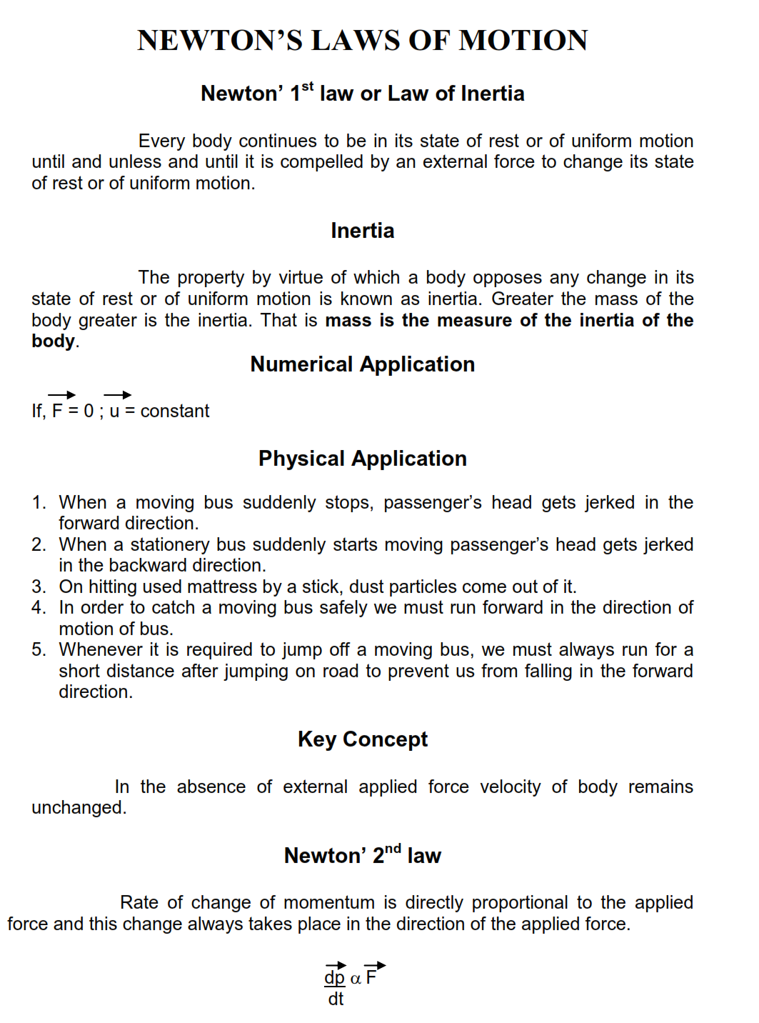

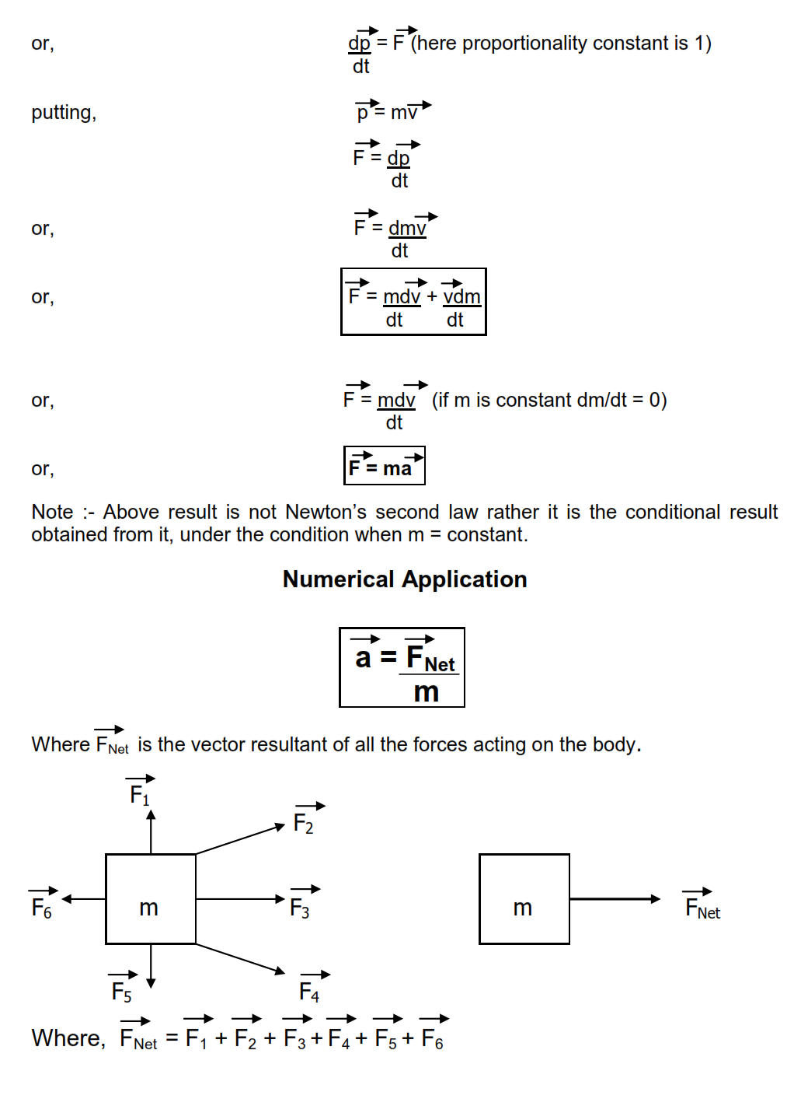

**APPLICATION OF SECOND LAW**

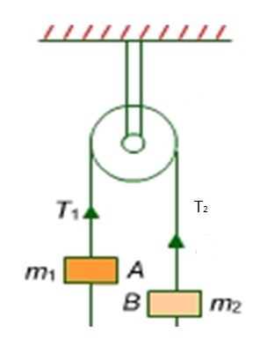

In above case m1 is greater than m2 and we have to find the tension in the string and acceleration in the masses

By free body diagram equation of first body is m1g-T=m1a …(1)

Similarly for mass m2 T-m2g=m2a …(2)

Adding (1) and (2) we get a= (m1 – m2 )g/m1+m2

Now calculation for tension T –

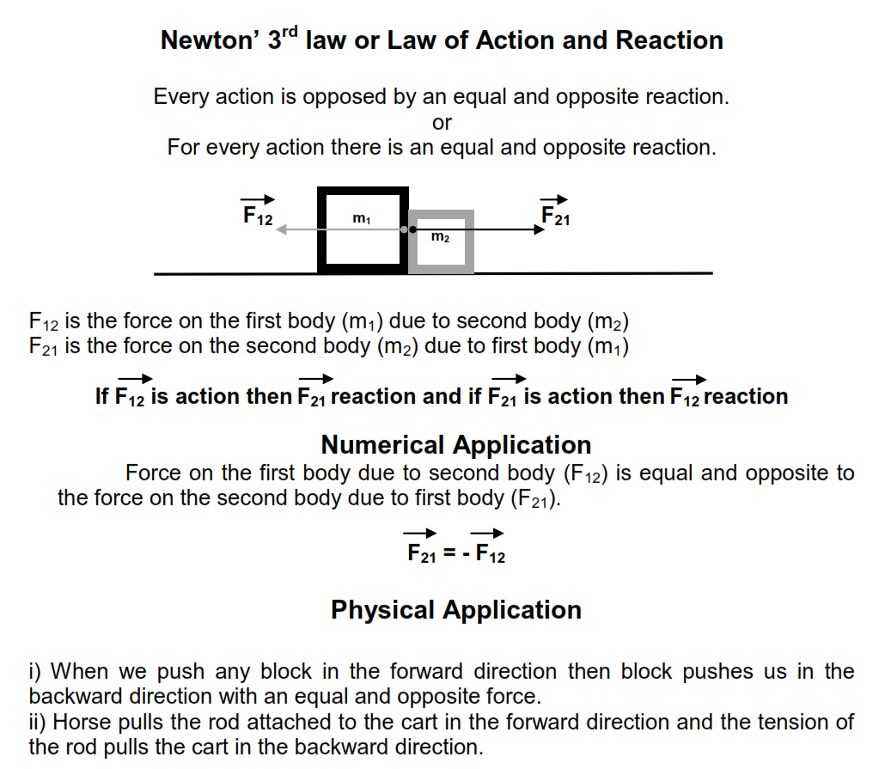Dividing 1 by 2 we get, T=2m1m2g/m1+m2

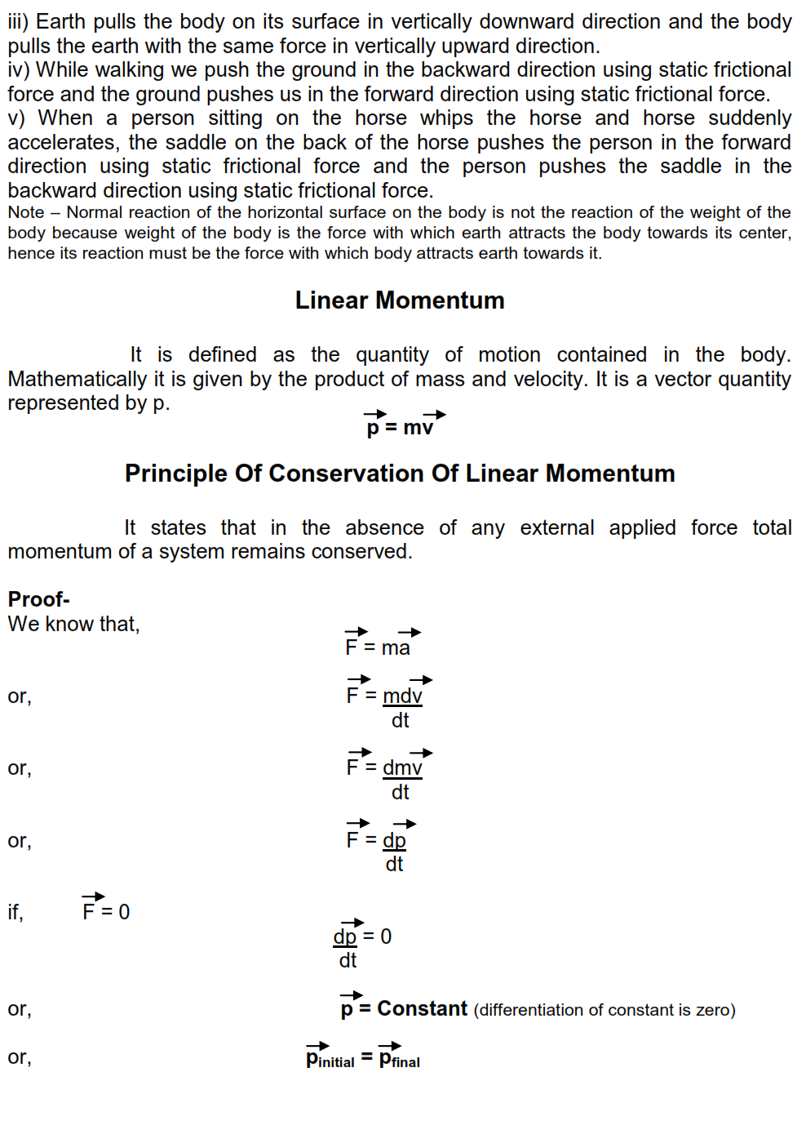

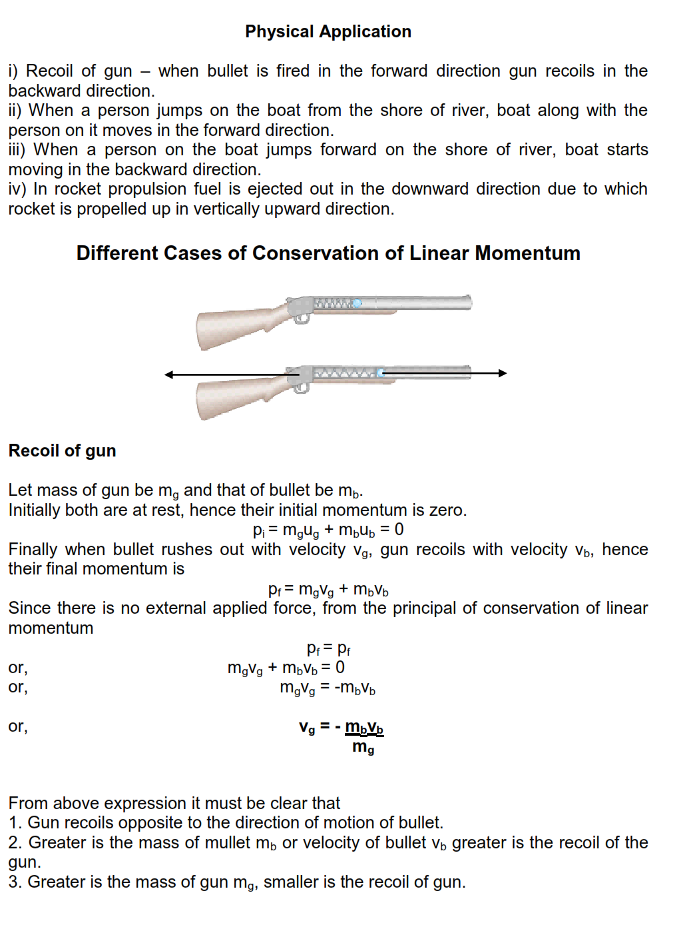

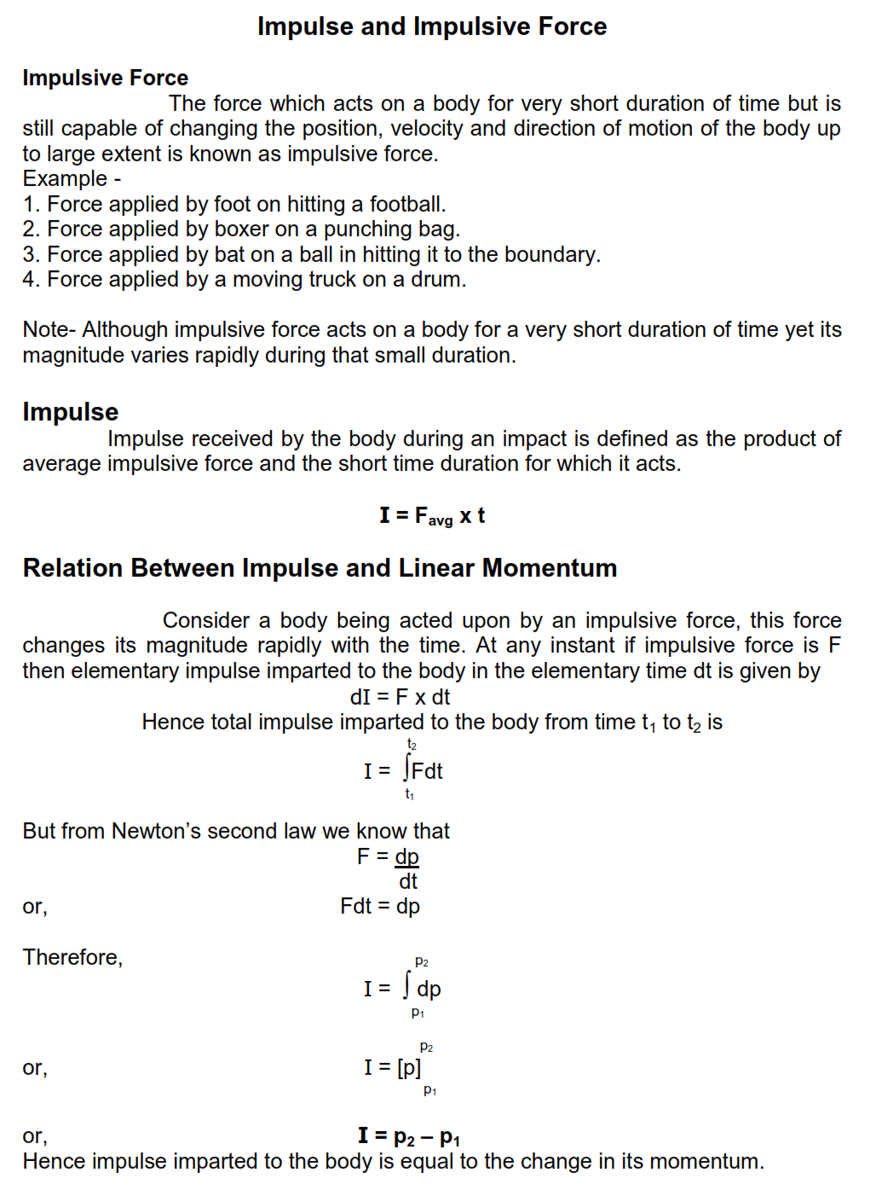

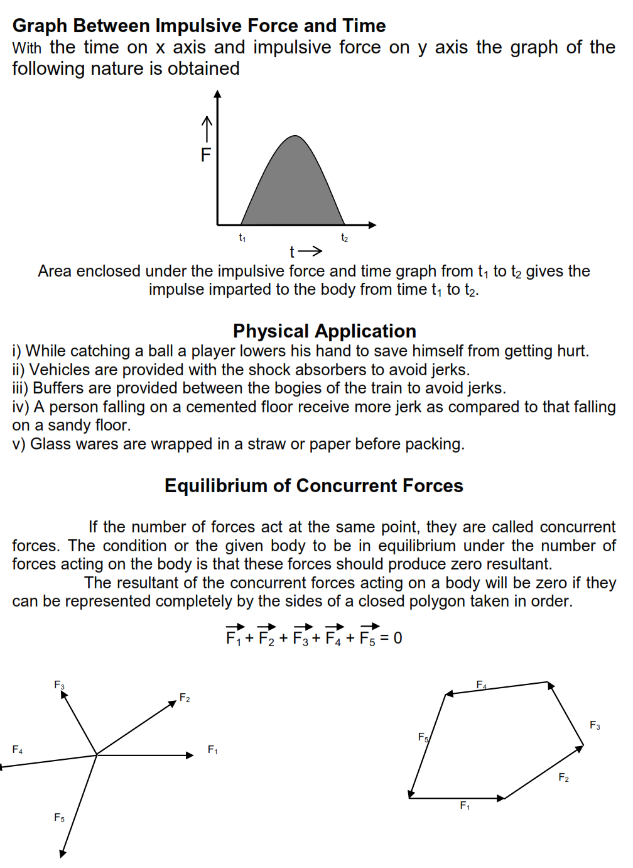

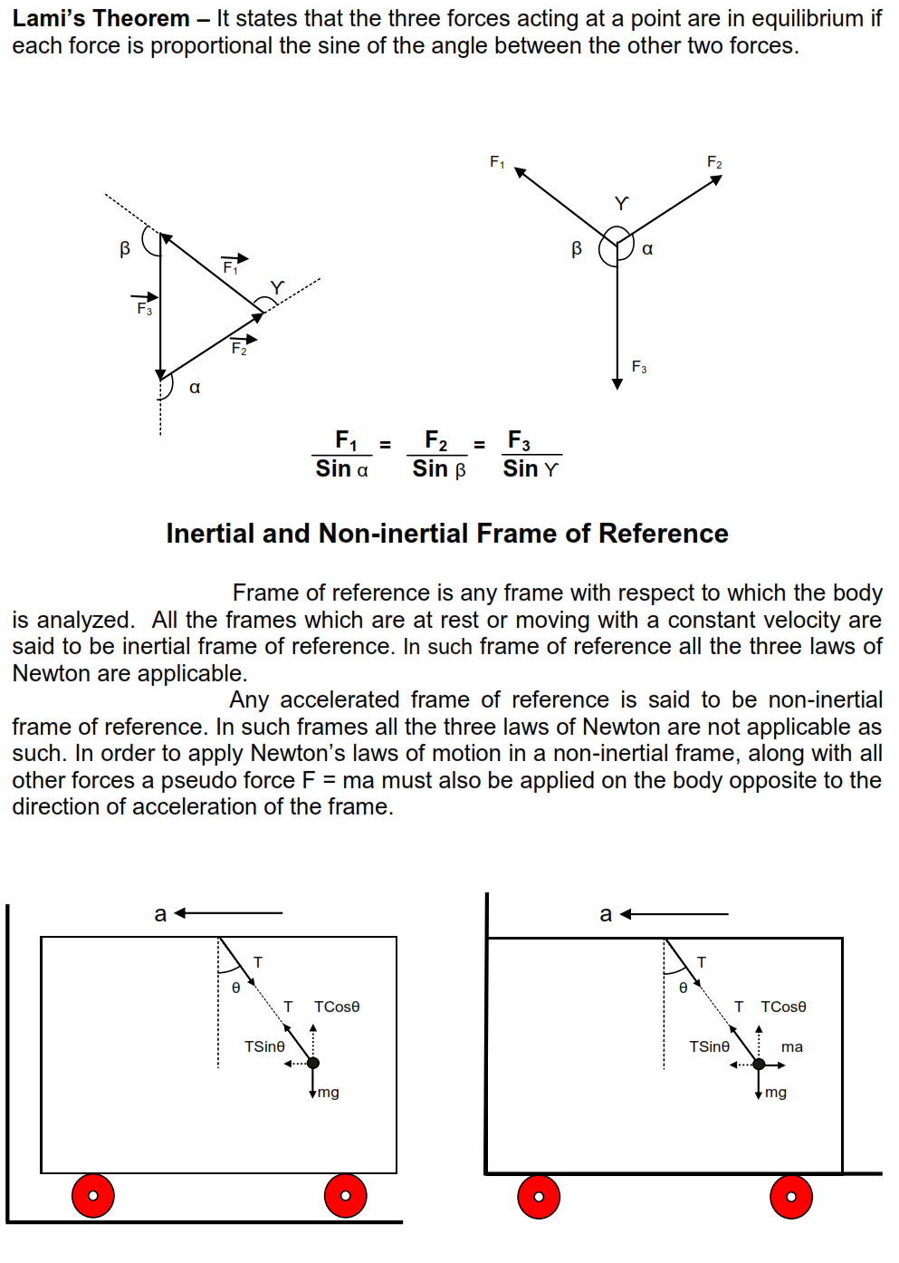

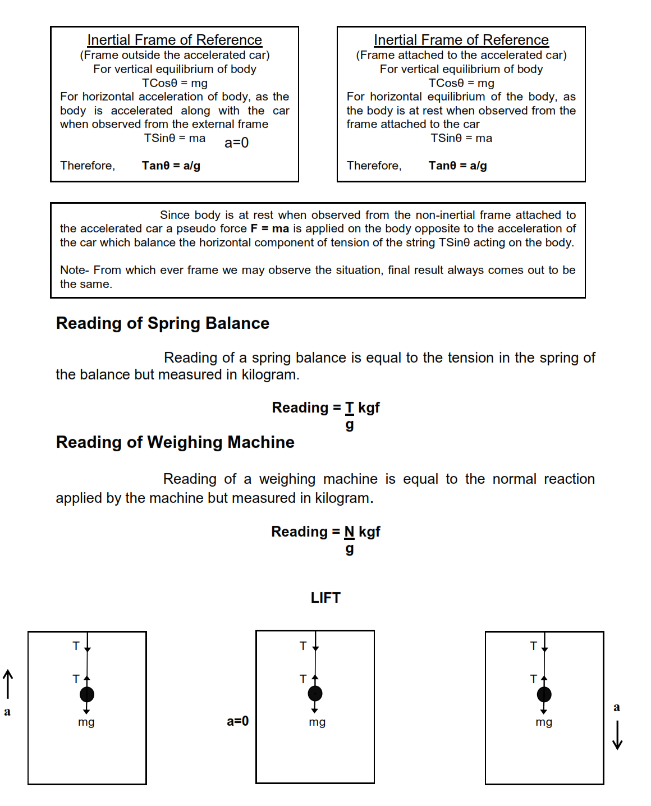

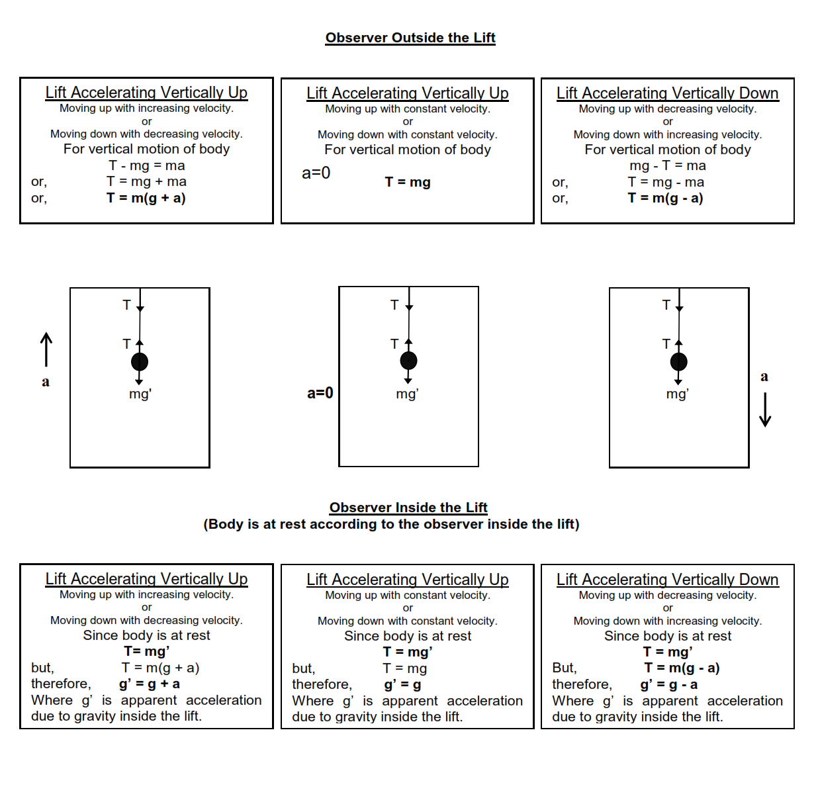

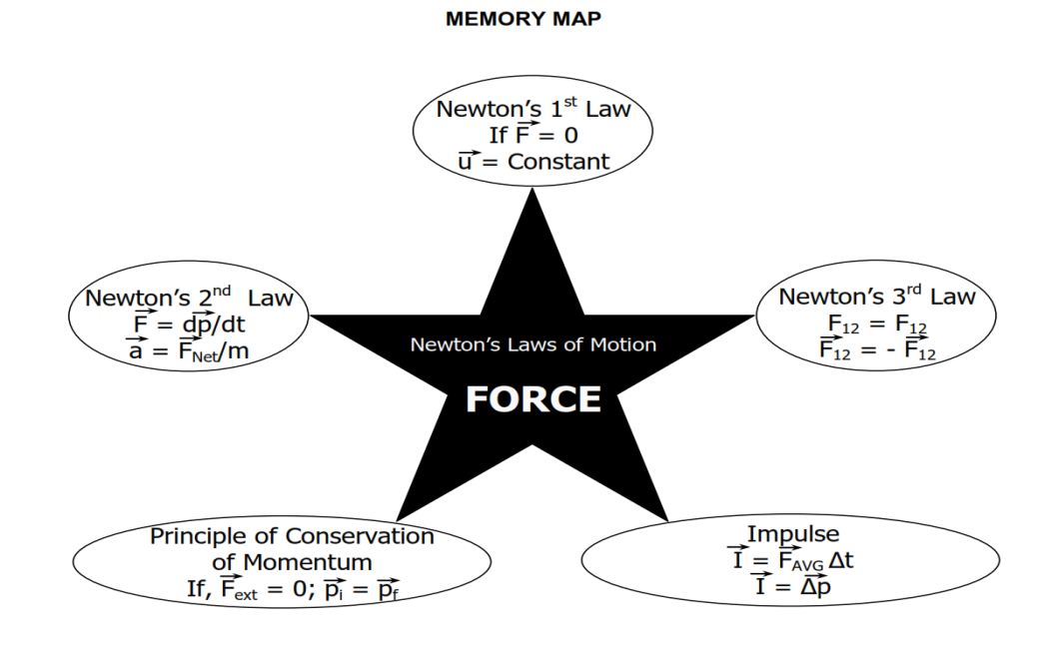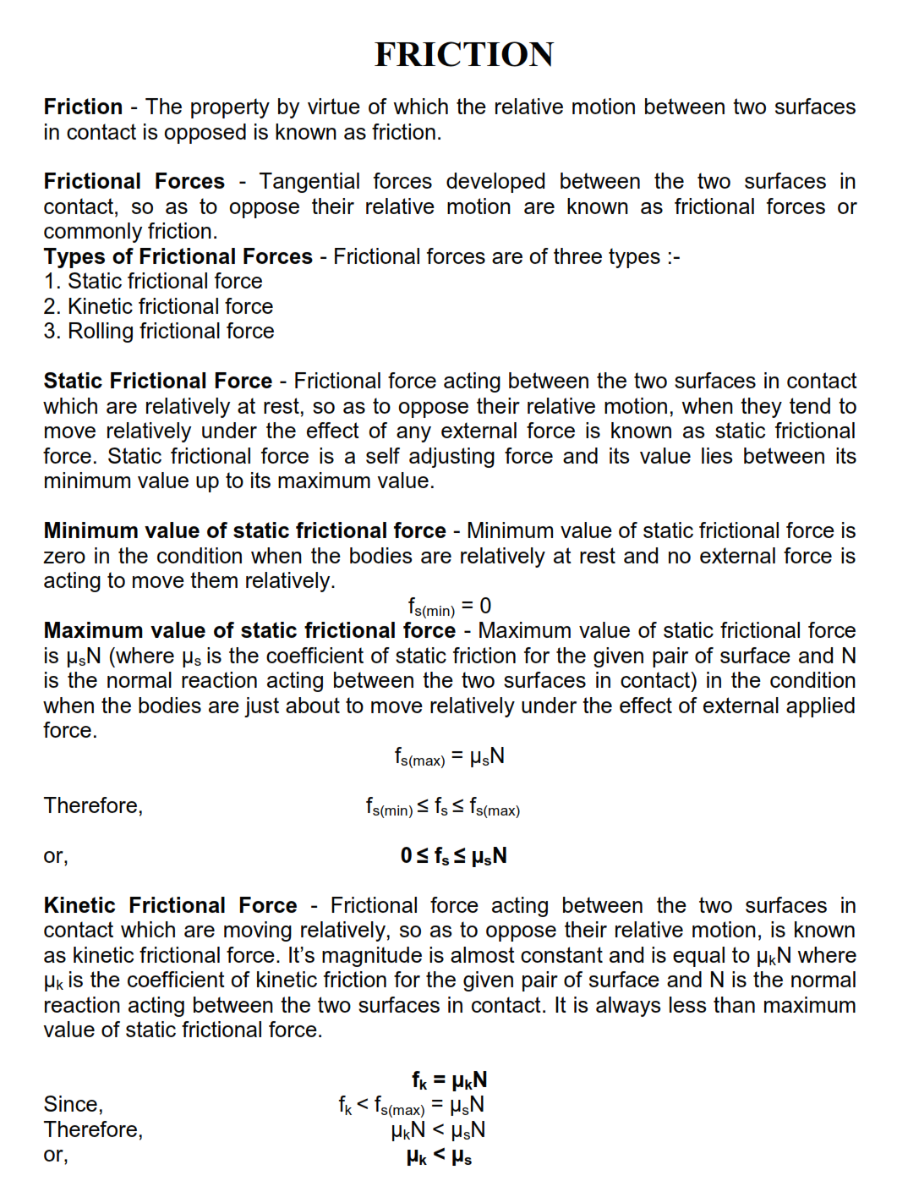

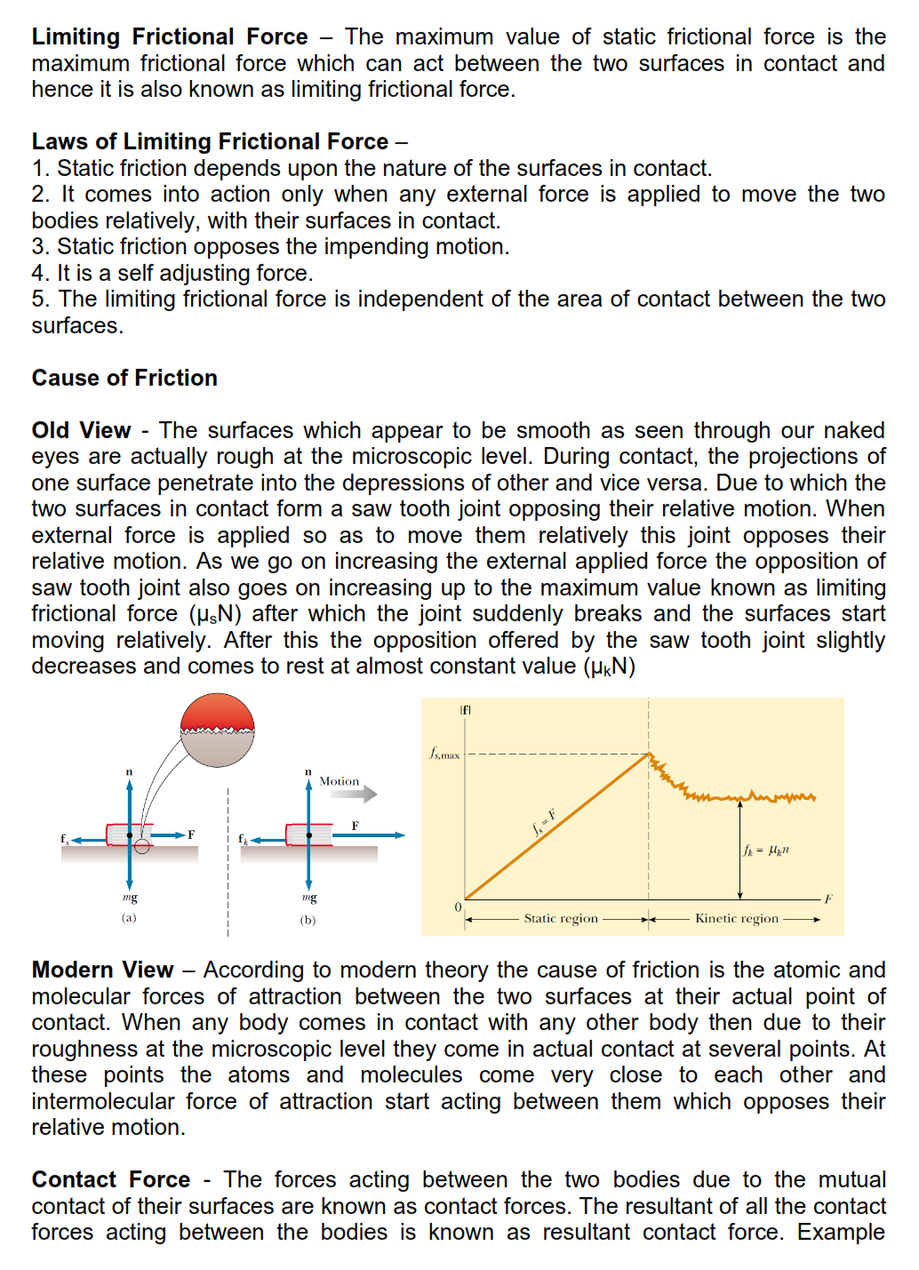

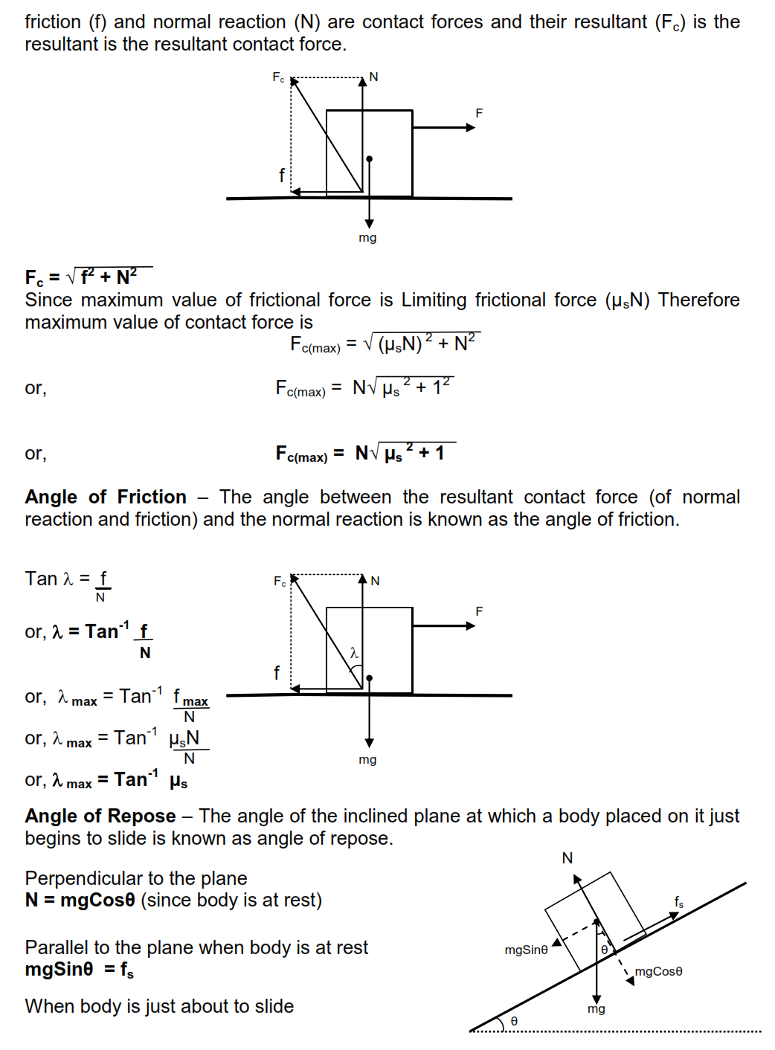

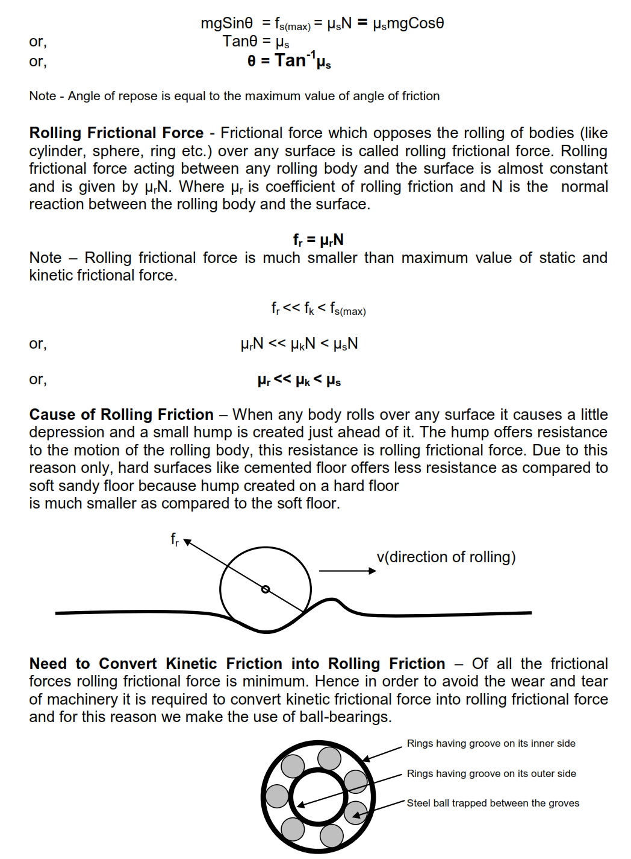

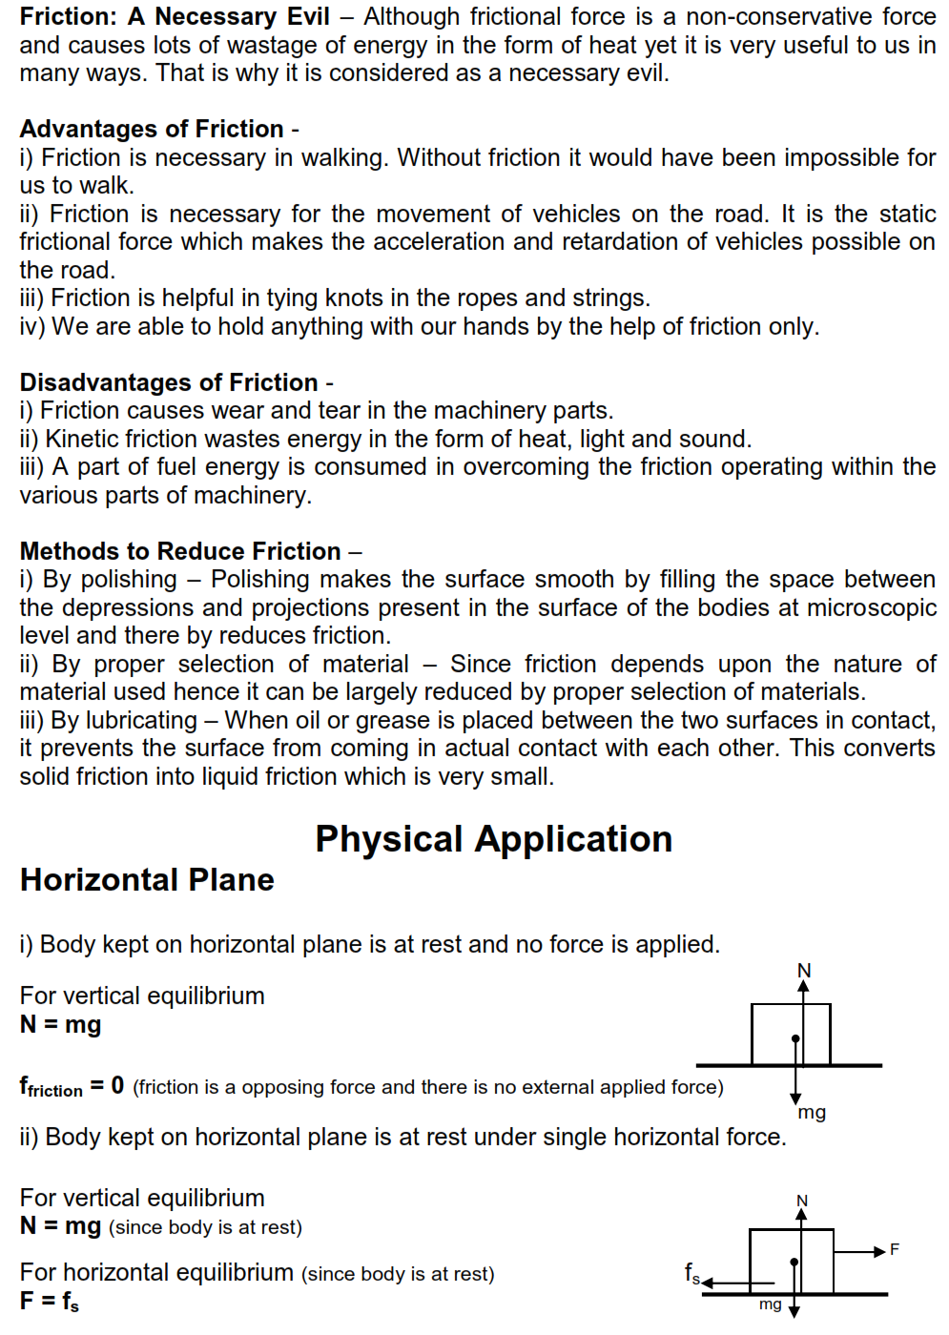

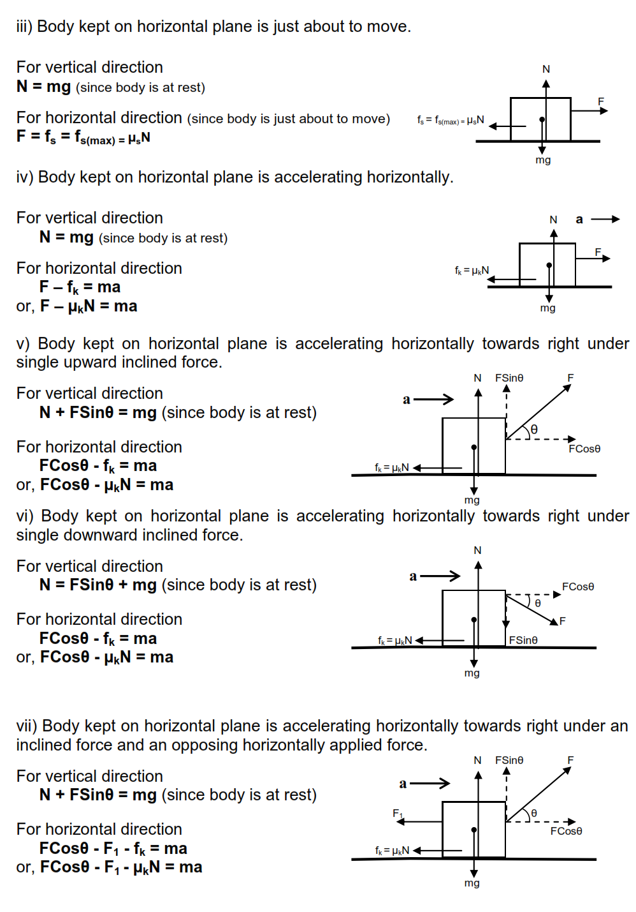

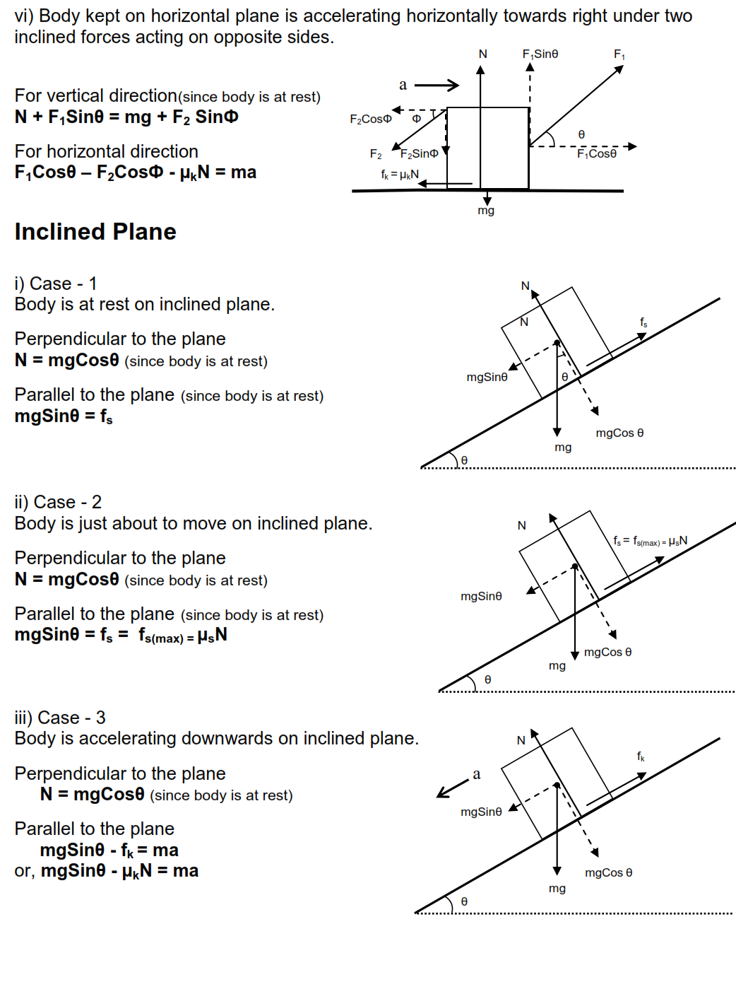

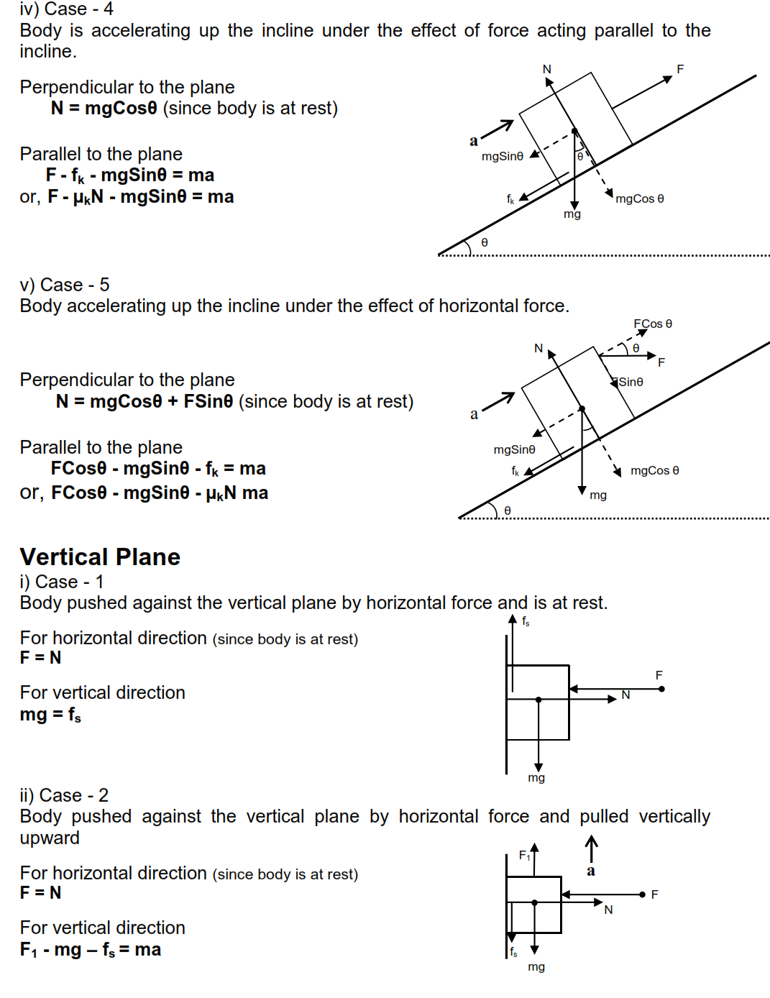

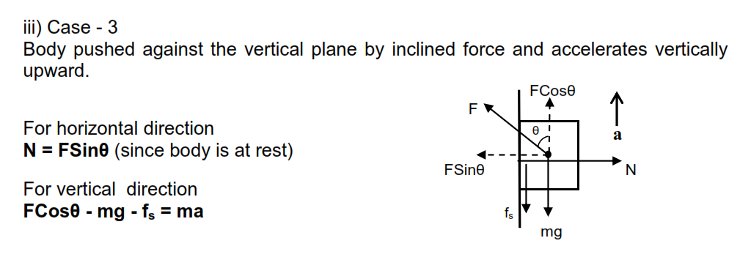

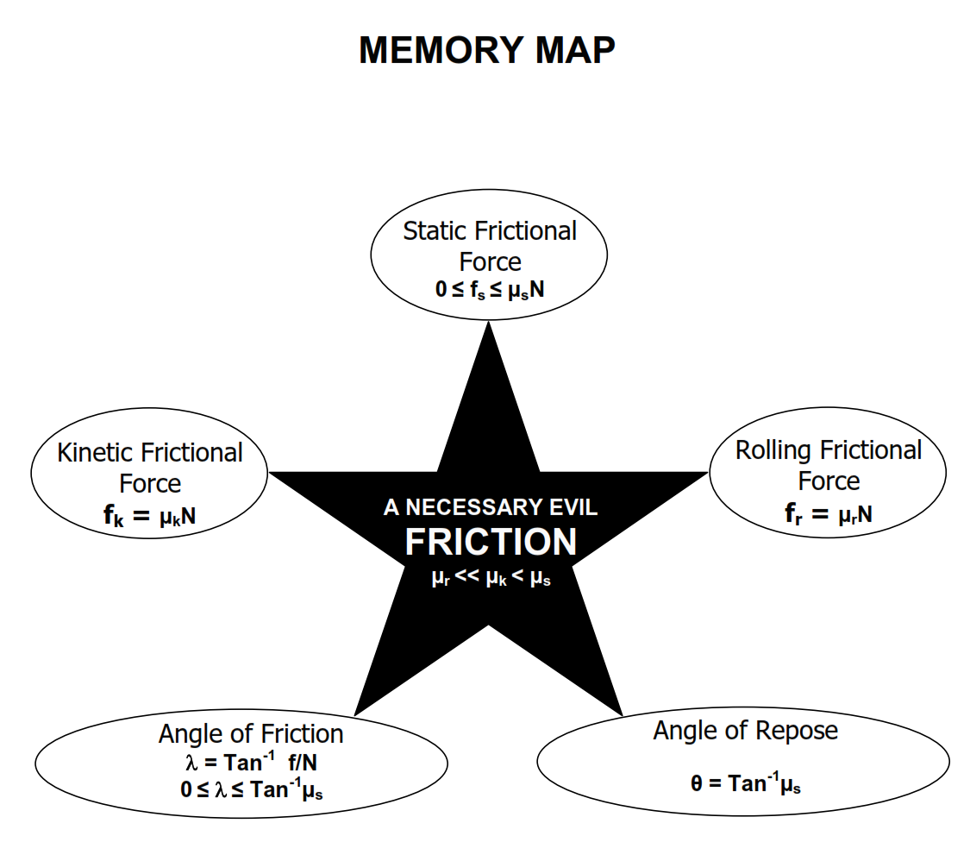

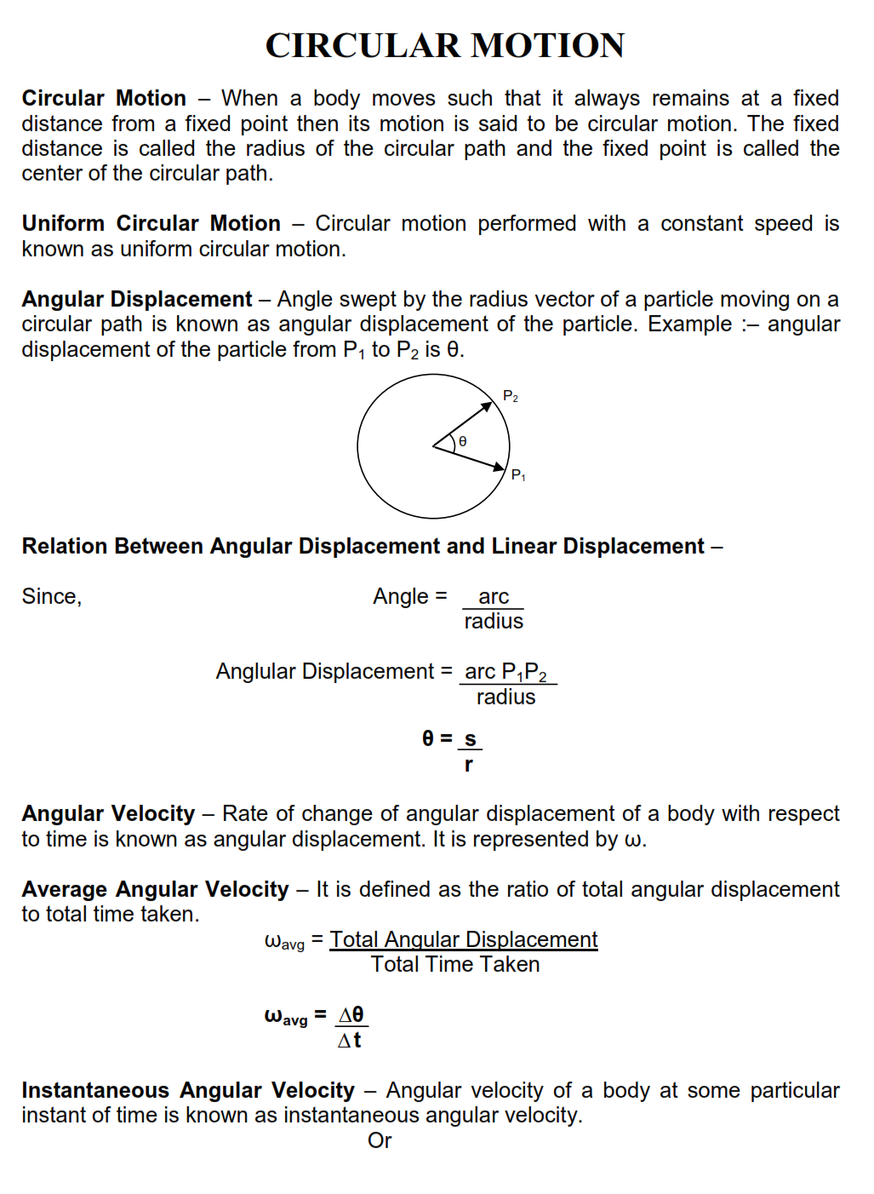

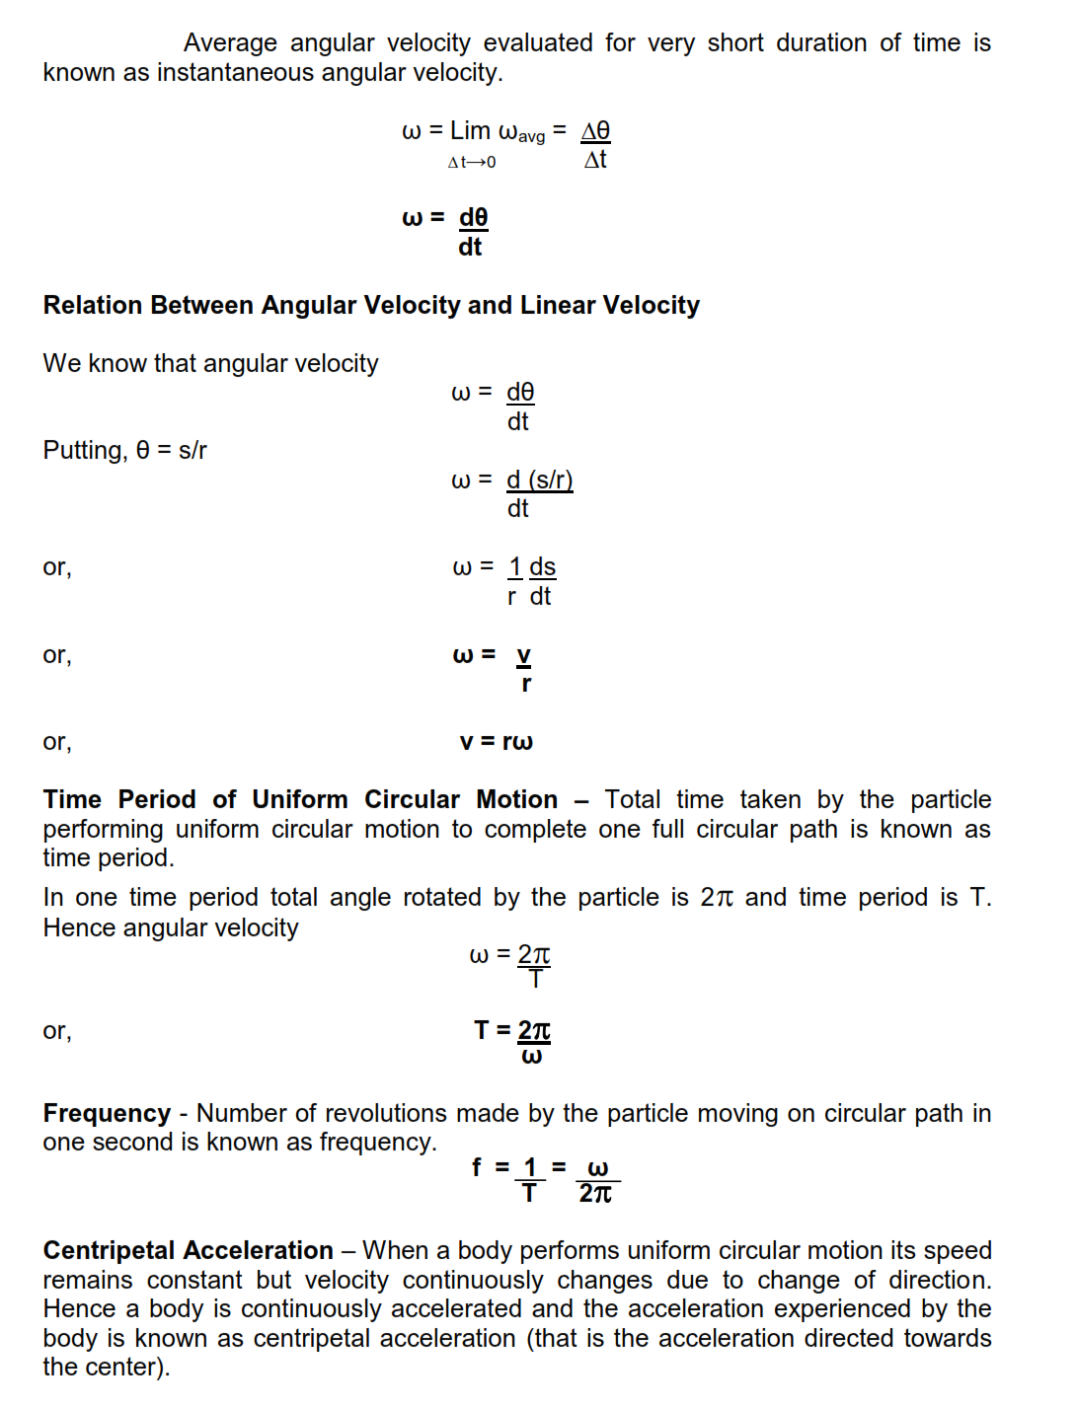

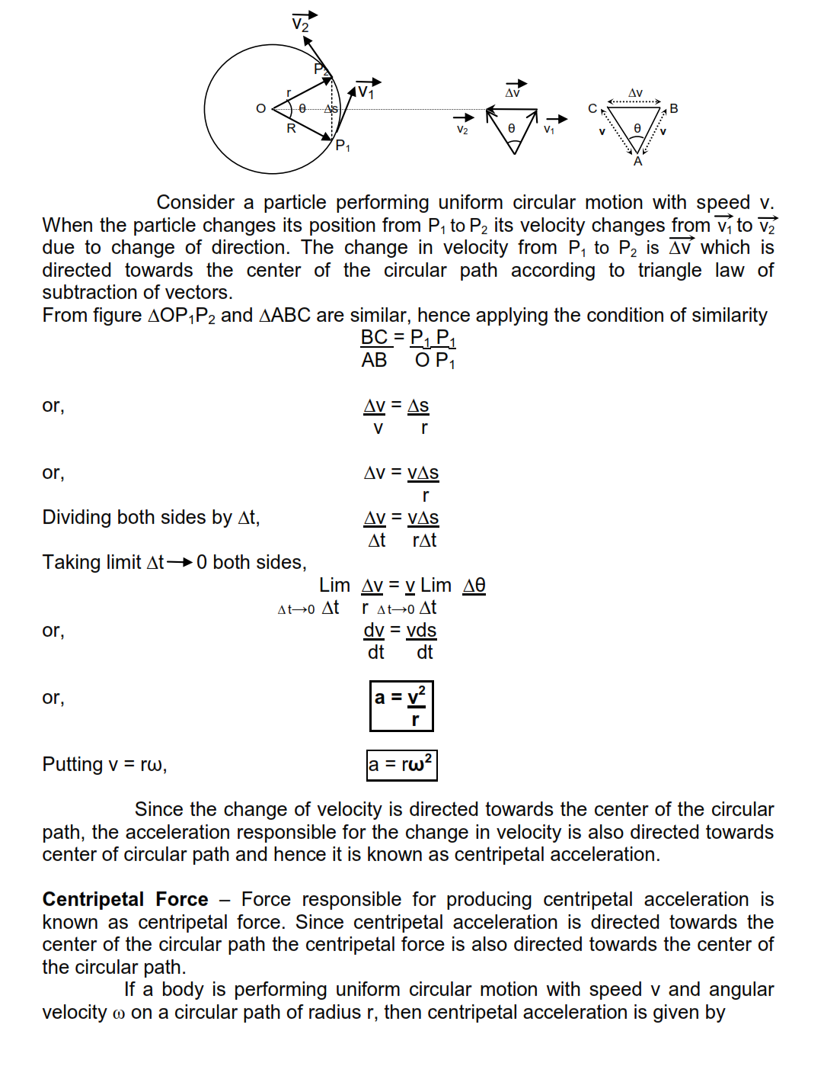

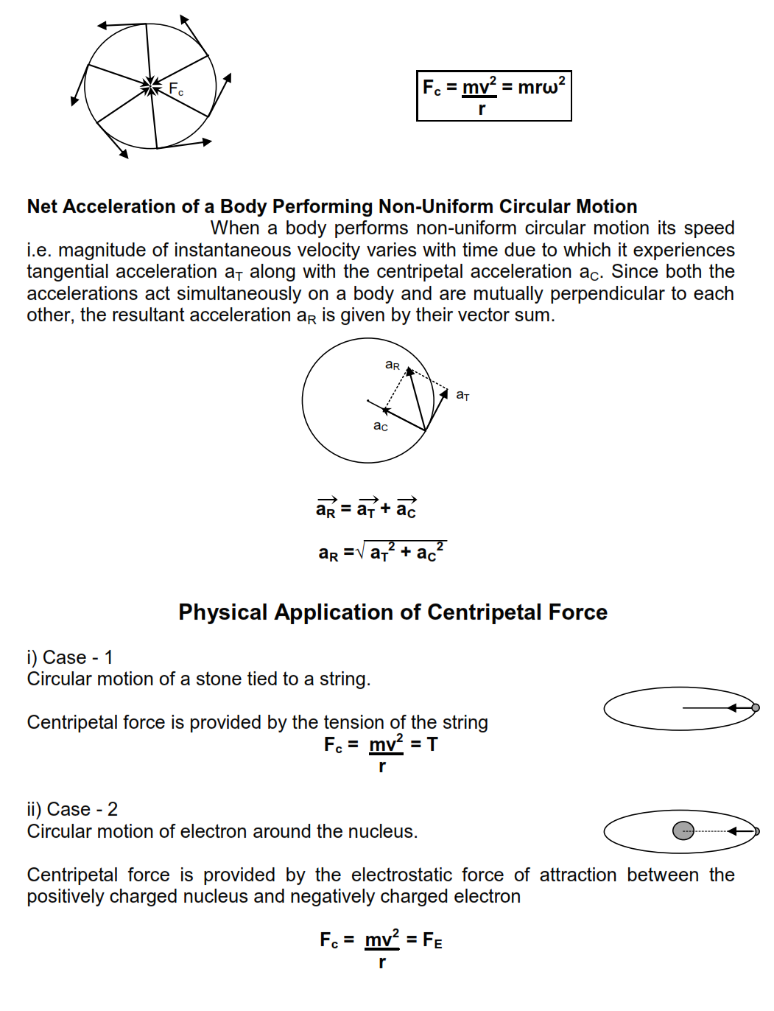

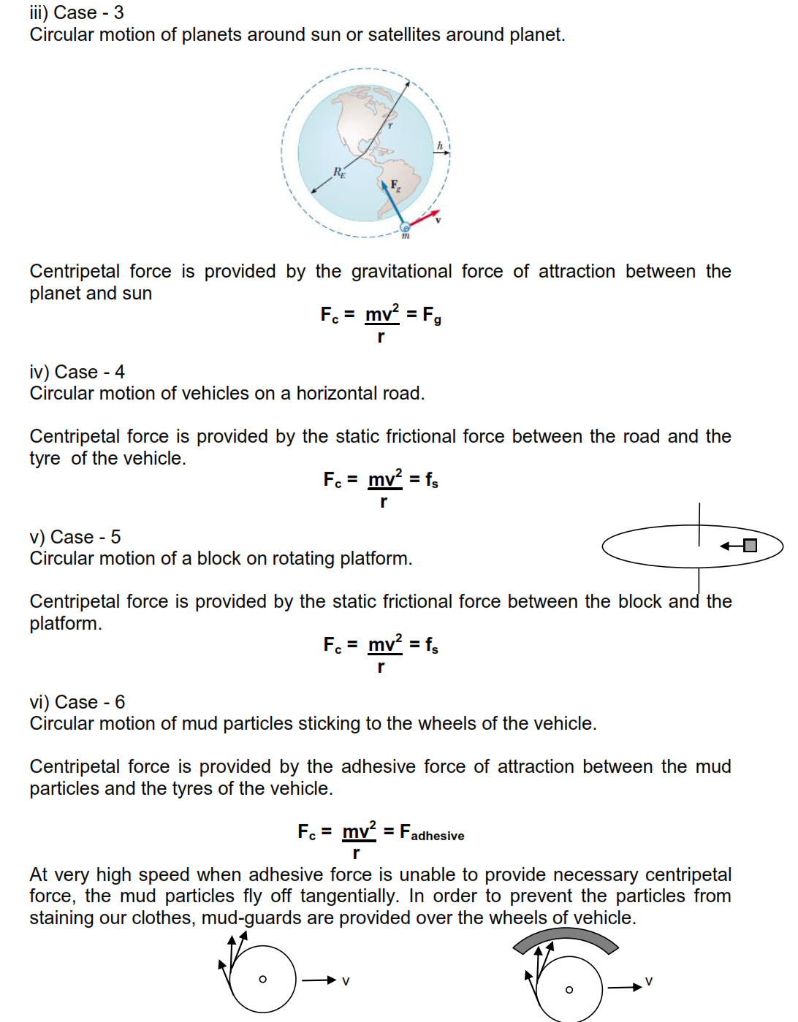

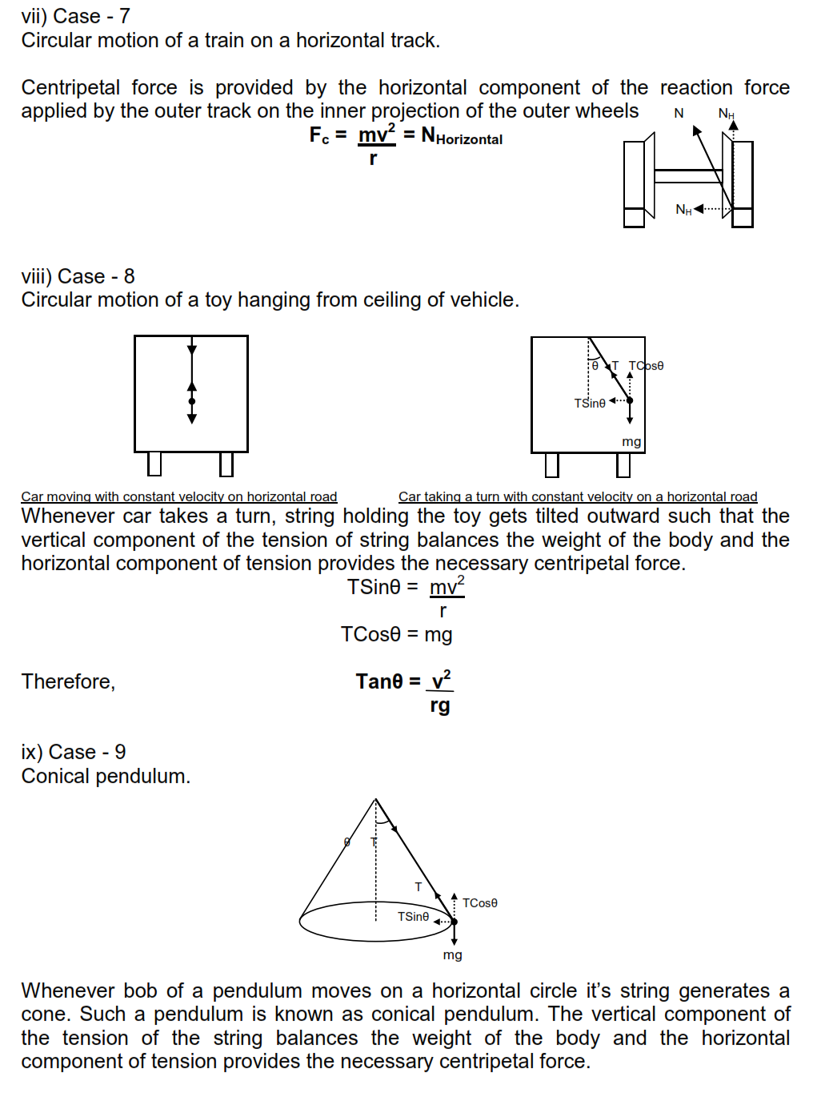

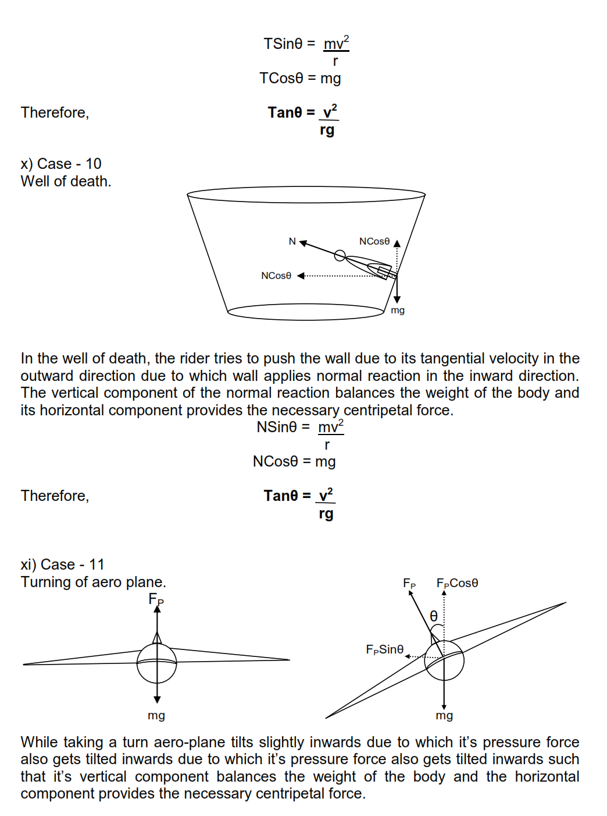

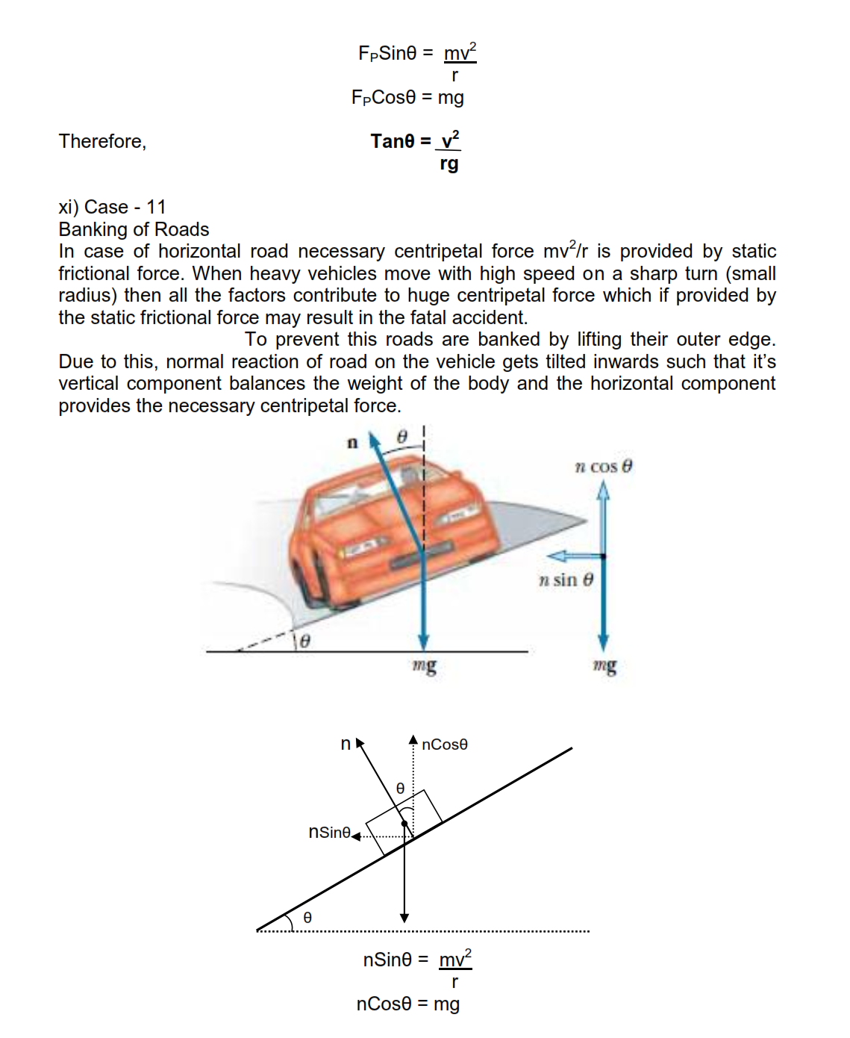

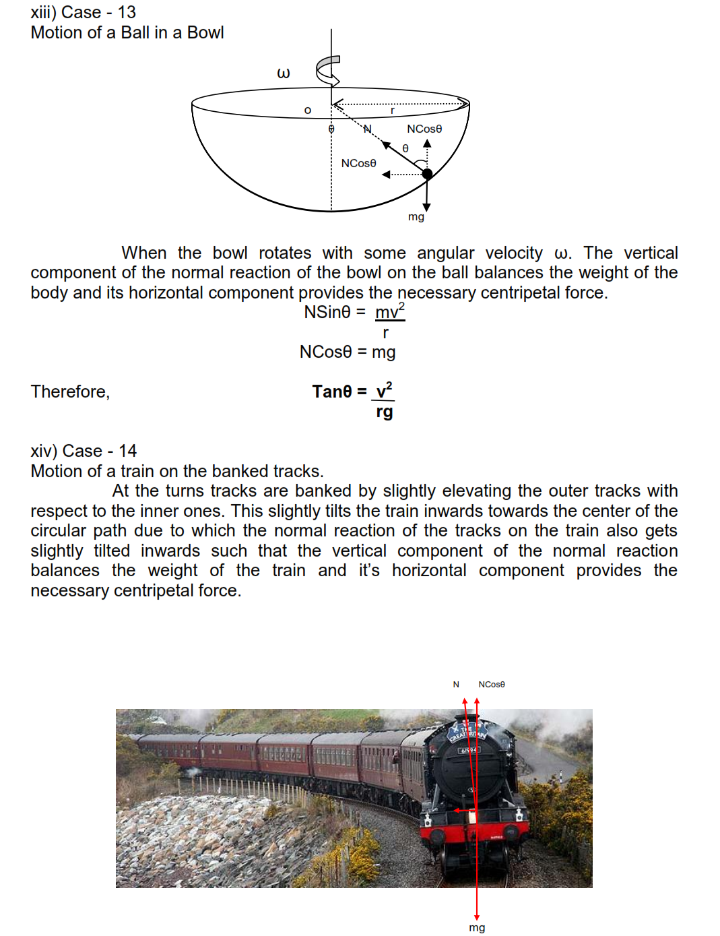

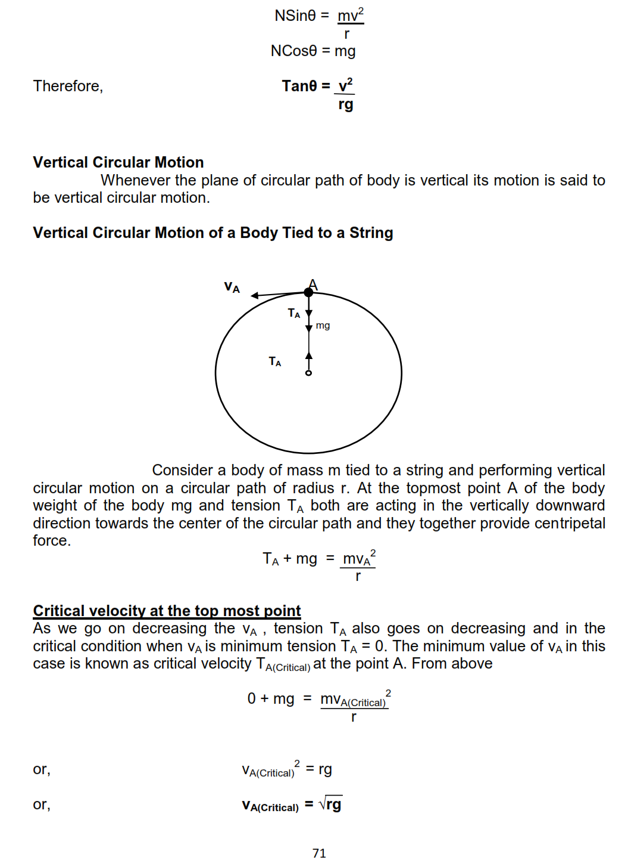

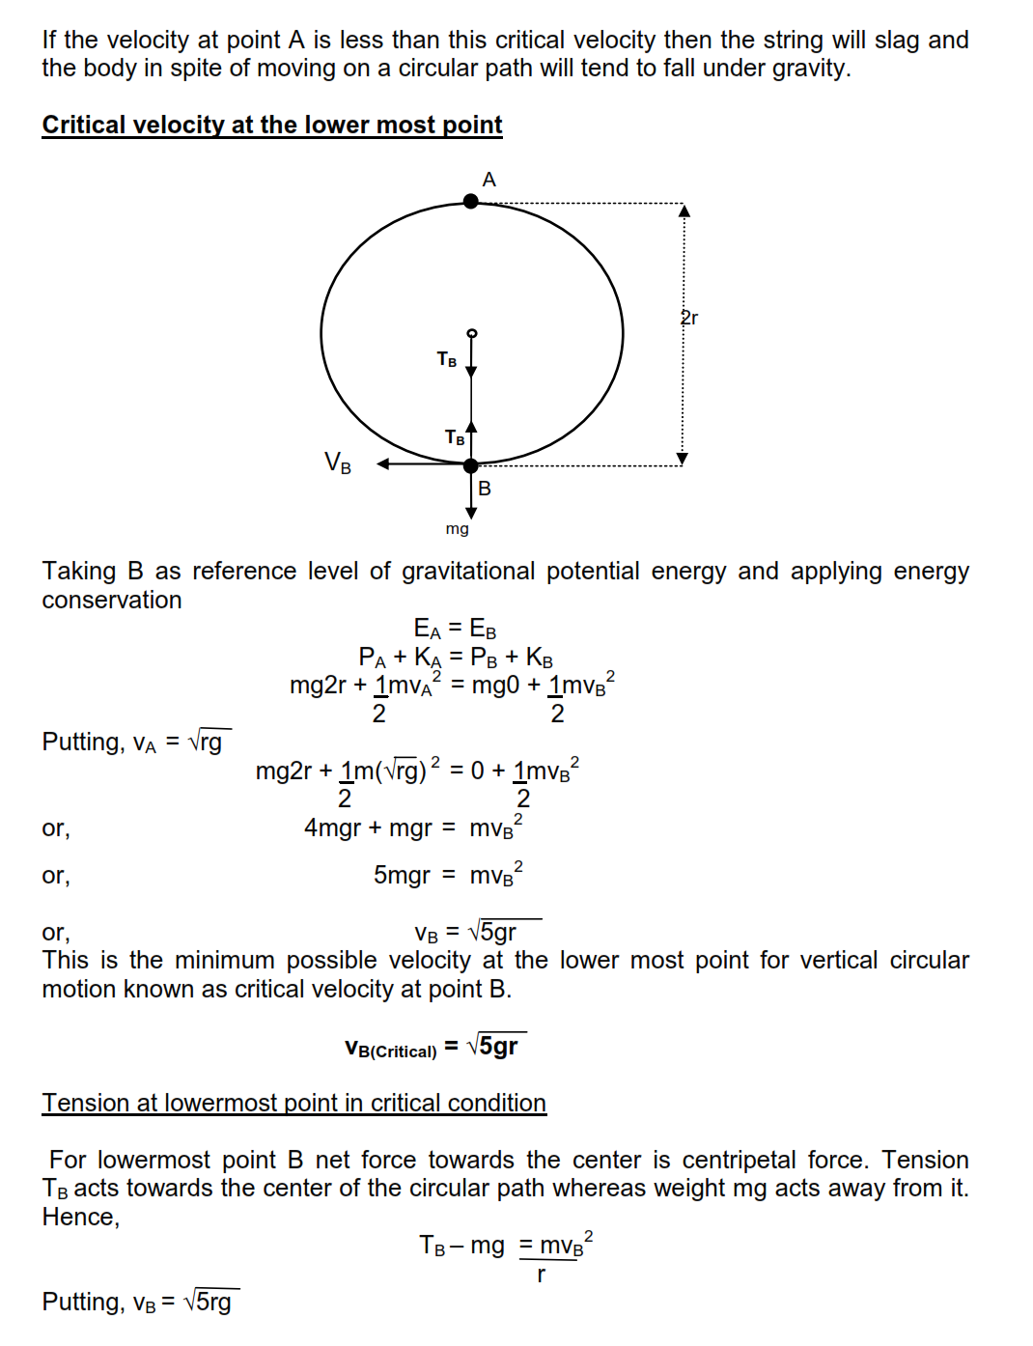

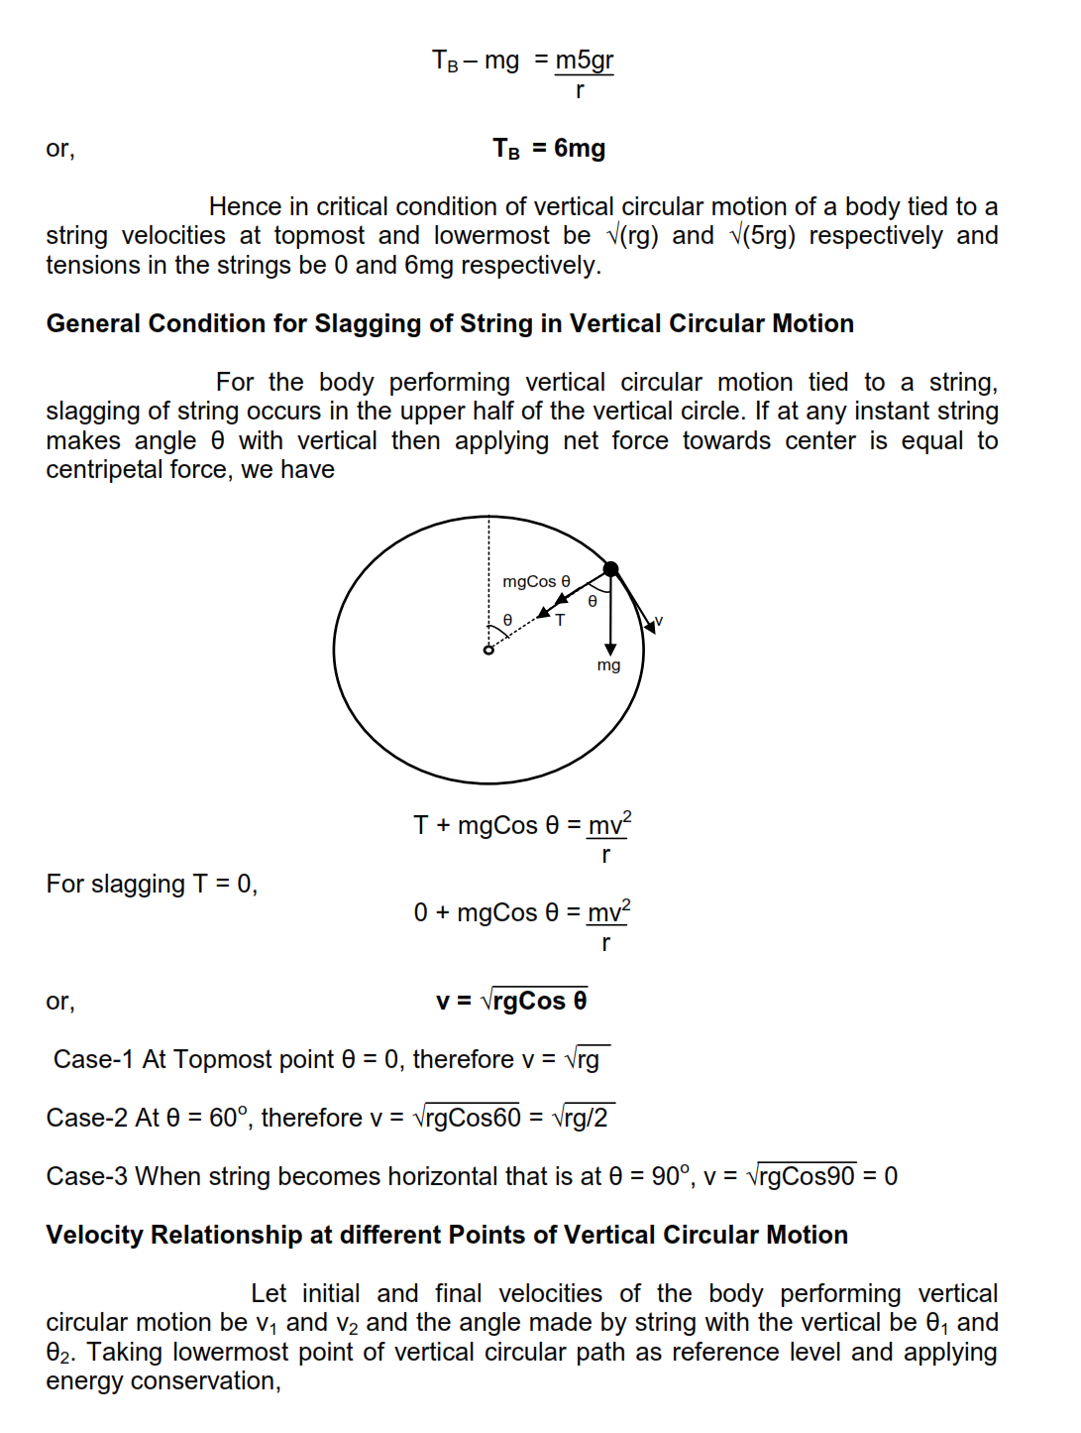

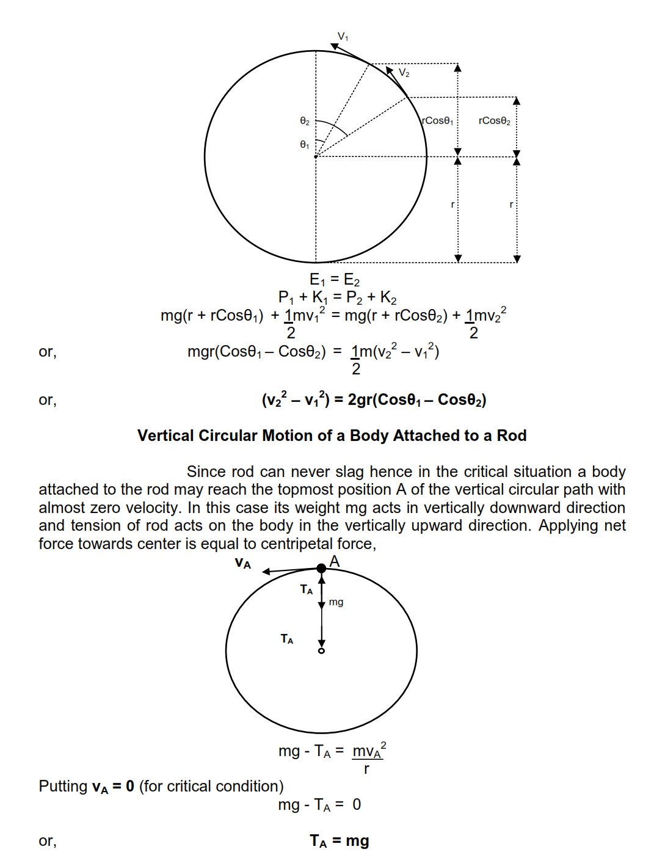

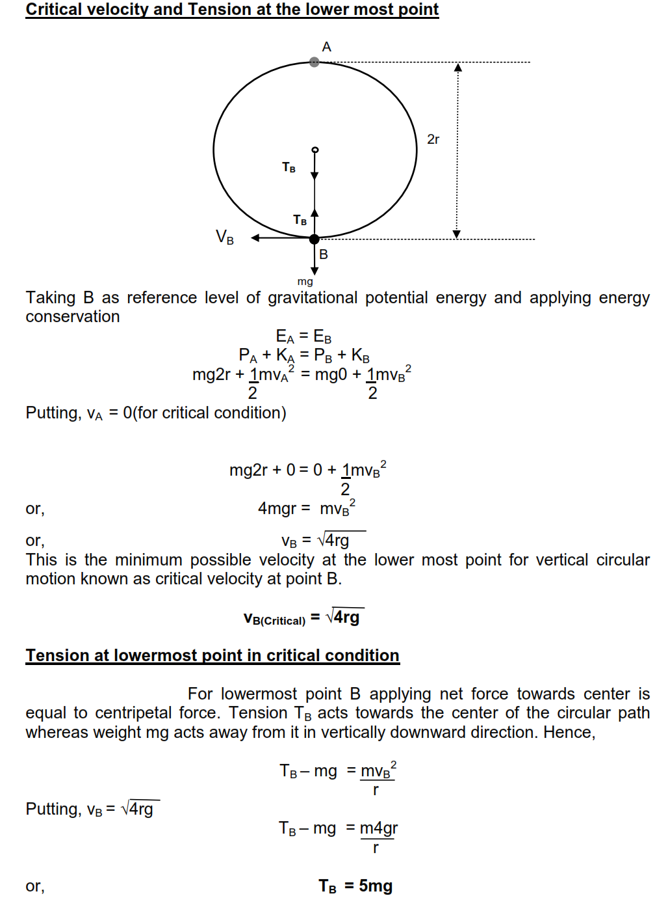

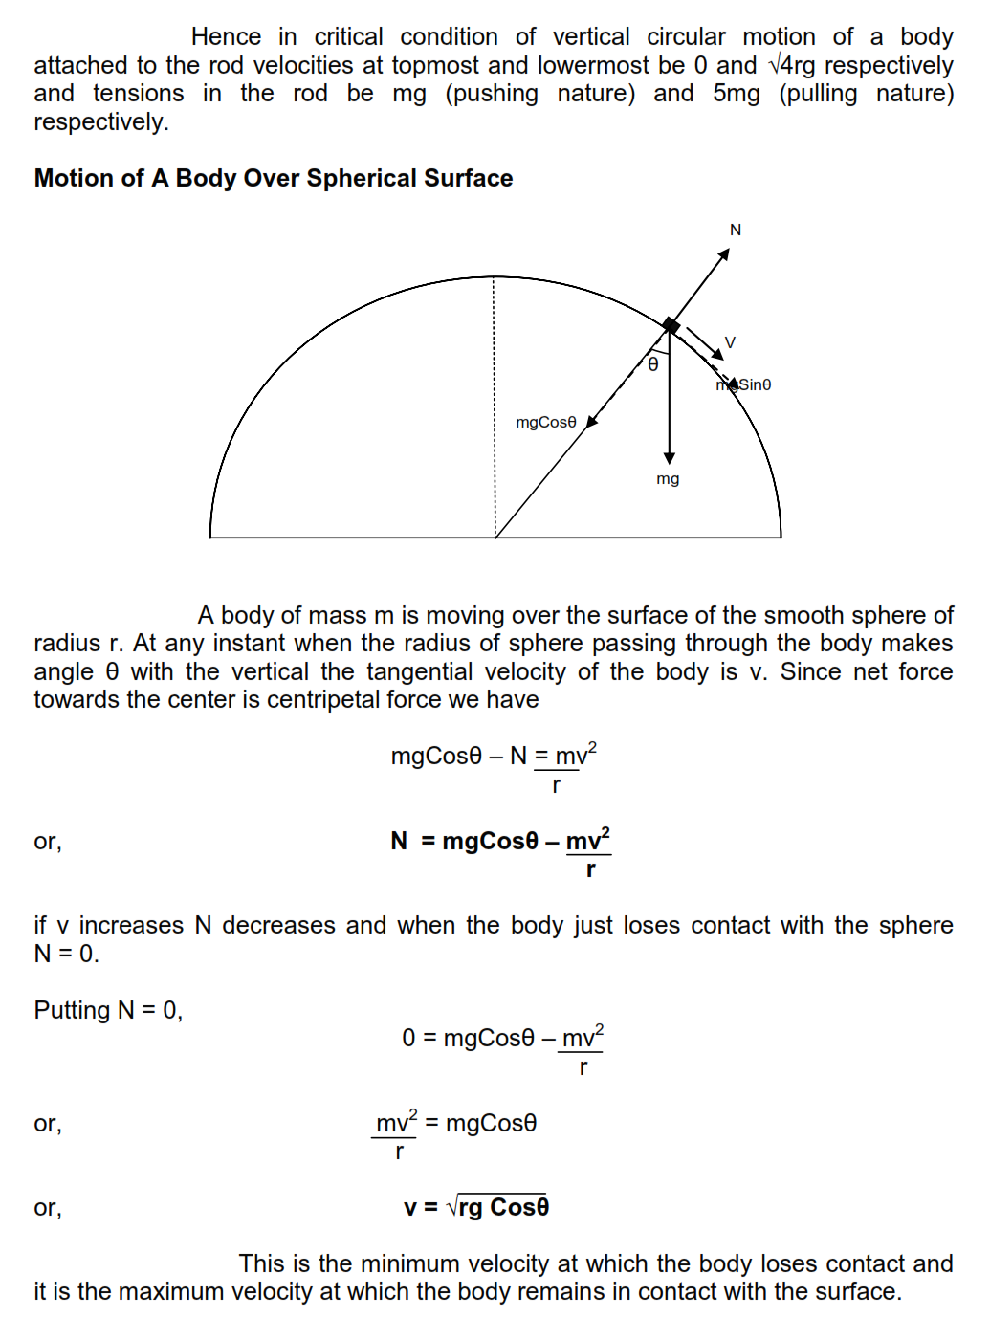

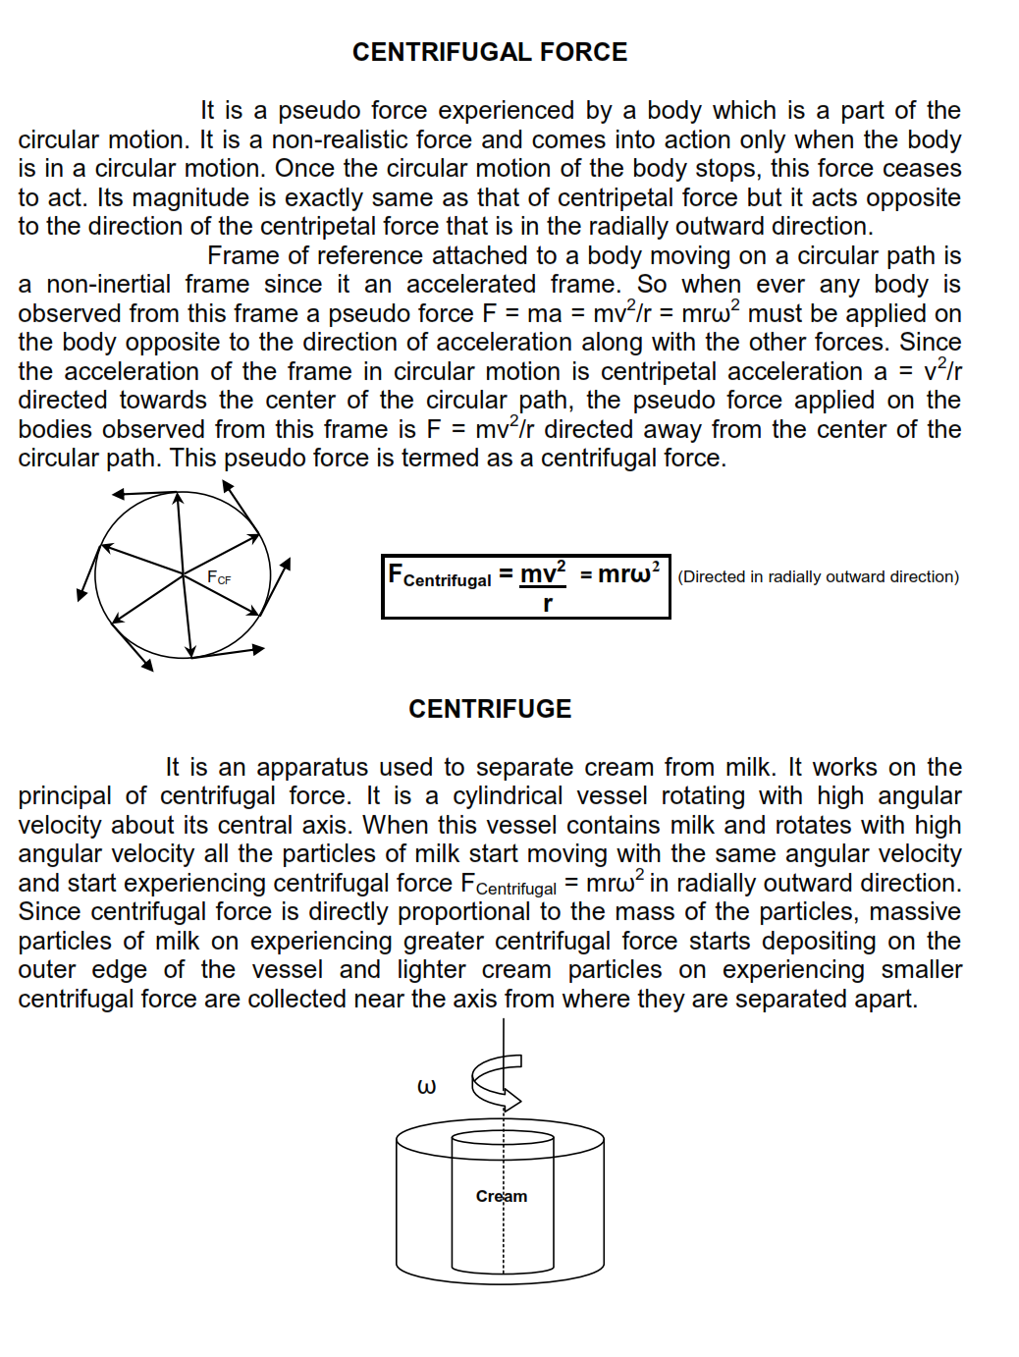

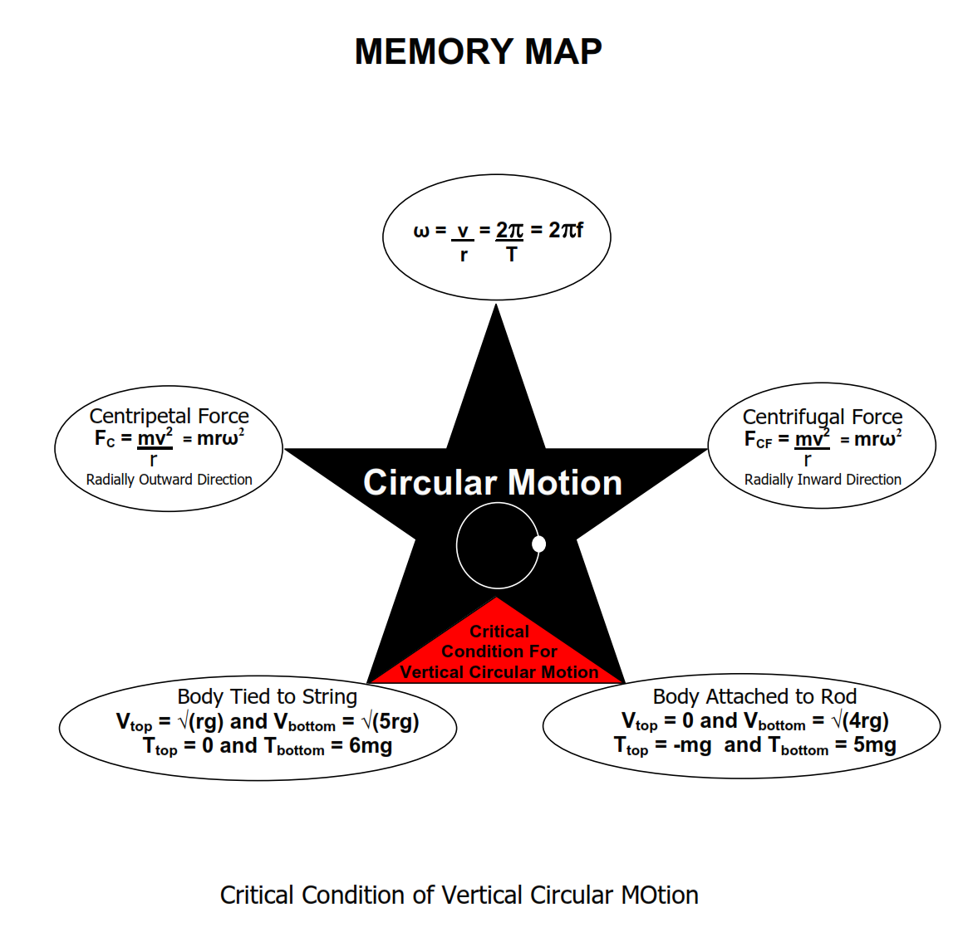

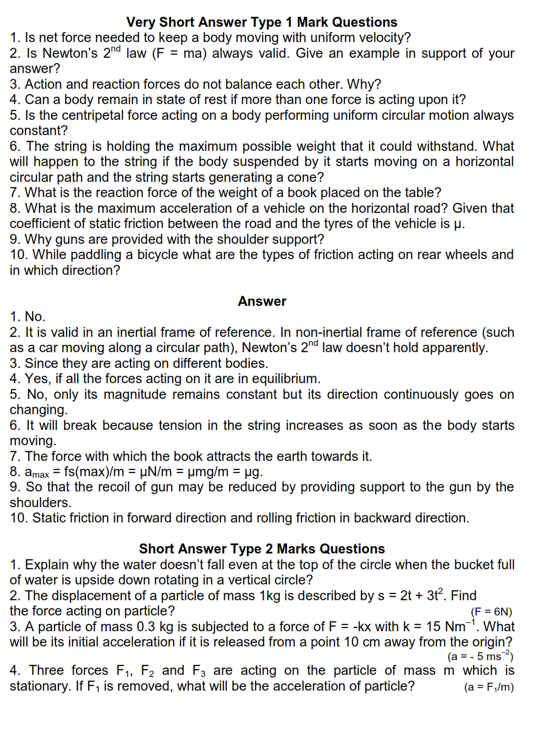

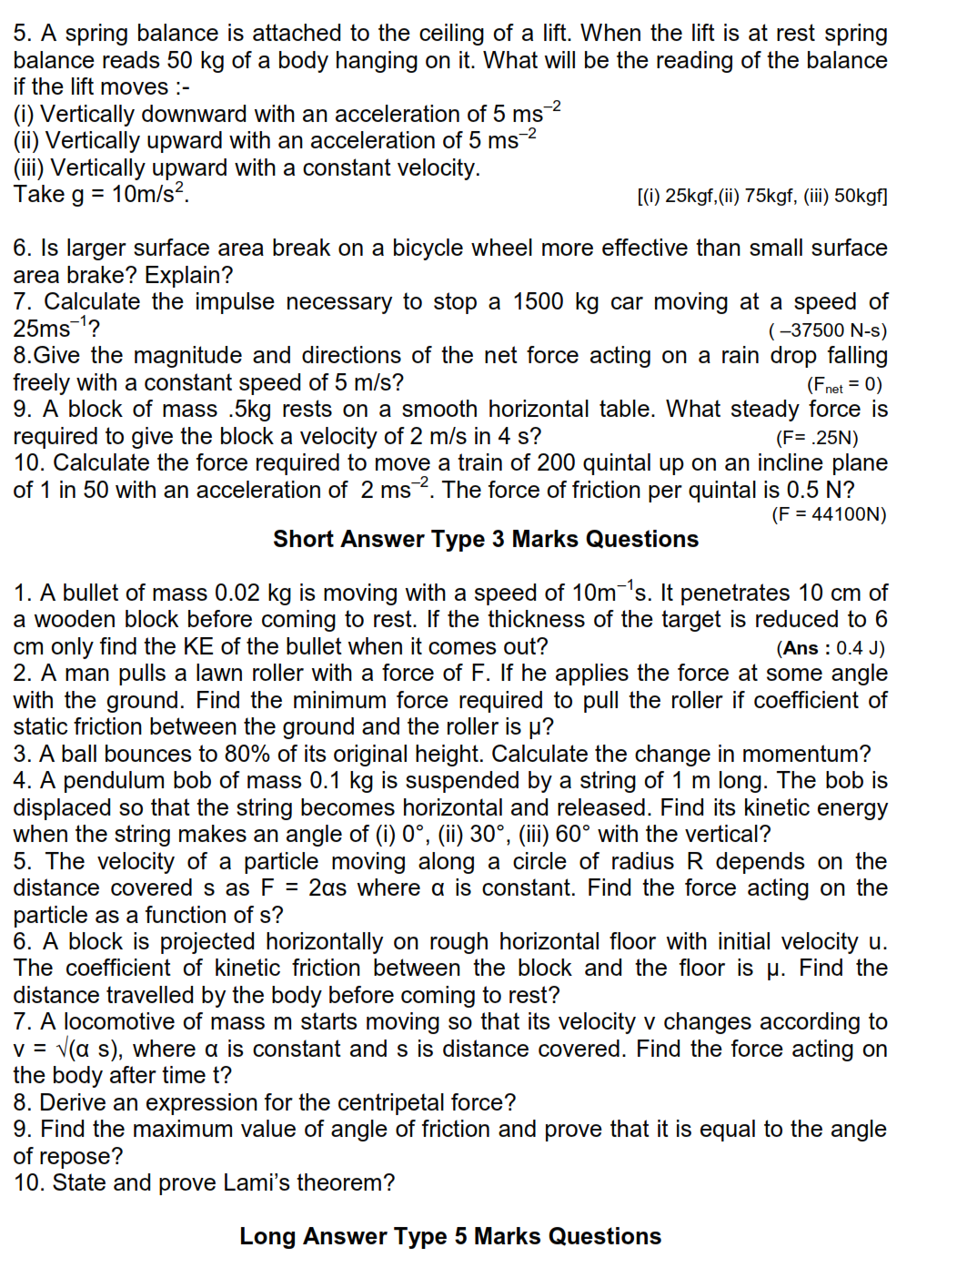

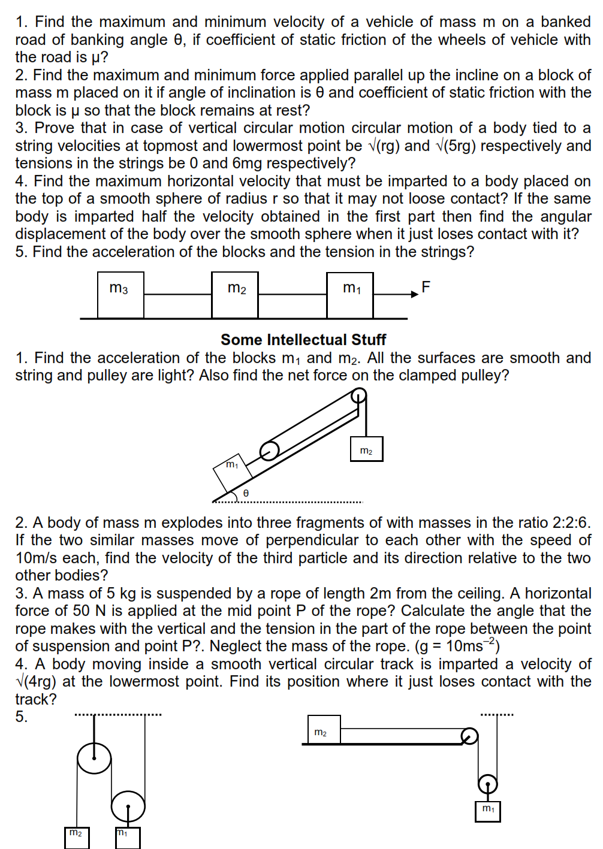

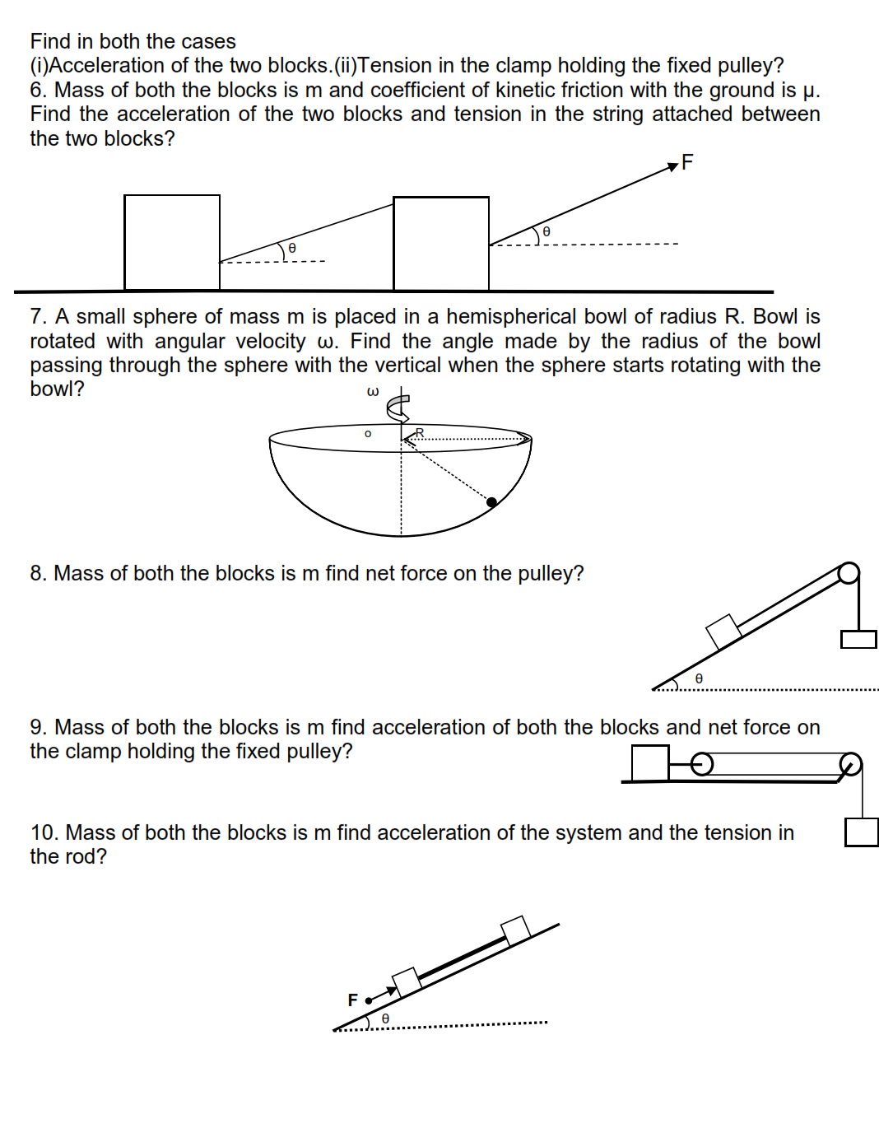

**WORK POWER ENERGY**

Work done by a constant force and a variable force; kinetic energy, work-energy theorem, power. Notion of potential energy, potential energy of a spring, conservative forces: conservation of mechanical energy (kinetic and potential energies); non-conservative forces: motion in a vertical circle; elastic and inelastic collisions in one and two dimensions.

CONCEPT MAP

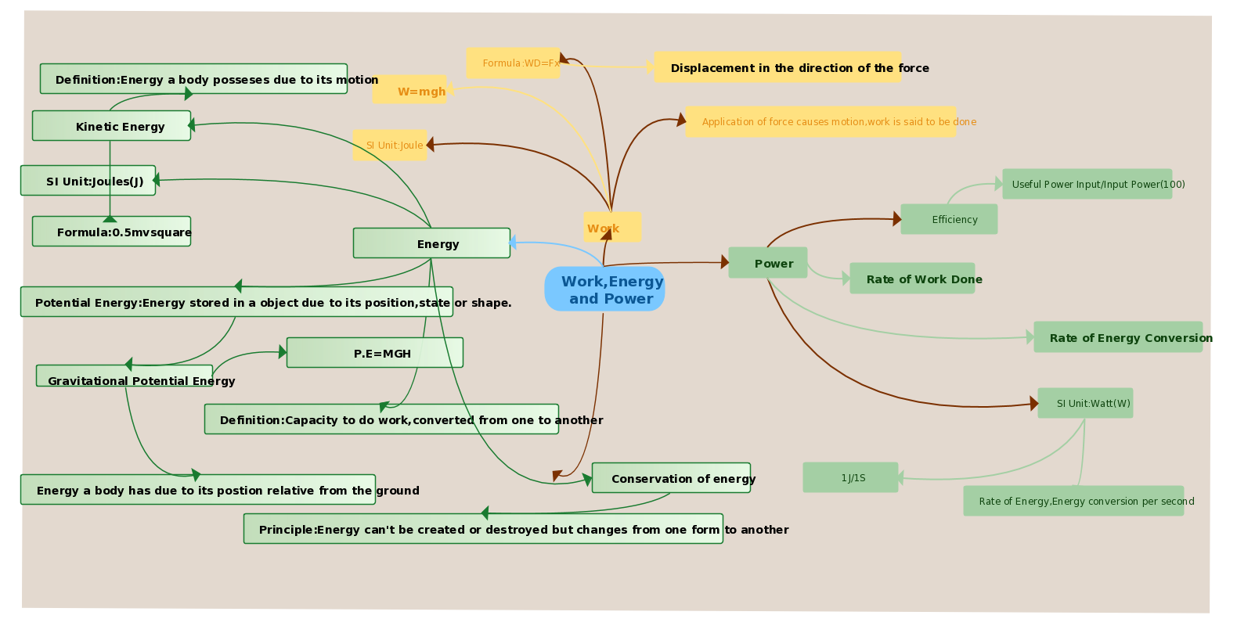

**WORK**

The simplest definition for the amount of work a force does on an object is magnitude of the force times the distance over which it’s applied

*W = F x*

This formula applies when:

* the force is constant
* the force is in the same direction as the displacement of the object

*F*

*x*

**NEGATIVE WORK**

A force that acts opposite to the direction of motion of an object does negative work. Suppose the crate of granola bars skids across the floor until friction brings it to a stop. The displacement is 7m to the right, but the force of friction is fk=20 N to the left. Therefore, the amount of work friction does is -140 J. (This will be the work under the effect of friction).

Friction doesn’t always do negative work. When you walk, for example, the friction force is in the same direction as your motion, so it does positive work in this case.

**ZERO WORK**

a) when zero work is done is when the displacement is zero. Think about a weight lifter holding a 200 lb barbell over her head. Even though the force applied is 200 lb, and work was done in getting over her head, no work is done just holding it over her head.

b)Work: Circular Motion Example Q. A ‘69 Thunderbird is cruising around a circular track. Since it’s turning a centripetal force is required. What type of force supplies this centripetal force?How much work does this force do?

*answer:* friction. None, since the centripetal force is always ⊥ to the car’s motion.



**v**

*r*

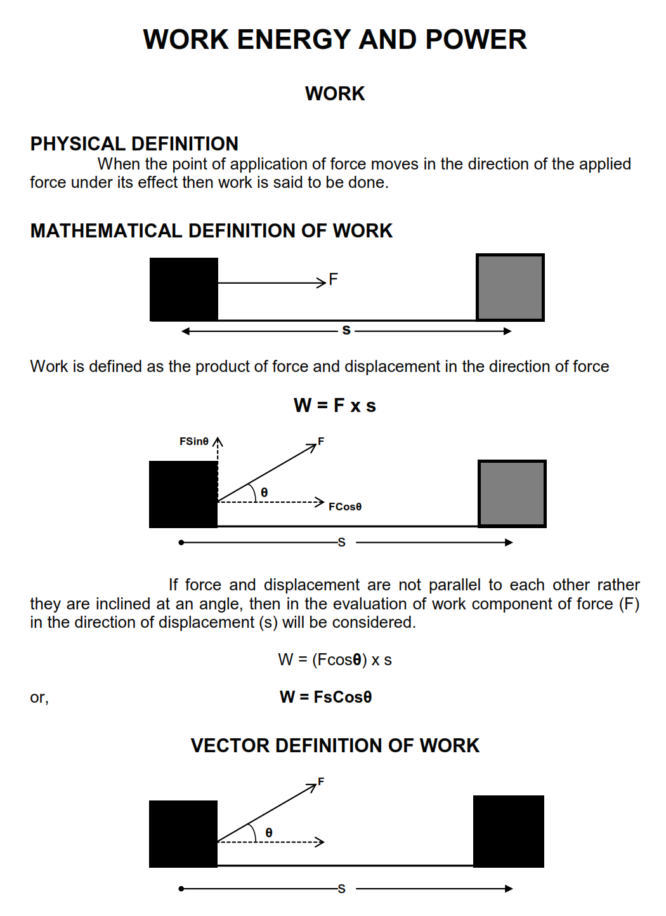

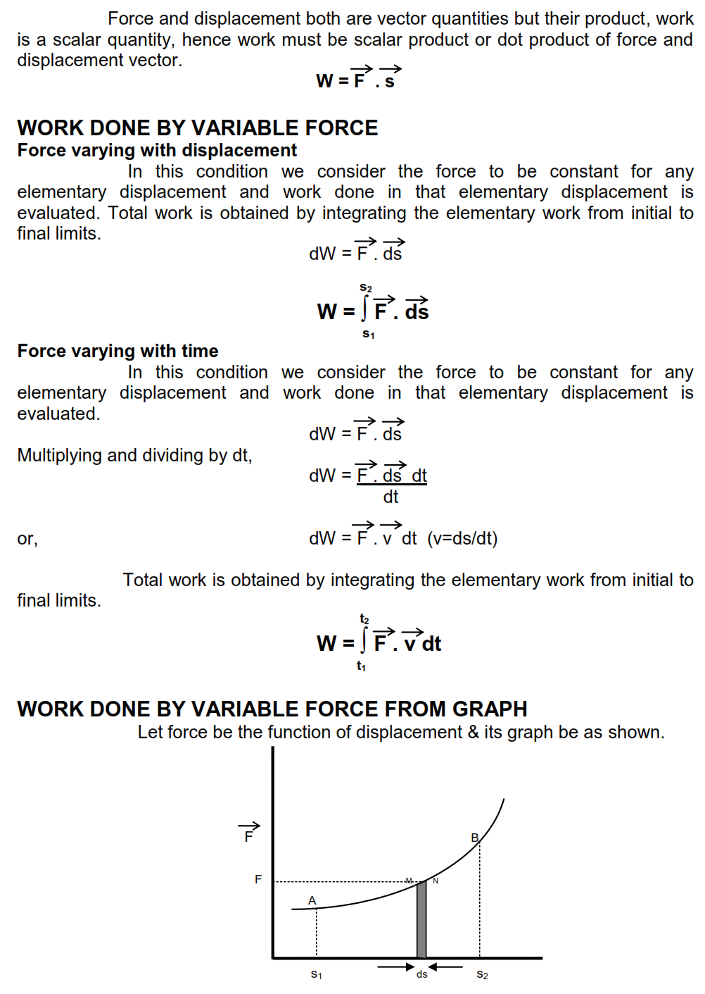

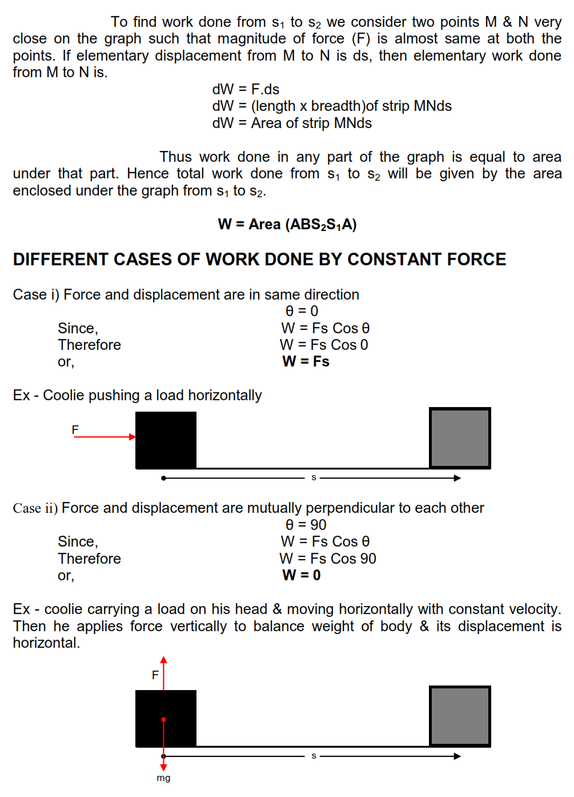

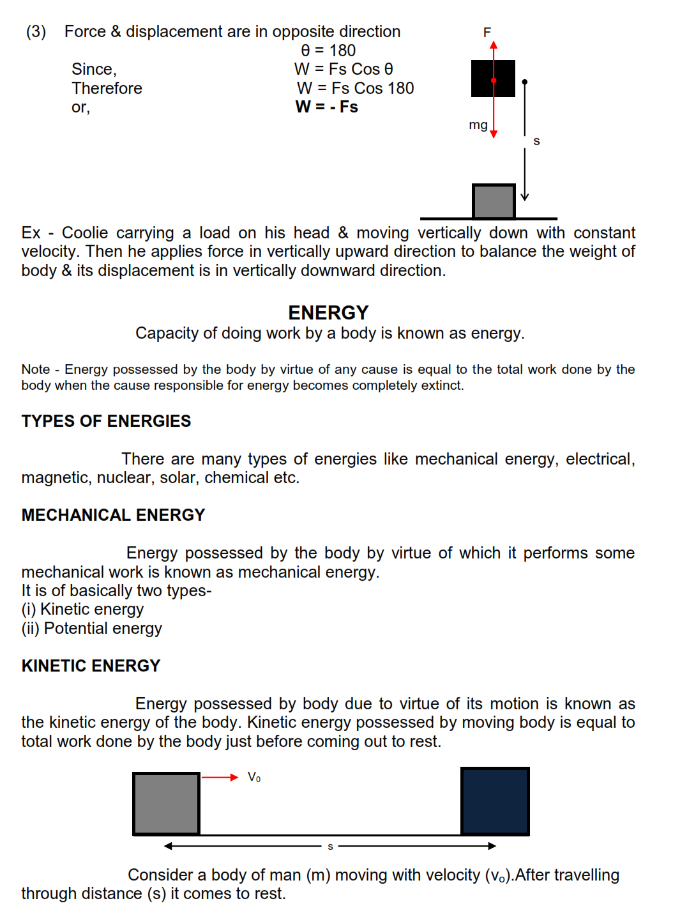

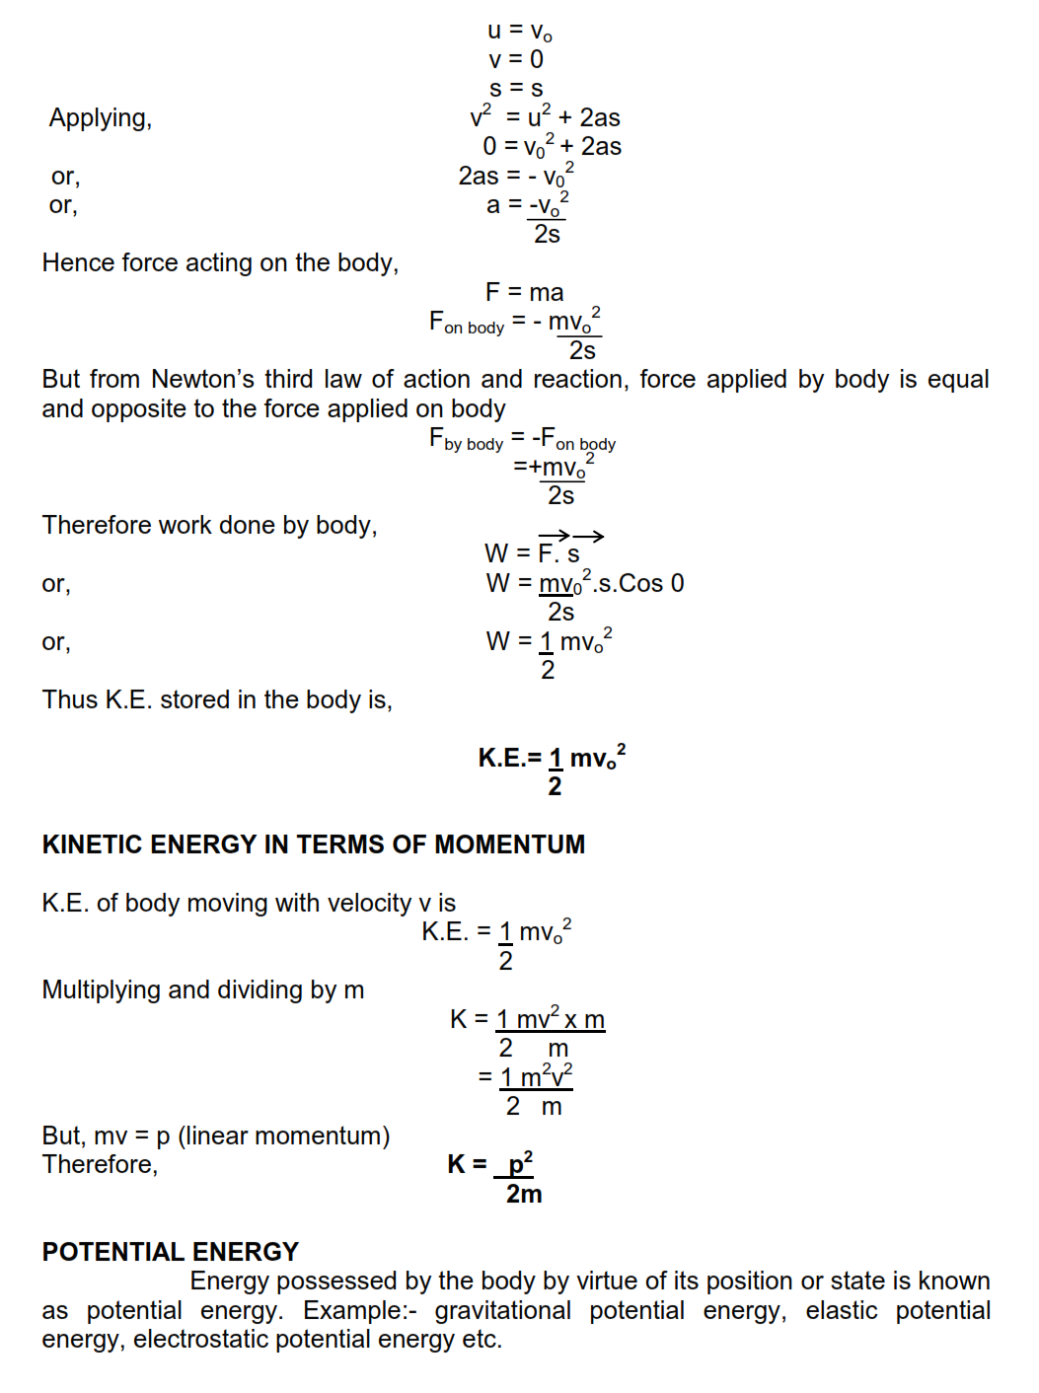

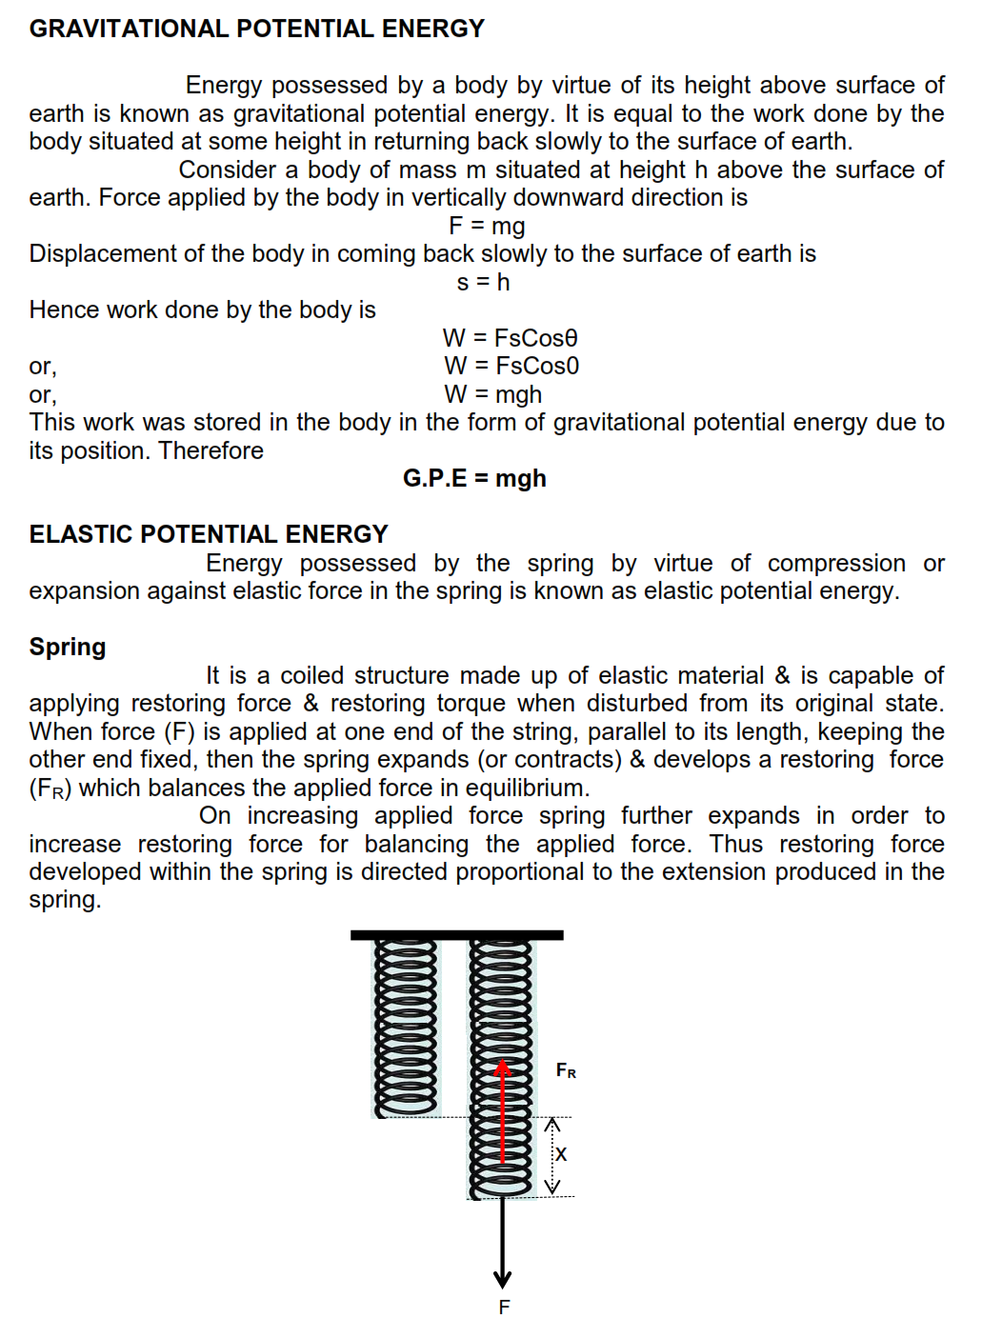

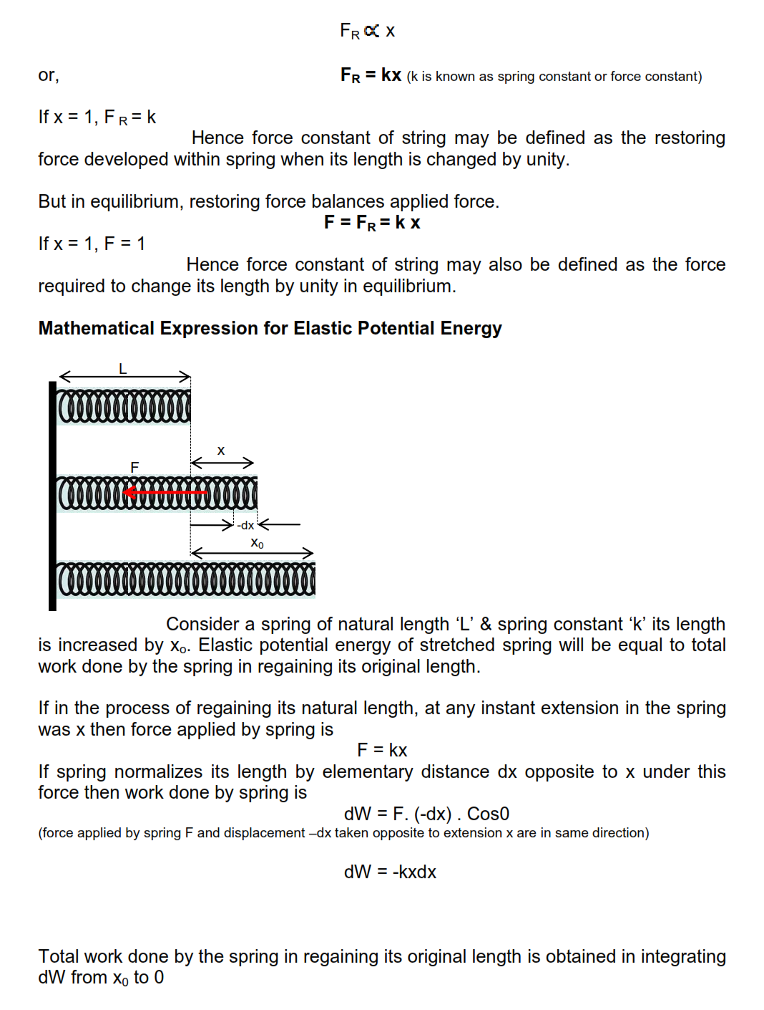

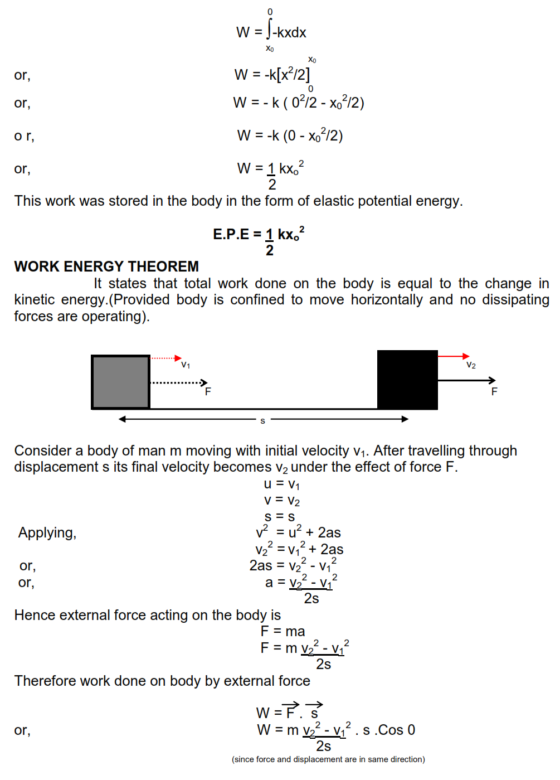

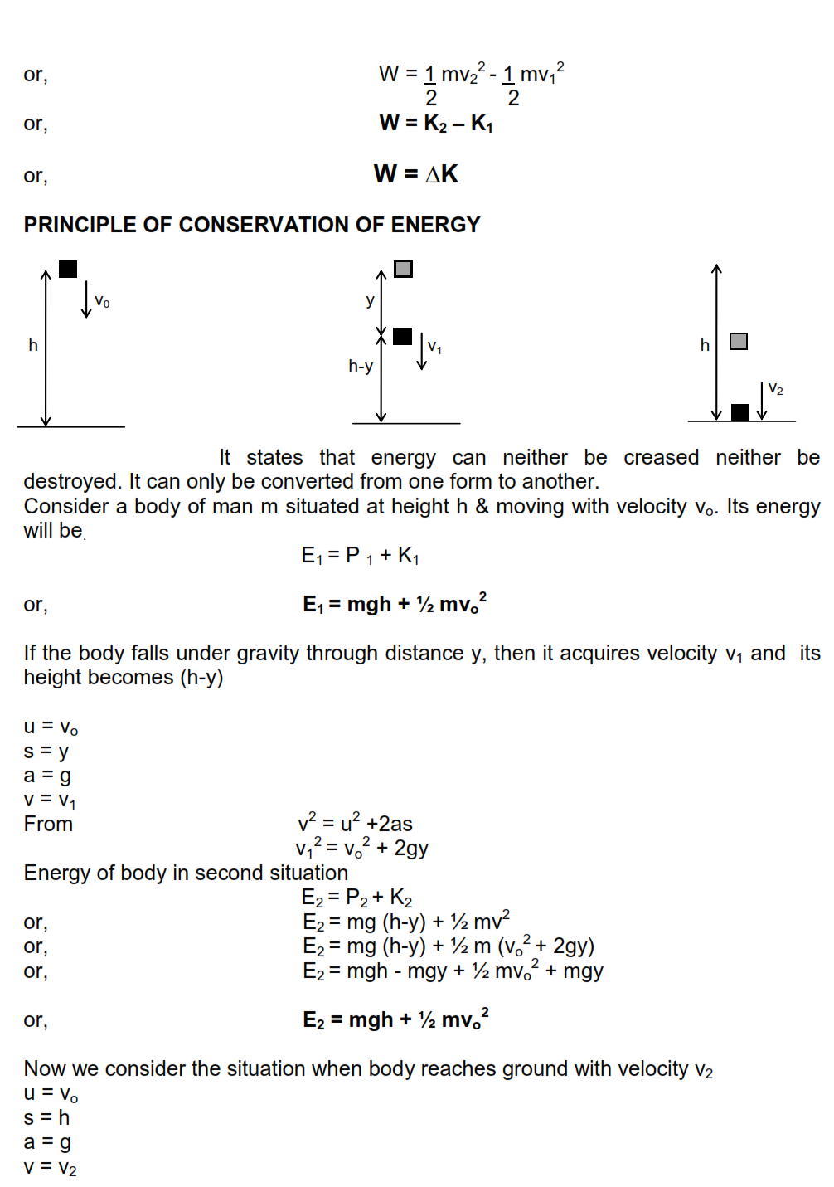

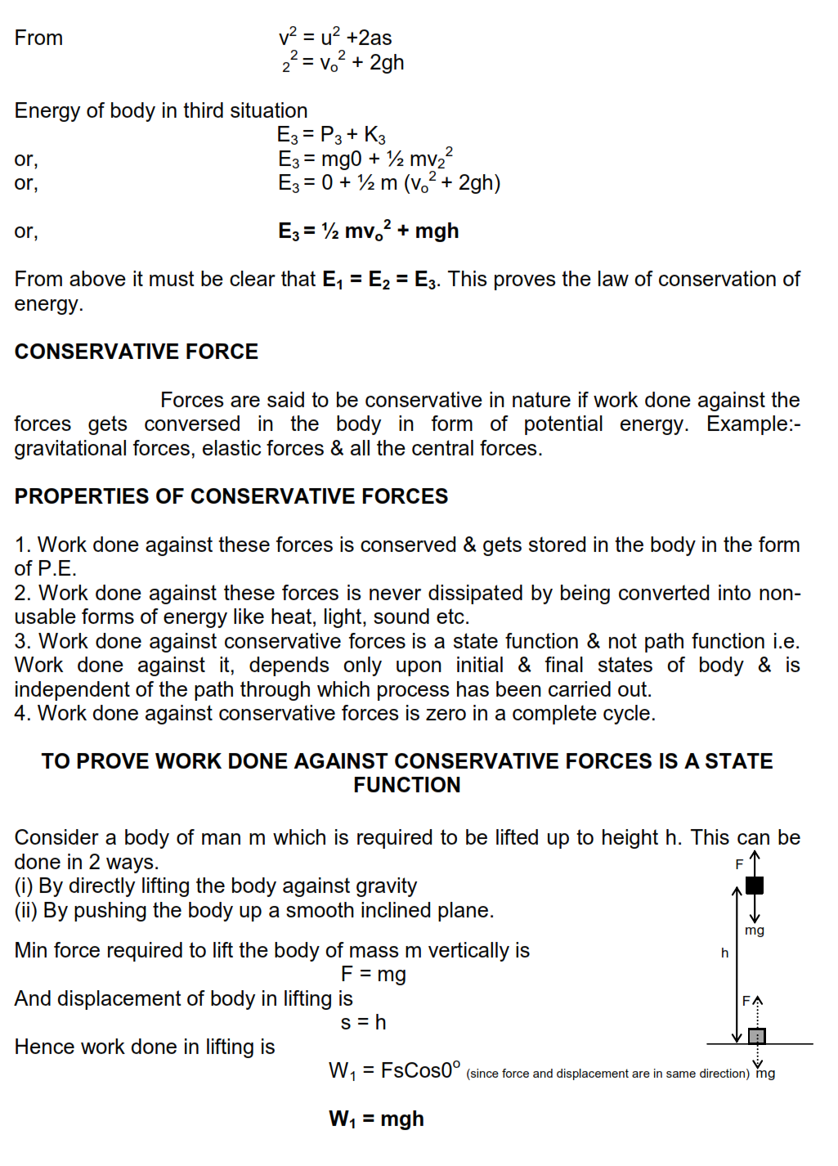

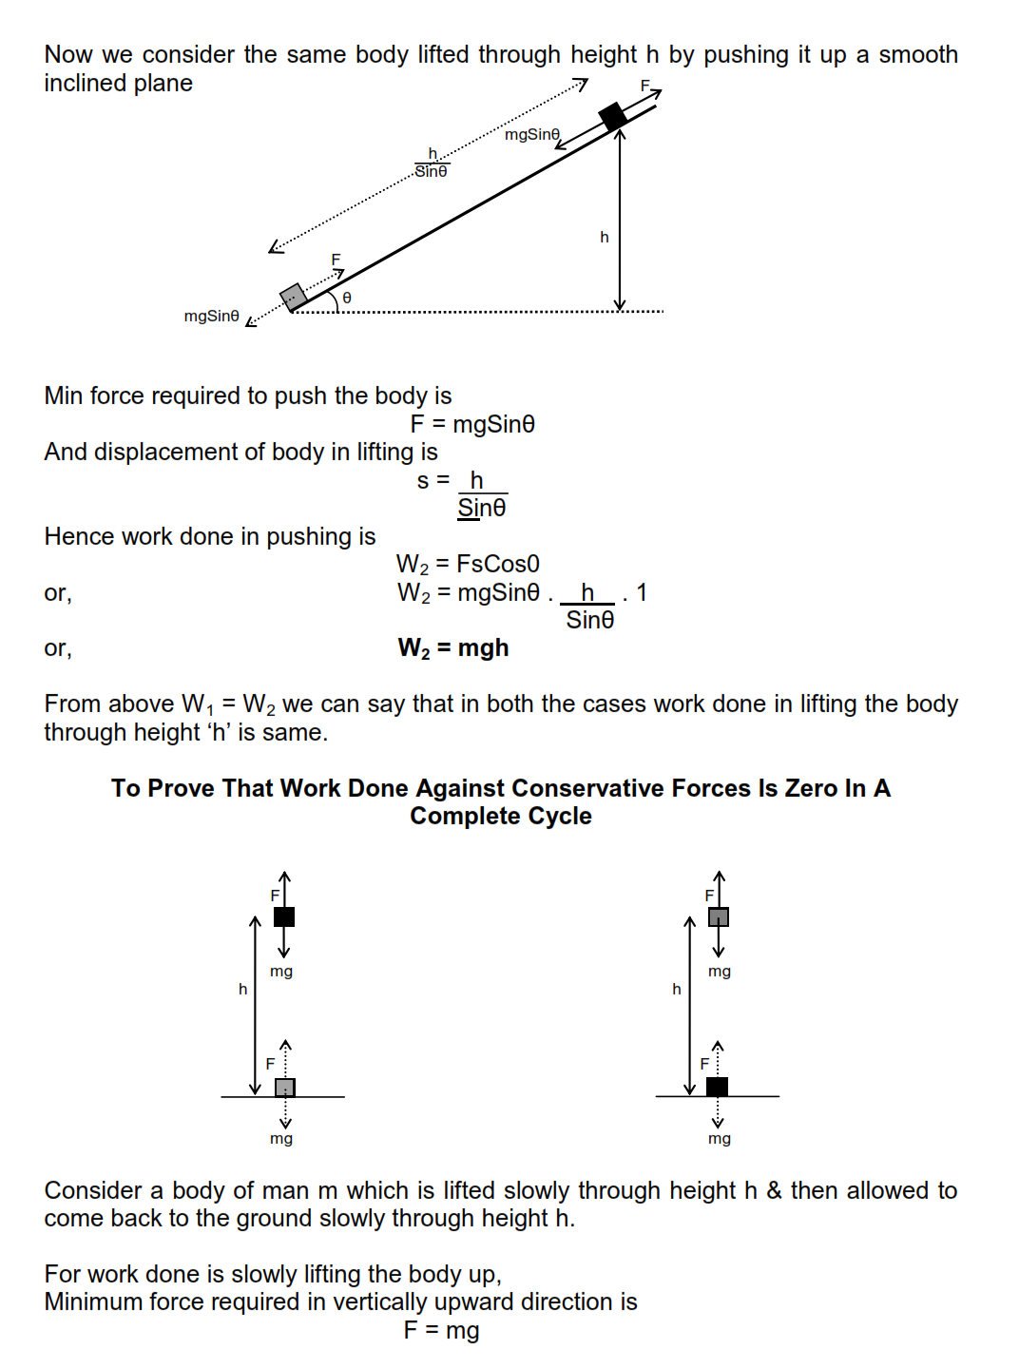

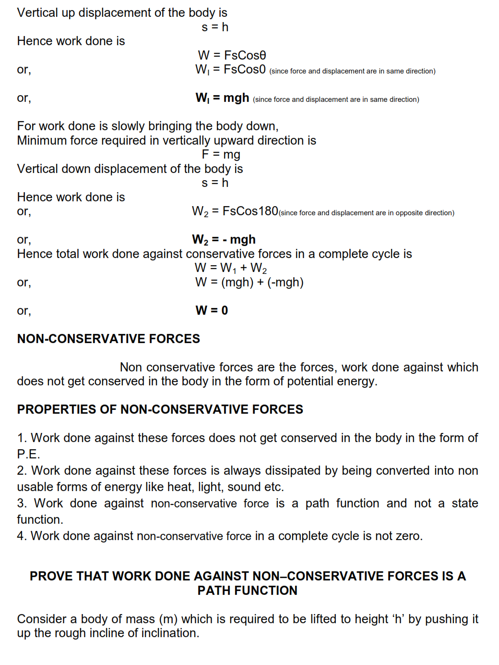

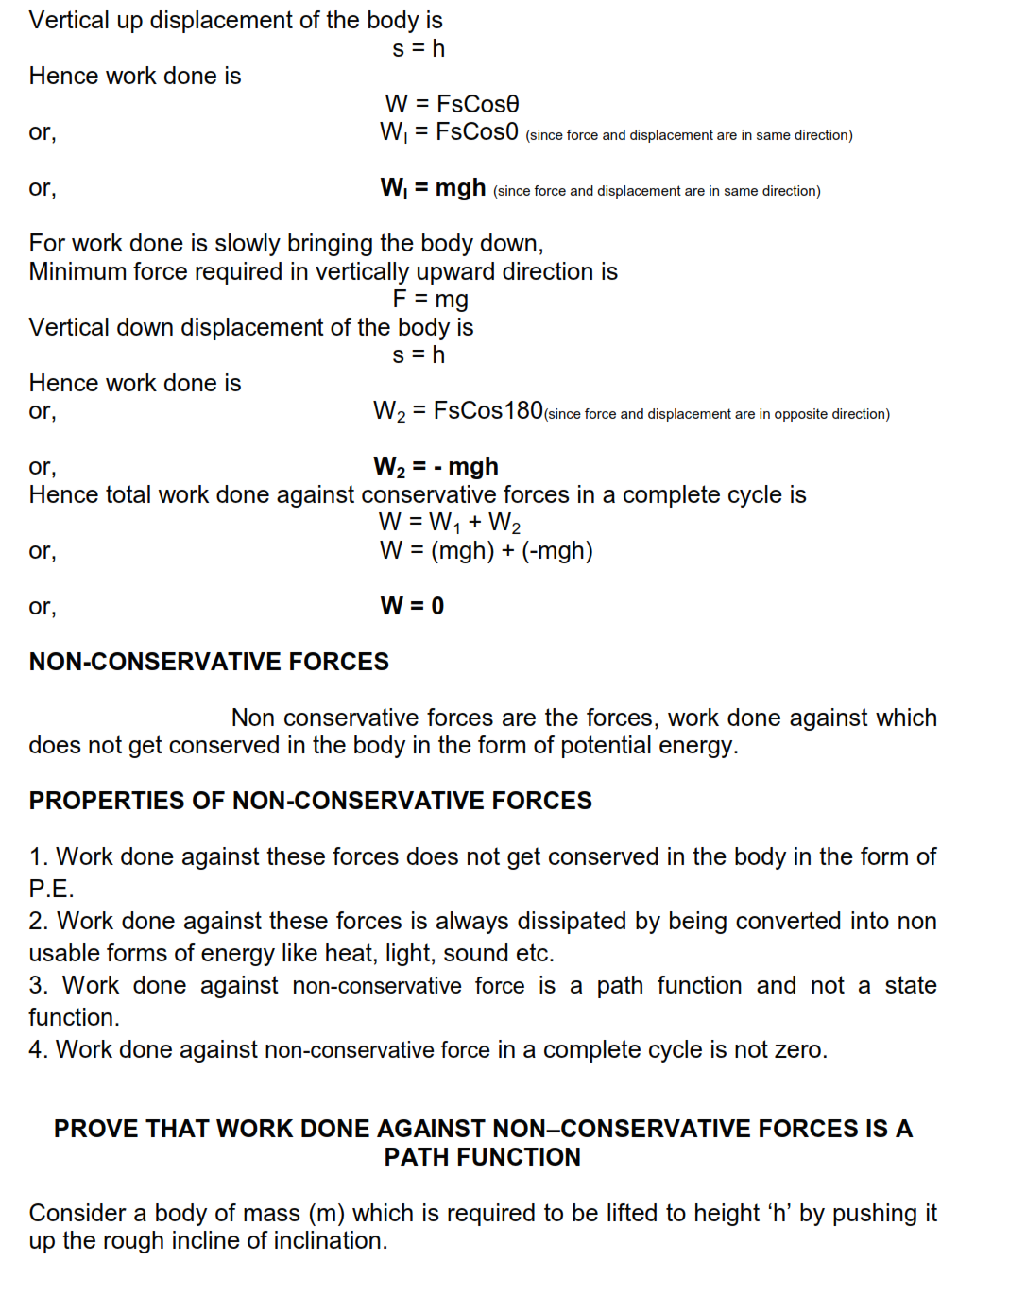

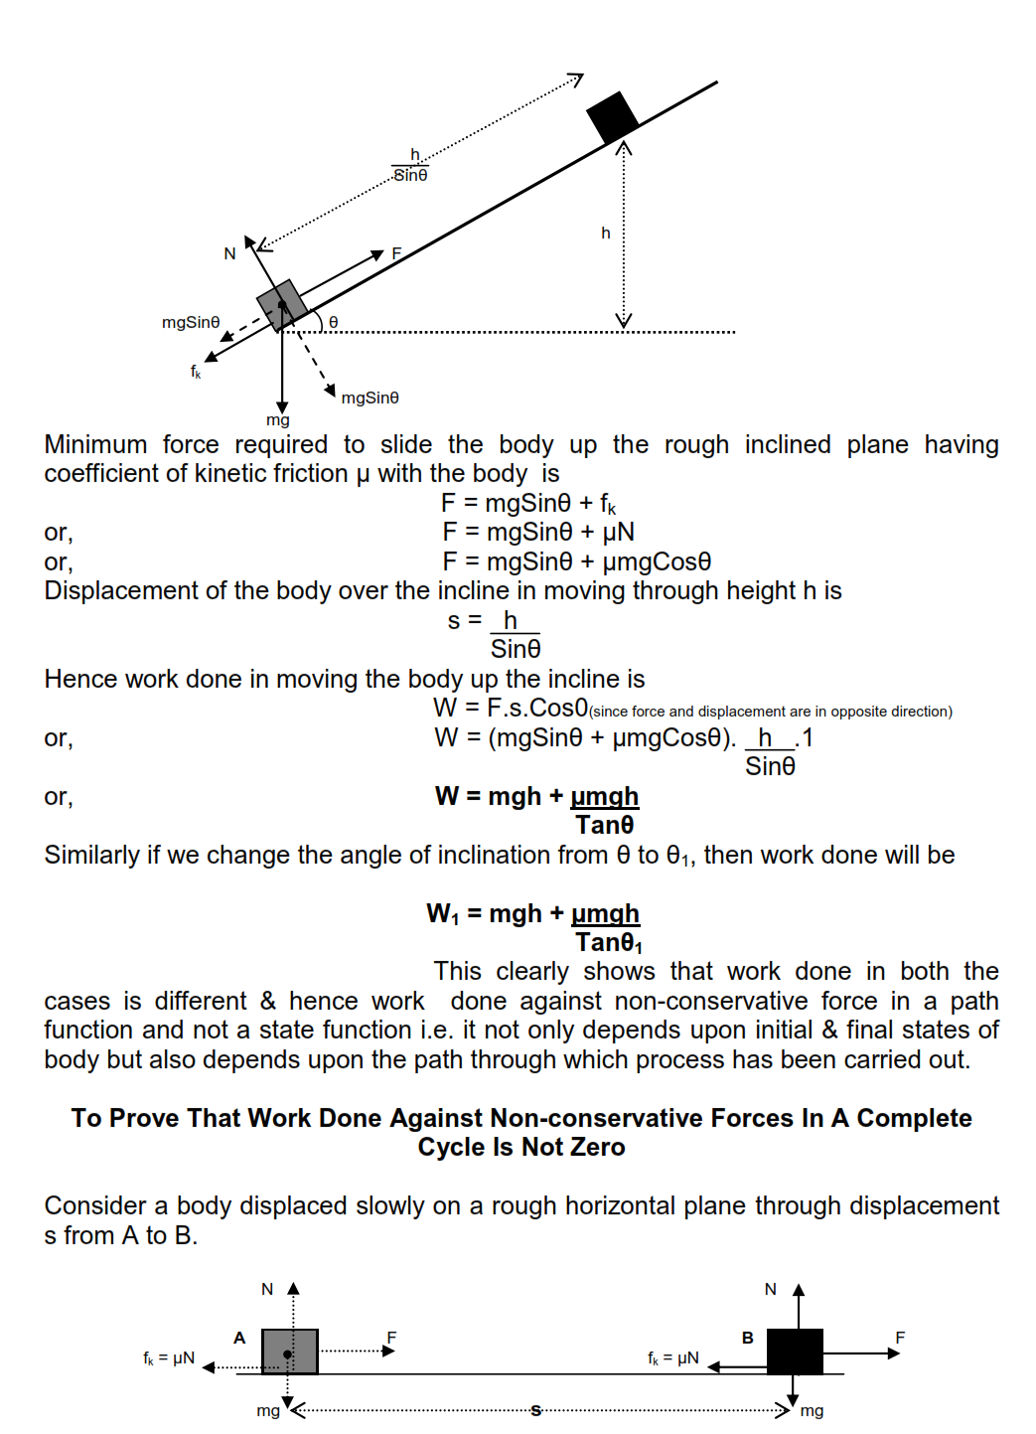

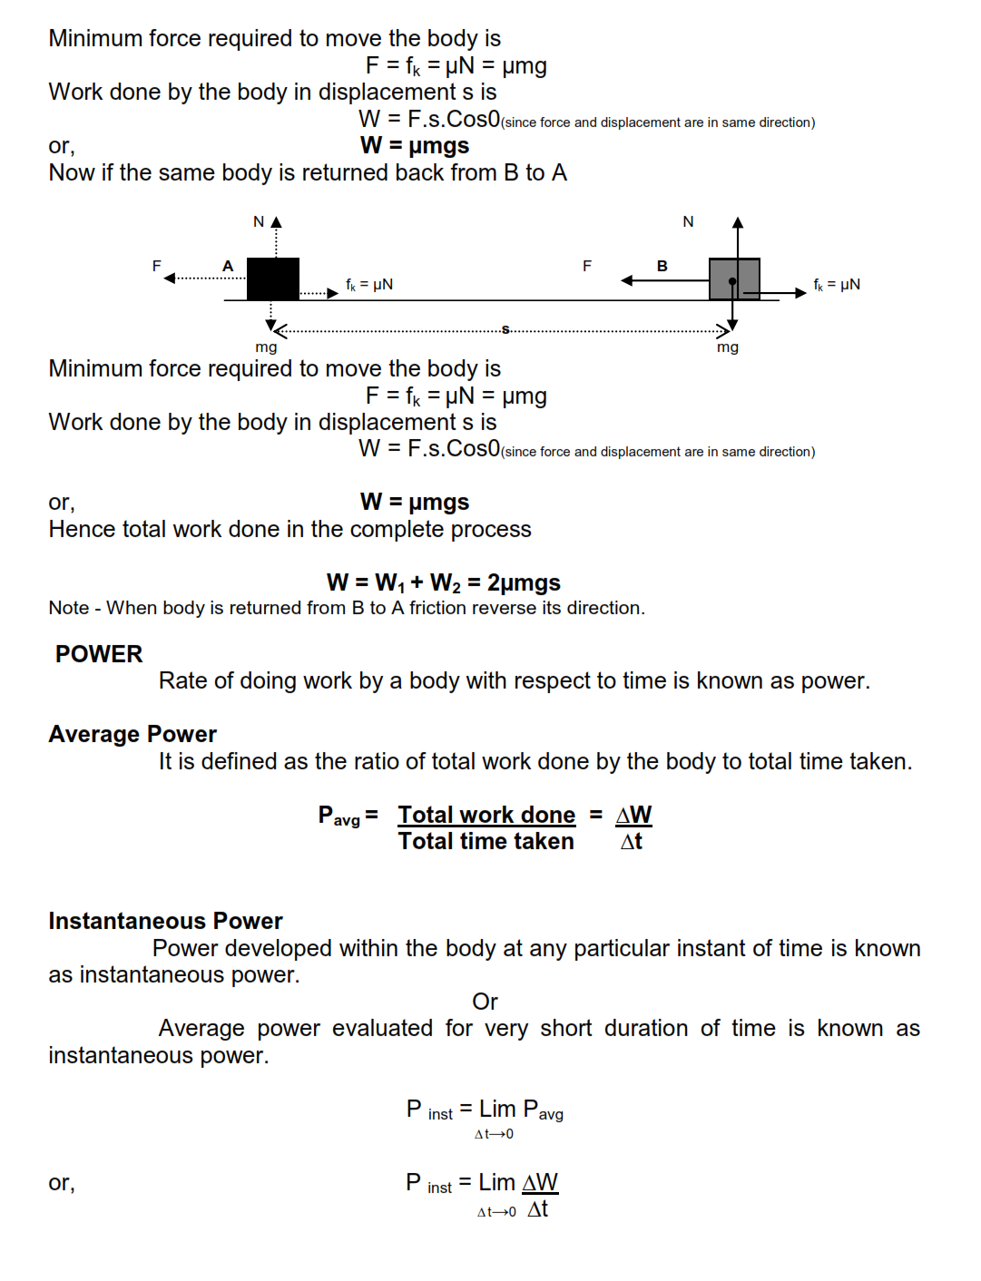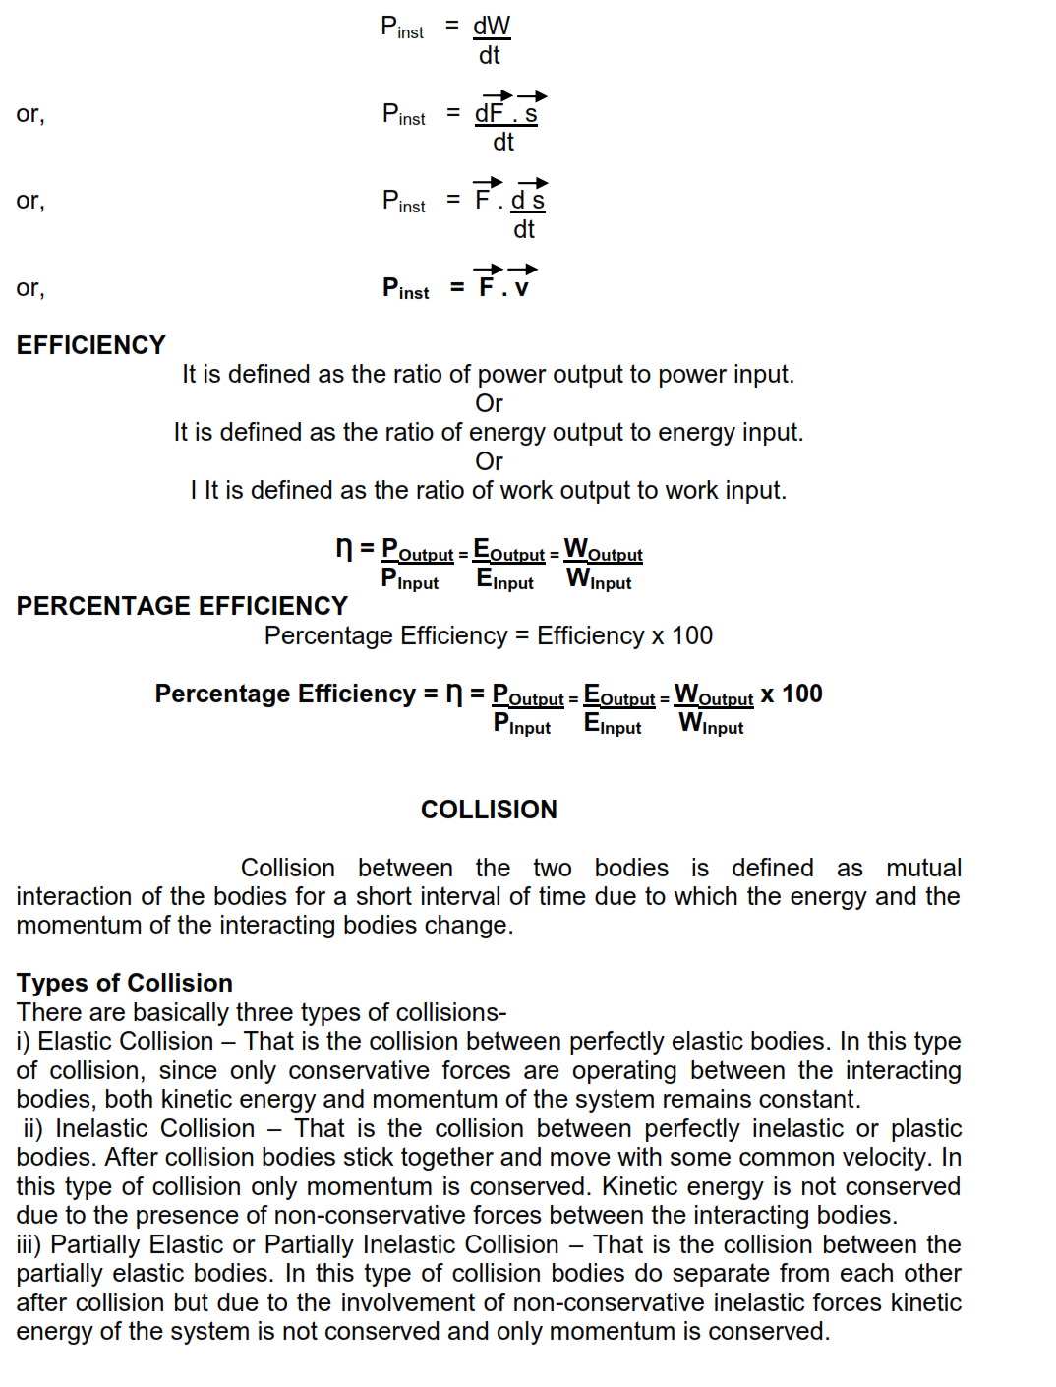

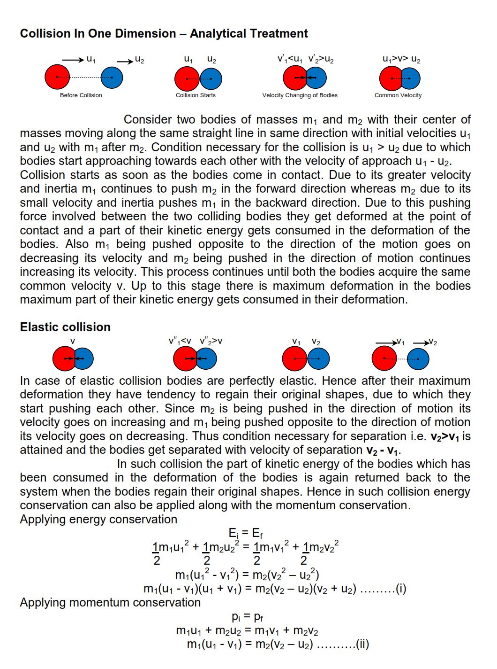

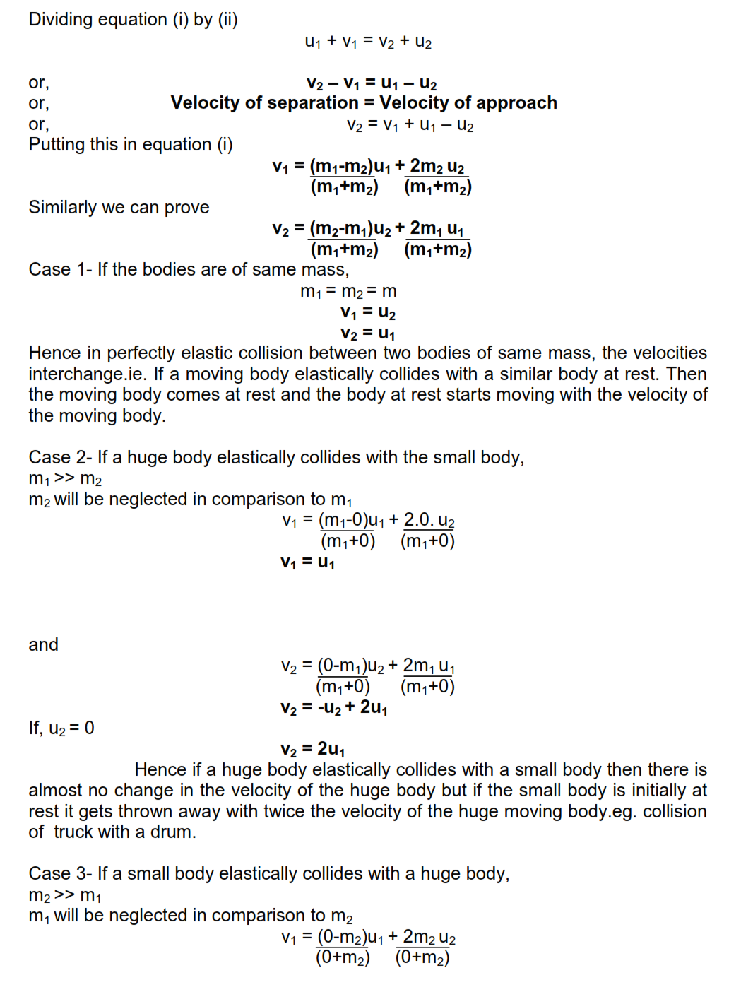

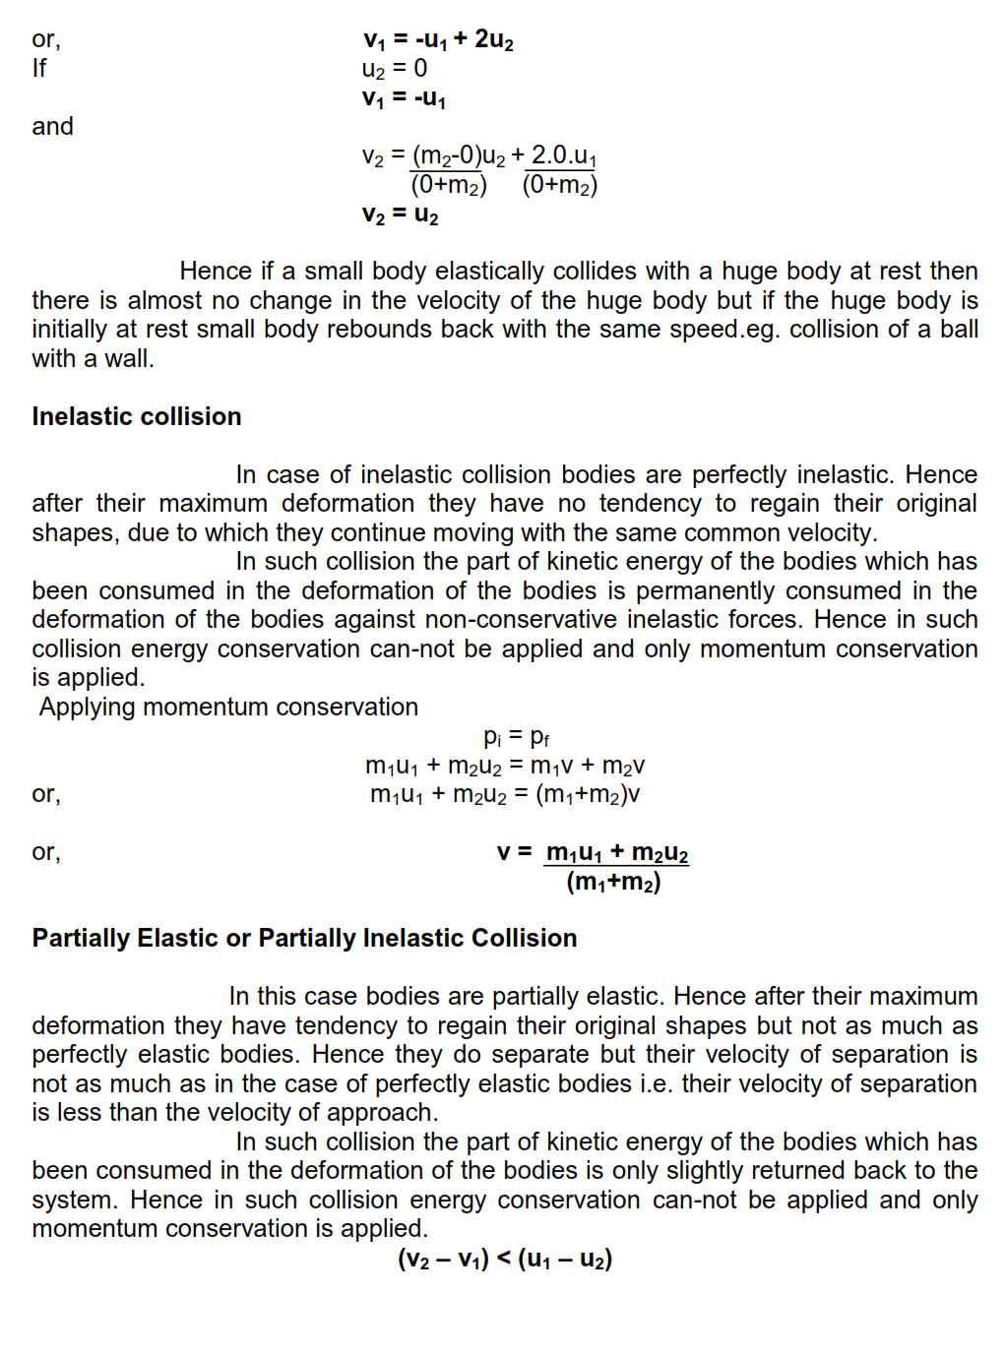

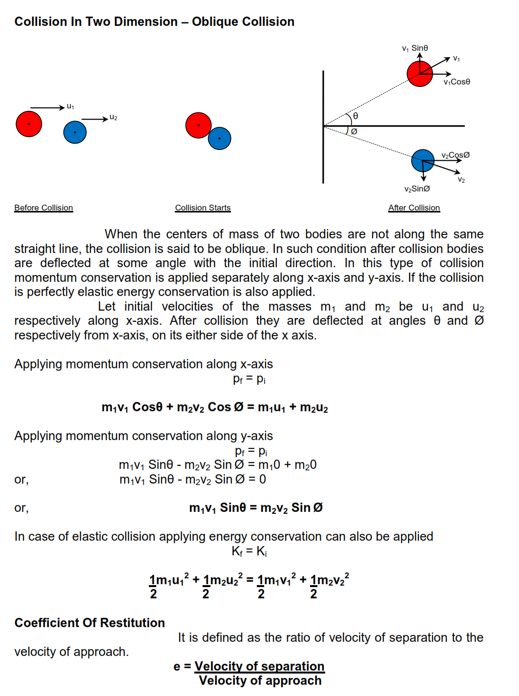

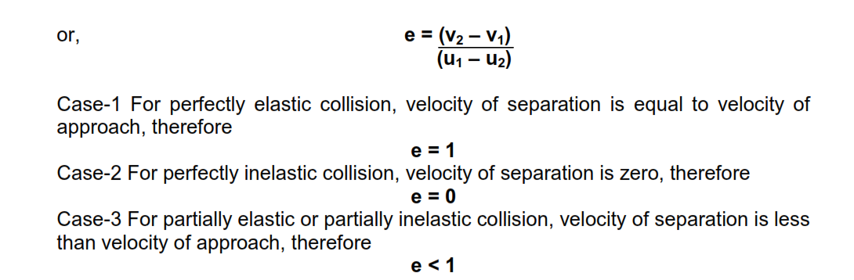

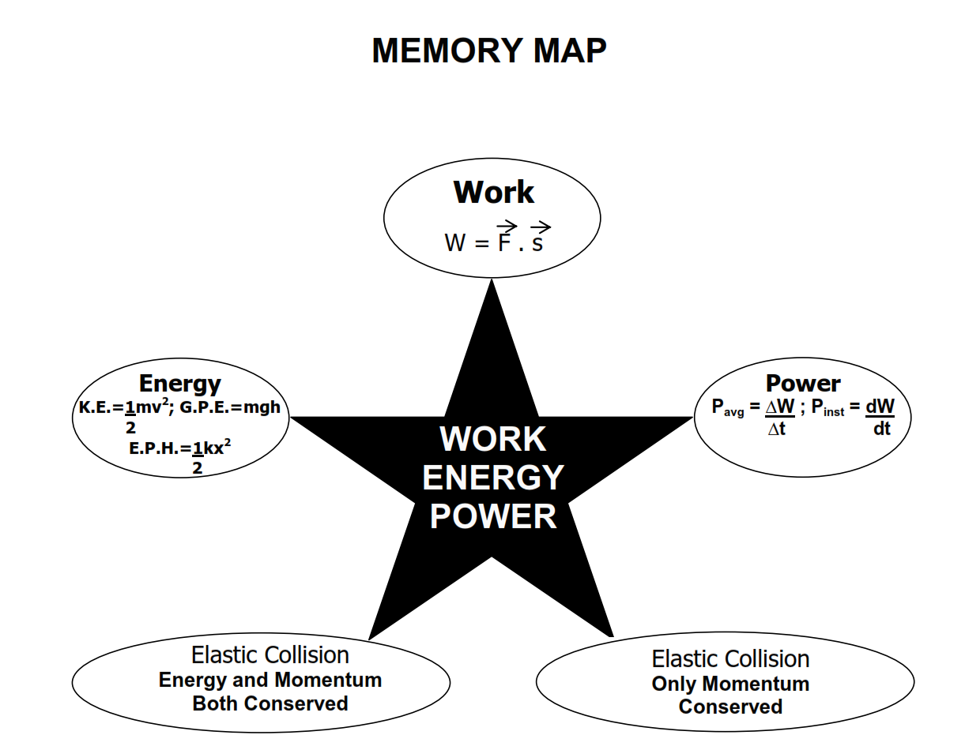

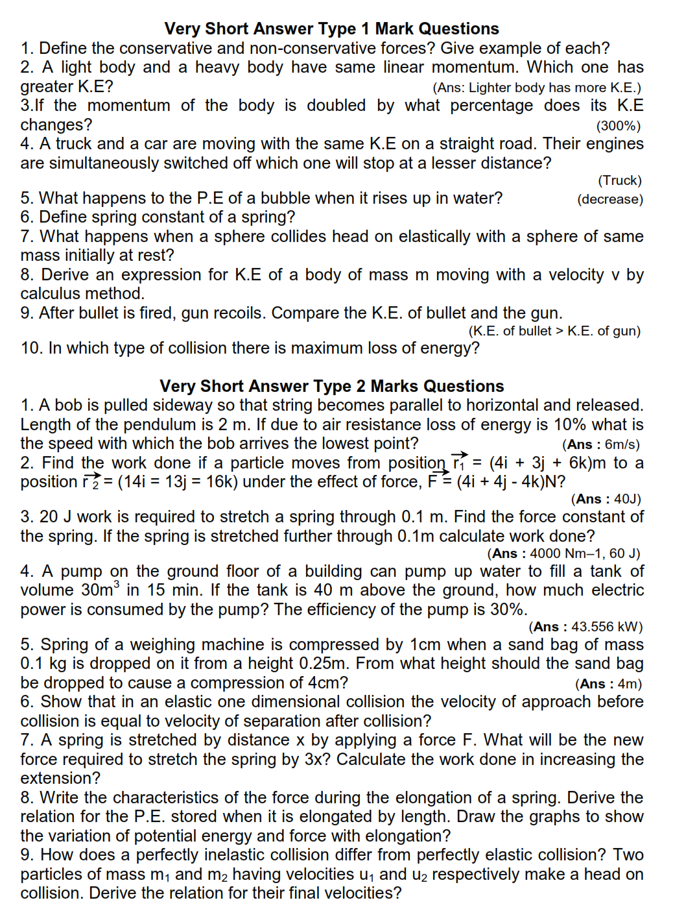

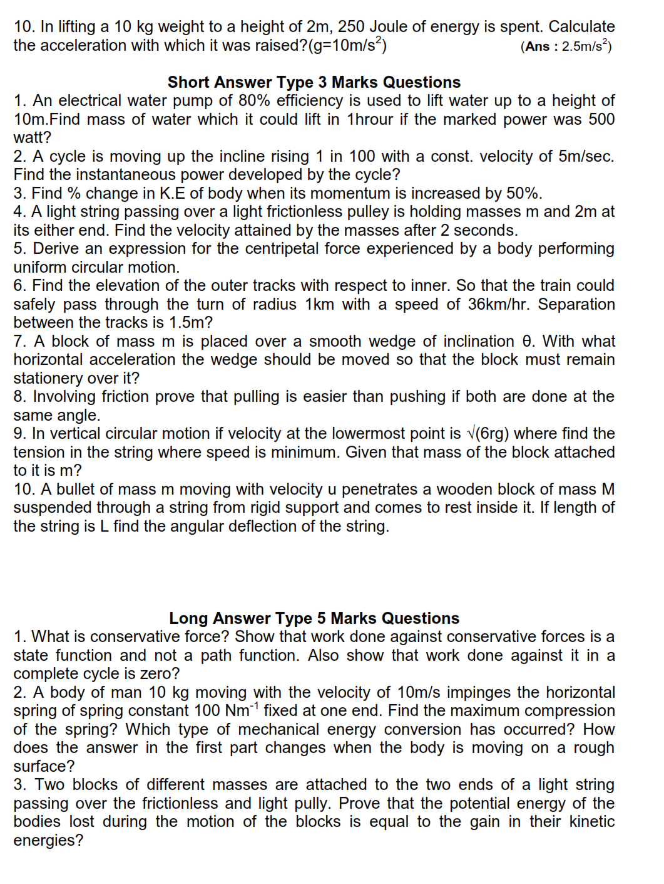

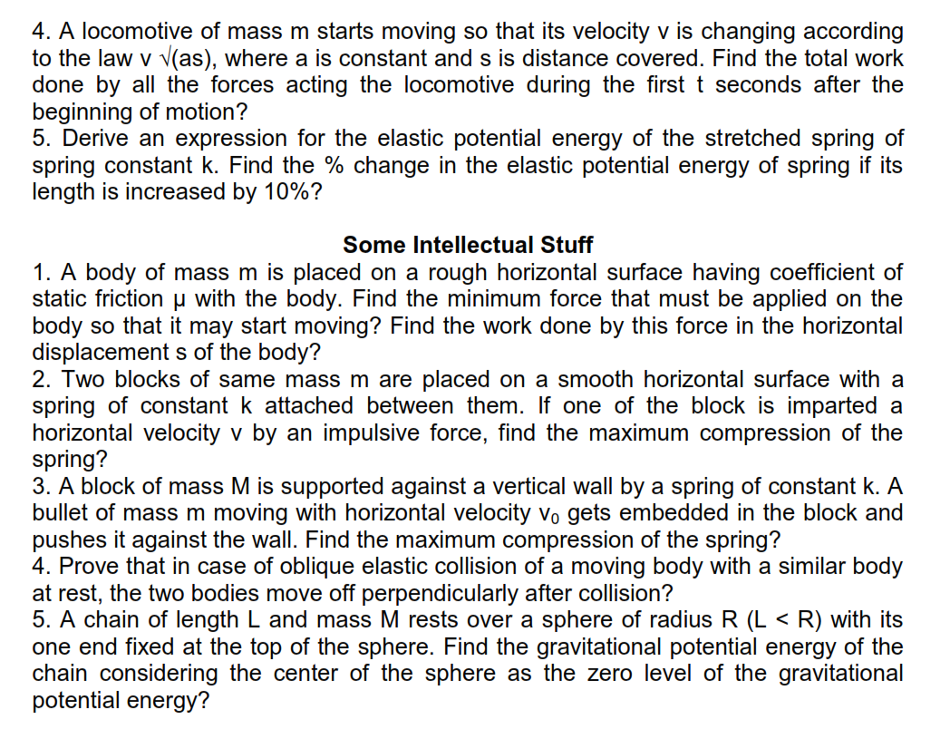

|  |
| --- |
| 1. An electric engine driver driving an engine of mass2000tons, moving with velocity 150 *km/h* locates a college going student walking between the rails by keeping the head phone of his mobile in his ears enjoying his favourite song .Immediately to warn him the driver blows the sound horn of the engine but of no use. He tried to apply the brakes but was sure that the train will not stop or come to rest with in the distance of approach .Helplessly he was waving hands at the boy but unable to get him .Suddenly his action was seen by a man working in the field close to the boy. Within no time the man ran towards the boy and just manages to pull the boy out of the railway track and saves his life. Find   1. The stopping distance of the train. 2. The values learnt by you. |
| 2. In village some children were playing near a pond. One of the child Ramu to have more fun climbed up a nearby tree up to a height of 5mts from the ground came over the pond and jumped into it .As a result of the impact of this he went into the water with his head down (why?) and was hit by a stone at the base of the pond, lost his control swallowed some water .Immediately a passer-by jumped in to the pond brought him up and saved him. Find (a) the amount of work done against the force of gravity (assume mass of Ramu is 50kg (b) What values do you imprecate in saving the boy? |

|  |
| --- |
| 3. After getting into the platform a passenger asked a porter to carry his bag of 50kg another place 80m away along a straight line. When the porter asked for money the gentle man refused to pay him as per physics laws. Name the law or rule under which such Condition may arise. But by mistake when he paid him excess, the porter came back to him and returned the excess amount.What values is shown by the porter In giving back the excess amount? |
|  | |

|  |  |
| --- | --- |
| 1.A ball whose kinetic energy is E is projected at an angle 45°to the horizontal. What will be the kinetic energy of the ball at the highest point of its flight | 2 Mark |
| 2.A body of mass m accelerates uniformly from rest to velocity v1 in time t1 Find the expression for the instantaneous power delivered to the body as a function of time | 2 Mark |
| 3.A bullet of mass 0.01kg and travelling at a speed of 500m/s strikes a block of mass 2kg which is suspended by a string of length 5m. The Centre of gravity of the block is found to rise a vertical distance of 0.1m What is the speed of the bullet after it emerges from the block | 2 Mark |
| 4.A particle of mass m is moving in a horizontal circle of radius r, under a centripetal force equal to k/r2 where k is constant What is the total energy of the particle | 2 Mark |
| 5.A force F=-k(yi+xj) where k is a particle constant acts on a particle moving in the XY plane. Starting from the origin the particle is taken along the positive X-axis to a point (a,0) and then parallel to the y axis to the point (a,a) Calculate the total work done by the force on the particle | 2 Mark |
| 6.A small object of weight mg hangs from a string of length l as shown in figure. A variable force F which starts at zero and gradually increases is used to pull the objects very slowly so that equilibrium exists at all times until the string makes an angle α with the vertical .Calculate the work done by the force. |  | 3 Mark |
| 7.A block of mass m is suspended by a light string of length L. It is imparted a horizontal velocity vo at the lowest point A such that it completes a semicircular trajectory in the vertical plane with the string becoming slack only on reaching the top most point |  | 3 Mark |
| 8.Two blocks A and B are connected to each other as shown in the figure The string and the spring is massless and the pulley frictionless. Block B slides over the horizontal top surface of stationary block C and Block A slides along the vertical side of C both with the same uniform speed. The coefficient of friction between the block is 0.2 and the spring constant of spring is 1960Nm-1. If mass of block A is 2kg. Calculate the mass of the Block B and the energy stored in spring |  | 3 Mark |
|  |  |  |
| 1.A 10 kg ball and 20 kg ball approach each other with velocities 20 m/s and 10 m/s respectively. What are their velocities after collision if the collision is perfectly elastic? | 2 Mark |  |
| 2.What are percentage of kinetic energy of a moving particle is transferred to a stationary particle, when moving particle strikes with a stationary particle of mass   1. 9 times in mass 2. Equal in mass and 3. 1/19 of its mass? | 2 Mark |  |
| 3.A body of mass M at rest is struck by a moving body of mass m. Prove that fraction of the initial K.E. of the mass m transferred to the stuck body is 4mM / (m+M)2 in an elastic collision. | 2 Mark |  |
| 4.A bullet of mass 0.01 kg and travelling at a speed of 500 m/s strikes a block of mass 2 kg which is suspend by a string of length 5m. The centre of gravity of the block is found to rise a vertical distance of 0.1 m. What is the speed of the bullet after it emerges from the block? | 2 Mark |  |
| 5.Two identical ball bearings in contact with each other and resting on a frictionless table are hit head-on by another ball bearing of the same mass moving initially with a speed v. If the collision is elastic, which of the situations shown in figure, is a possible result after collision |  | 2 Mark |
| 6.The bob A of a pendulum released from 300 to the vertical hits another bob B of the same mass at rest on a table as shown in figure. How high does the bob A rise after the collision? Neglect the size of the bobs and assume the collision to be elastic. |  | 3 Mark |
| 7.The bob of a pendulum is released from a horizontal position A as shown. If the length of the pendulum is 1.5 m, what is the speed with which the bob arrives at the speed with which the bob arrives at the lowermost point B, given that it dissipates 5% of its initial energy against air resistance? |  | 3 Mark |
| 8.A molecule in a gas container hits a horizontal wall with speed 200 m/s and ∠ 300 with the normal, and rebounds with the same speed. Is momentum conserved in the collision? Is the collision elastic or inelastic? | 3 Mark |  |

**MOTION OF SYSTEM OF PARTICLES AND RIGID BODY**

**CONCEPT MAP**

CENTRE OF

MASS

CHARACTERISTICS

POSITION VECTOR COORDINATES MOTION

R = $\frac{m_{1}r_{1+} m_{2}r_{2+}…..+m_{n}r_{n}}{m_{1}+m_{2}+ …….. + m_{n}}$ x = $\frac{1}{M}\sum_{p=1}^{N}{m_{p} x_{p}}$ (IN CASE OF AN

Y = $\frac{1}{M}\sum_{p=1}^{N}{m_{p} x_{p}}$ ISOLATED SYSTEM)

x = $\frac{1}{M}\sum_{p=1}^{N}{m_{p} x_{p}}$ UNIFORM VELOCITY

ROTATIONAL MOTION OF A PARTICLE IN A PLANE

CAUSES CONSEQUENCES

TORQUE

ANGULAR MOTION OF A STONE MOTION OF A

MOMENTUM TIED TO A STRING BODY ROLLING DOWN

WOUND OVER A ROTATING AN INCLINED PLANE

CYLINDER WITHOUT SLIPPING

**GIST**

**Centre of mass** of a body is a point where the entire mass of the body can besupposed to be concentrated

For a system of n-particles, the centre of mass is given by

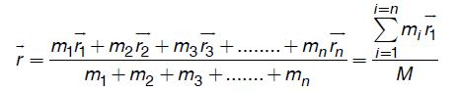

**Torque $\vec{(τ })$** :The turning effect of a force with respect to some axis, is called momentof force or torque due to the force. Torque is measured as the product of the magnitude of the force and the perpendicular distance of the line of action of the force from the axis of rotation.

  

**Principle of moment:** When an object is in rotational equilibrium then algebraic sum of all torques acting on it is zero. Clock wise torques are taken negative and anti-clock wise torque are taken positive. F1 R F2

and

F1d1 – F2d2 =0 d1 d2

**Angular momentum ($\vec{L }$)**. It is the rotational analogue of linear momentum and ismeasured as the product of linear momentum and the perpendicular distance of its line of axis of rotation.

Mathematically: If $\vec{P}$ is linear momentum of the particle and $\vec{ r}$ its position vector, then angular momentum of the particle,   

(a)In Cartesian coordinates: 𝐿𝑍 = 𝑥𝑝𝑦 − 𝑦𝑝𝑥

(b)In polar coordinates: 𝐿 = 𝑟 𝑝 𝑠𝑖𝑛∅,

Where ∅ is angle between the linear momentum vector $\vec{P}$ and the position of vector $\vec{ r}$.

S.I unit of angular momentum is kg 𝑚2 𝑠-1 .

**Geometrically,** angular momentum of a particle is equal to twice the product ofmass of the particle and areal velocity of its radius vector about the given axis.

**Relation** between torque and angular momentum:

1. $\vec{τ}$ = $\frac{d\vec{L}}{dt}$
2. If the system consists of n-particles, then

$\vec{τ }$ = $\frac{d\vec{L_{1}}}{dt}$ + $\frac{d\vec{L_{2}}}{dt}+\frac{d\vec{L_{3}}}{dt}+ ………+\frac{d\vec{L_{n}}}{dt}$

**Law of conservation of angular momentum.** If no external torque acts on asystem, then the total angular momentum of the system always remain conserved.

Mathematically: 1 + 2 + 3 + ⋯ + n = total = 𝑎 𝑐𝑜𝑛𝑠𝑡𝑎𝑛𝑡

**Moment of inertia** **(I).**the moment of inertia of a rigid body about a given axis of rotation is the sum of the products of masses of the various particles and squares of their respective perpendicular distances from the axis of rotation.

|  |  |  |  |  |  |
| --- | --- | --- | --- | --- | --- |
| Mathematically: $I= m_{1}r_{1}^{2}$ + $m_{2}r_{2}^{2}+ m_{3}r_{3}^{2}$ + ………. + $m_{n}r_{n}^{2}$ |  |  |  |  |  |
|  |  |  |  |  |  |

SI unit of moment of inertia is kg m2.

MI corresponding to mass of the body. However, it depends on shape & size of the body and also on position and configuration of the axis of rotation.

**Radius of gyration (K).**it is defined as the distance of a point from the axis ofrotation at which, if whole mass of the body were concentrated, the moment of inertia of the body would be same as with the actual distribution of mass of the body.

Mathematically: $K= \frac{r_{1}^{2}+ r_{2}^{2}+ {r_{3}^{2}+…+ r}_{n}^{2}}{N}$ = rms distance of particles from the axis of rotation.

SI unit of gyration is m.

Note that the moment of inertia of a body about a given axis is equal to the product of mass of the body and squares of its radius of gyration about that axis i.e. I=M k2.

**Theorem of perpendicular axes.** It states that the moment of inertia of a plane lamina about an axis perpendicular to its plane is equal to the sum of the moment of inertia of the lamina about any two mutually perpendicular axes in its plan andintersecting each other at the point, where the perpendicular axis passes through the lamina.

Mathematically: Iz = Ix + Iy ′

Where x & y-axes lie in the plane of the Lamina and z-axis is perpendicular to its plane and passes through the point of intersecting of x and y axes

**Theorem of parallel axes.**It states that the moment of inertia of a rigid body aboutany axis is equal to moment of inertia of the body about a parallel axis through its center of mass plus the product of mass of the body and the square of the perpendicular distance between the axes.

Mathematically: I = Ic + Ma2, where Ic is moment of inertia of the body about an axis through its centre of mass and a is the perpendicular distance between the two axes

**Moment of inertia and angular momentum.**The moment of inertia of a rigid body about an axis is numerically equal to the angular momentum of the rigid body, when rotating with unit angular velocity about that axis.

Mathematically: L = $I ω$.

**Moment of inertia**of a few bodies of regular shapes:

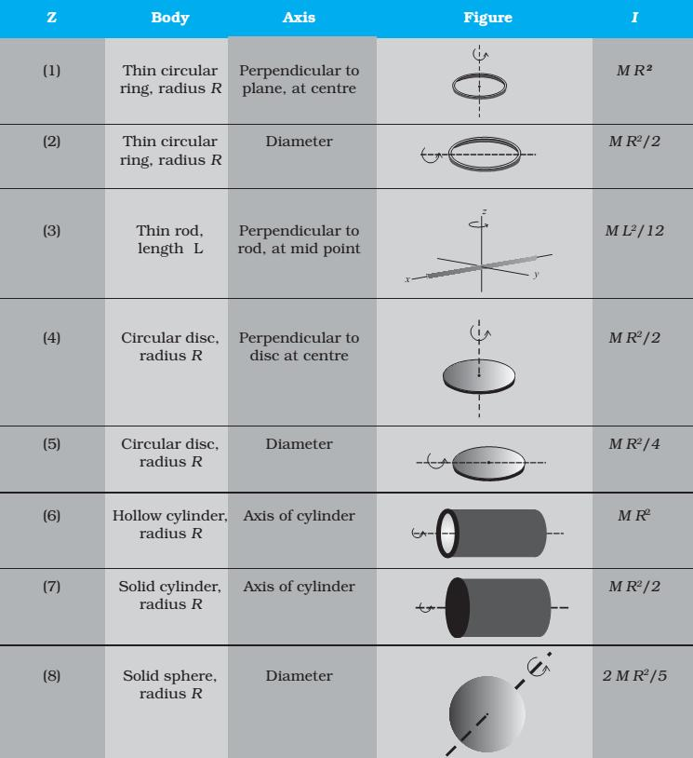

**Moment of inertia and kinetic energy of rotation.** The moment of inertia of a rigid body about an axis of rotation is numerically equal to twice the kinetic energy of rotation of the body, when rotation with unit angular velocity about that axis.

Mathematically : K. E. of rotation = $\frac{1}{2} I ω^{2}$.

**Moment of inertia and torque.** The moment of inertia of a rigid body about an axis of rotation is numerically equal to the external torque required to produce a unit angular acceleration in the body about the given axis.

Mathematically: 𝜏 = 𝐼 α.

**Law of conservation of angular momentum.** If no external torque acts on a system, the total angular momentum of the system remains unchanged.

Mathematically:

𝐼𝜔 = 𝑐𝑜𝑛𝑠𝑡𝑎𝑛𝑡 𝑣𝑒𝑐𝑡𝑜𝑟, 𝑖. 𝑒. , 𝑖𝑛 𝑚𝑎𝑔𝑛𝑖𝑡𝑢𝑑𝑒, 𝐼1𝜔1 = 𝐼2𝜔2,

𝑝𝑟𝑜𝑣𝑖𝑑𝑒𝑠 𝑛𝑜 𝑒𝑥𝑡𝑒𝑟𝑛𝑎𝑙 𝑡𝑜𝑟𝑞𝑢𝑒 𝑎𝑐𝑡𝑠 𝑜𝑛 𝑡𝑕𝑒 𝑠𝑦𝑠𝑡𝑒𝑚.

|  |  |  |  |
| --- | --- | --- | --- |
| **For translational equilibrium**of a rigid body, = |  |  |  |
| |  |  |  | | --- | --- | --- | | **For rotational equilibrium** of a rigid body, = = 0 |  |  | |  |  |

1. The following table gives a summary of the **analogy** between various quantities

describing linear motion and rotational motion

|  |  |  |
| --- | --- | --- |
| Sl. No. | Linear motion | Rotational motion |
| 1 | Distance/displacement (s) | Angle or angular displacement (𝜽) |
| 2 | Linear velocity, v = $\frac{dr}{dt}$ | Angular velocity, 𝝎 = $\frac{dθ}{dt}$ |
| 3 | Linear acceleration a = $\frac{dv}{dt}$ = $\frac{d^{2}r}{dt^{2}}$ | Angular acceleration α = $\frac{dω}{dt}$ = $\frac{d^{2}θ}{dt^{2}}$ |
| 4 | Mass (m) | Moment of inertia (𝑰) |
| 5 | Linear momentum, 𝒑 = 𝒎 𝒗 | Angular momentum, 𝑳 = 𝑰𝝎 |
| 6 | Force, 𝑭 = 𝒎 𝒂 = $\frac{dp}{dt}$ | Torque, 𝝉 = 𝑰𝒂 = = $\frac{dL}{dt}$ |
| 7 | Translational KE, 𝑲𝑻 = $\frac{1}{2} m v^{2}$ | Rotational KE, 𝑲𝑹 = $\frac{1}{2} I ω^{2}$ |
| 8 | Work done, 𝑾 = 𝑭𝒔 | Work done, 𝑾 = 𝝉𝜽 |
| 9 | Power, 𝑷 = 𝑭 𝒗 | Power, 𝑷 = 𝝉𝝎 |
| 10 | Linear momentum of a system is conserved when no external force acts on the system. | Angular momentum of a system is conserved when no external torque acts on the system |
| 11 | Equations of translational motion  𝒗 = 𝒖 + 𝒂𝒕  𝒔 = 𝒖𝒕 + $\frac{1}{2}$ 𝒂𝒕𝟐  𝒗𝟐 − 𝒖𝟐 =𝟐𝒂𝒔, | Equations of rotational motion  𝝎 = 𝝎0 + 𝒂𝒕  𝜽 = 𝝎0𝒕 + 𝒂𝒕𝟐  𝝎 𝟐− 𝝎0𝟐 = 𝟐𝒂𝜽, |

**(1 Marks Questions)**

1. **The bottom of ship is made heavy. Why?**

Ans: The bottom of a ship is made heavy so that its centre of gravity remains low. This ensures the stability of its equilibrium.

1. **If a cube is melted and is casted into a sphere does moment of inertia about an axis through centre of mass increases or decreases.**

Ans: Moment of inertia of a sphere is less than that of a cube of same mass.

1. **If no external torque act on a body will its angular velocity remains conserved?**

Ans: No angular velocity is not conserved but angular momentum is conserved.

1. **If one of the particles is heavier than the other, to which will their centre of mass shift?**

Ans:- The centre of mass will shift closer to the heavier particle.

1. **Can centre of mass of a body coincide with geometrical centre of the body?**

Ans:- Yes, when the body has a uniform mass density.

1. **Which physical quantity is represented by a product of the moment of inertia and the angular velocity?**

Ans: - Product of I and ω represents angular momentum(L=I ω).

1. **What is the angle between $\vec{A}$**  **and $\vec{B}$**   **, if $\vec{A}$** **and $\vec{B}$ denote the adjacent sides of a parallelogram drawn from a point and the area of parallelogram is $\frac{1}{2}$ AB.**

Ans:- Area of parallelogram= $\left|\vec{A}x\vec{B}\right|$ = ABsin Ѳ = $\frac{1}{2}$**AB** . (Given)

sin Ѳ = = sin 300 or θ = 300

1. **Which component of linear momentum does not contribute to angular momentum?**

Ans:- The radial component of linear momentum makes no contribution to angular momentum.

1. **A disc of metal is melted and recast in the form of solid sphere. What will happen to the moment of inertia about a vertical axis passing through the centre?**

Ans:- Moment of inertia will decrease, because Id = 1/2 m r2 and Is = 2/5 m r2, the radius of sphere formed on recasting the disc will also decrease.

1. **What is rotational analogue of mass of body?**

Ans:- Rotational analogue of mass of a body is moment of inertia of the body.

1. **What are factors on which moment of inertia depend upon?**

Ans:- Moment of inertia of a body depends on position and orientation of the axis of rotation. It also depends on shape, size of the body and also on the distribution of mass of the body about the given axis.

1. **Is radius of gyration of a body constant quantity?**

Ans:- No, radius of gyration of a body depends on axis of rotation and also on distribution of mass of the body about the axis.

1. **Is the angular momentum of a system always conserved? If no, under what** **condition is it conserved?**

Ans:- No, angular momentum of a system is not always conserved. It is conserved only when no external torque acts on the system.

**(2 Marks Questions)**

**1. Why is the handle of a screw made wide?**

Ans:- Turning moment of a force= force × distance(r) from the axis of rotation. To produce a given turning moment, force required is smaller, when r is large. That’s what happens when handle of a screw is made wide.

**2. Can a body in translatory motion have angular momentum? Explain.**

Ans:- Yes, a body in translatory motion shall have angular momentum, the fixed point about which angular momentum is taken lies on the line of motion of the body. This follows from

L = r p sin Ѳ.

L= 0, only when Ѳ =00 or Ѳ =1800.

**3. A person is sitting in the compartment of a train moving with uniform velocity on a smooth track. How will the velocity of centre of mass of compartment change if the person begins to run in the compartment?**

Ans:- We know that velocity of centre of mass of a system changes only when an external force acts on it. The person and the compartment form one system on which no external force is applied when the person begins to run. Therefore, there will be no change in velocity of centre of mass of the compartment.

**4. A particle performs uniform circular motion with an angular momentum L. If the frequency of particle’s motion is doubled and its K.E is halved, what happens to the angular momentum?**

Ans:- L = m v r and v = r ω = r 2 π n

$r= \frac{v}{2πn}$ $L=mv\frac{v}{2πn}$ = $\frac{mv^{2}}{2πn}$

K. E. = $\frac{1}{2} m v^{2}$ therefore $L= \frac{K.E.}{πn}$

When K.E. is halved and frequency (n) is doubled,

$L= \frac{K.E.'}{πn'}$ $= \frac{K.E./2}{π(2n)}$ = $\frac{K.E.}{4πn}$ = $\frac{L}{4}$

i.e. angular momentum becomes one fourth.

**5. An isolated particle of mass m is moving in a horizontal plane(x-y), along the x-axis at a certain height above the ground. It explodes suddenly into two fragments of masses m/4 and 3 m/4. An instant later, the smaller fragments is at y= +15 cm. What is the position of larger fragment at this instant?**

Ans:- As isolated particle is moving along x-axis at a certain height above the ground, there is no motion along y-axis. Further, the explosion is under internal forces only. Therefore, centre of mass remains stationary along y-axis after collision. Let the co-ordinates of centre of mass be (xcm , 0).

Now $y_{cm = \frac{m_{1}y_{1}+ m_{2}y_{2}}{m_{1+m_{2}}}=0}$

$m_{1}y_{1}+ m_{2}y_{2}$ = 0

So, larger fragment will be at y= -5 ; along x-axis.

**6. Why there are two propellers in a helicopter?**

Ans:- If there were only one propeller in a helicopter then, due to conservation of angular momentum, the helicopter itself would have turned in the opposite direction.

**7. A solid wooden sphere rolls down two different inclined planes of the same height but of different inclinations. (a) Will it reach the bottom with same speed in each case? (b) Will it take longer to roll down one inclined plane than other? Explain.**

Ans: - (a) Yes, because at the bottom depends only on height and not on slope.

(b) Yes, greater the inclination(θ), smaller will be time of decent, as t ∝1/ sin θ.

**8. There is a stick half of which is wooden and half is of steel. It is pivoted at the wooden end and a force is applied at the steel end at right angles to its length. Next, it is pivoted at the steel end and the same force is applied at the wooden end. In which case is angular acceleration more and why?**

Answer:- We know that torque, τ= Force × Distance = I α = constant

|  |  |  |  |  |  |
| --- | --- | --- | --- | --- | --- |
| ∴ α = | τ | i. e α ∝ | 1 |  |  |
| I | I | |  |
|  |  |  |

Angular acc. (α) will be more, when I is small, for which lighter material (wood) should at larger distance from the axis of rotation I.e. when stick is pivoted at the steel end.

**9. Using expressions for power in rotational motion, derive the relation** = **, where letters have their usual meaning.**

Ans:-We know that power in rotational motion, P = τ ω

and K.E. of motion, E= $\frac{1}{2} I ω^{2}$

As power = time rate of doing work in rotational motion, and work is stored in the body in the form of K.E.

$P= \frac{d}{dt }$ (K.E. of rotation) = $\frac{d}{dt }$ ($\frac{1}{2} I ω^{2}$) = $\frac{1}{2} I 2ω \frac{dω}{dt }$

P = I ω α

Using (i), P = τ ω = I ω α or τ = I α , which is the required relation.

**10. Calculate radius of gyration of a cylindrical rod of mass m and length L about an axis of rotation perpendicular to its length and passing through the centre.**

Ans: - K = ? , mass = m, length = L

Moment of inertia of the rod about an axis perpendicular to its length and passing through the centre is

$I= \frac{ml^{2}}{12}$

Also, I = mK2 = or

**(3 Marks Questions)**

1. **If angular momentum is conserved in a system whose moment of inertia is decreased, will its rotational kinetic energy be also conserved? Explain.**

Ans:- Here, L = I ω = constant

K.E. of rotation K = $\frac{1}{2} I ω^{2}$ = $\frac{1}{2}\frac{I^{2}ω^{2}}{I}$ = $\frac{L^{2}}{2I}$

As L is constant, ∴ K ∝ 1/I

When moment of inertia (I) decreases, K.E. of rotation (K) increases. Thus K.E. of rotation is not conserved.

**2. How will you distinguish between a hard-boiled egg and a raw egg by spinning each on a table top?**

Ans:- To distinguish between a hard-boiled egg and a raw egg, we spin each on a table top. The egg which spins at a slower rate shall be raw. This is because in a raw egg, liquid matter inside tries to get away from its axis of rotation. Therefore, its moment of inertia I increases. As τ = I α = constant, therefore, α decreases i.e. raw egg will spin with smaller angular acceleration. The reverse is true for a hard boiled egg which will rotate more or less like a rigid body.

**3. A thin wheel can stay upright on its rim for a considerable length when** **rolled with a considerable velocity, while it falls from its upright position at the slightest disturbance when stationary. Give reason.**

Ans:- When the wheel is rolling upright, it has angular momentum in the horizontal direction i.e., along the axis of the wheel. Because the angular momentum is to remain conserved, the wheel does not fall from its upright position because that would change the direction of angular momentum. The wheel falls only when it loses its angular velocity due to friction.

**4.** **Why is the speed of whirl wind in a tornado so high?**

Ans:- In a whirl wind, the air from nearby region gets concentrated in a small space thereby decreasing the value of moment of inertia considerably. Since, I ω= constant, due to decrease in moment of inertia, the angular speed becomes quite high.

5. **Explain that torque is only due to transverse component of force. Radial component has nothing to do with torque.**

**6. Show that Centre of mass of an isolated system moves with a uniform velocity along a straight line path.**

**7. Equal torques are applied on a cylindrical and a hollow sphere. Both have same mass and radius. The cylinder rotates about its axis and the sphere rotates about one of its diameters. Which will acquire greater speed? Explain.**

1. **Locate the centre of mass of uniform triangular lamina and a uniform cone.**
2. **Explain the physical significance of moment of inertia and radius of gyration.**
3. **Obtain expression for K.E. of rolling motion.**

**(5 Marks Questions)**

**1**. Define centre of mass. Obtain an expression for perpendicular of centre of massof two particle system and generalize it for particle system.

1. Find expression for linear acceleration of a cylinder rolling down on a inclined plane.

A ring, a disc and a sphere all of them have same radius and same mass roll down on inclined plane from the same heights. Which of these reaches the bottom (i) earliest (ii) latest?

1. (i) Name the physical quantity corresponding to inertia in rotational motion. How is it calculated? Give its units.

(ii)Find expression for kinetic energy of a body.

1. State and prove the law of conservation of angular momentum. Give one illustration to explain it.
2. State parallel and perpendicular axis theorem.

Define an expression for moment of inertia of a disc R, mass M about an axis along its diameter.

**GRAVITATION**

Gravitational force is the name given to the force of attraction between any two objects in the universe. It is the weakest among the fundamental forces of nature.

**Newton’s law of gravitation:**

It states that every body in the universe attract every other body with a force whose magnitude is directly proportional to the product of their masses and inversely proportional to the square of the distance between the two. The direction of the force is along the line joining their centers.

**Note:** As gravitational force obeys inverse square law, it is a central force and hence is a conservative force.

If two bodies of masses m1 and m2 are separated by a distance of r ; according to the law the gravitational force is

 ∴ F = 

Where G is called Universal Gravitational constant, whose value is 6.67x10-11 Nm2/kg2

If m1 = m2 = 1kg and r =1m , then G = F .

**Note:** ∴ Universal Gravitational constant is defined as the force of attraction between two unit masses separated by unit distance apart.

**Dimensional formula for G :**

We know, F = **  = **

**Characteristics of gravitational force:**

1. It is independent of the nature of the medium between the bodies
2. It is a central force ( i.e. it acts along the line joining the two bodies )
3. It is a conservative force (i.e. Work done by the force or against the force is independent of the path )
4. Independent of the nature and size of the bodies

**Gravity :** It is the force of attraction exerted by earth on the bodies lying near it , towards it. It can also be called as the gravitational pull of earth on other objects.

**Note:** The force of gravity on a body is called the weight of the body.

**Acceleration due to gravity (g):** Acceleration due to gravity is the constant acceleration produced during the motion of a body when it falls under the influence of the gravitational pull of earth only. **Notes:** i. It has a unit of m/s2 and dimensions of LT-2.

ii. Being acceleration, it is a vector, whose direction is **towards the center of earth**.

### iii. Weight of any body of mass ‘m’ on the surface of earth is W=mg.

### Expression for g: Consider earth be a spherical body with mass Me and radius Re. Let a body of mass ‘m’ lying near the surface of earth, where the acceleration due to gravity is g.

According to law of gravitation, the gravitational force that earth exerts on the object is,

F = 

But as weight (mg) of the body is the gravitational pull of earth on the body**,** we have.

mg =  g = 

**Note**: i. On substituting the known values of G, Re & Me in the above expression, we get

‘**g’** on the surface of earth as 9.8 m/s2

ii. The Value of ‘**g’** is independent of mass, size and shape of the object but depends upon the

mass and radius of earth

iii. Acceleration due to gravity on the surface of any planet can be determined by ****,

where M is the mass and R is the radius of that planet

**Mass of earth:** We know, **g** on the surface of earth =**** Me **= ** On substituting the values of g , G and Re , we get Me = 6.018x 1024 kg ≈ 6 x1024kg.)

**Density of earth:**If earth is considered as a homogeneous sphere of uniform density ‘ρ’ and radius ‘Re’, then Volume of earth, V = ****. We know density, ρ =  = ****. Substituting the value of Me as above, we get **ρ = **

On substituting values of g , Re and G , we obtain ρ = 5.5 x103 kg/m3)

**Variation of acceleration due to gravity**

**(i) Variation of g with altitude (h):**

Consider earth to be a sphere of radius **Re** and mass **Me** with acceleration due to gravity **g** at the surface and g ' at a height ‘h’ from the surface.

For the surface, we have ** &** for height we have ** ,** where r = Re+h

**=  = **

On applying Binomial expansion and rearranging, we get 

Note: i. Equation with (1) is to be used when h is large and (2) is to be used when h is small.]

ii. From equations it is clear that as ‘h’ increases ‘g1’ will decrease and at a height h = Re,

**.**

**(ii) Variation of g with depth (d)** *:*

Consider earth to be a homogeneous sphere of density **ρ** , mass **Me** and radius **Re** and let **g** be the acceleration due to gravity at a point on the surface .

For this, we have ** & **

∴ 

Consider a point P at a depth d below the surface of earth , where the acceleration due to gravity is g1 . The body at P experiences gravitational pull due to the sphere of radius (Re-d) and mass Me1

For this, we have ** &******





**Note:** From the equation **,** it is clear that as ‘d’ increases g1 will decrease and at a depth d = Re, g1 becomes zero. i.e. at the **centre of earth** a body will be **weightless** due to the absence of acceleration due to gravity .

**(iii) Variation of g with shape of earth:**

As earth is not a perfect sphere it has different radius at the poles and equator where polar radius (Rpole) < equatorial radius (Requitorial ),  the difference being 21 km.

We know, on the surface g = ****.

As G and Me are constants,**** (As Re>Rp , gp>ge )

**Note:** i) The value of g is least at the equator and maximum at the poles.

ii) When one moves from equator to pole , the acceleration due to gravity increases and thus

the weight too.

iii) The difference between ge and gp is only 1.8 cm/s2.

**iv) Variation of g with latitude (λ) [ rotation of earth ] :**

Latitude at a place is defined as the angle that the line joining the place to the centre of the earth makes with the equatorial plane. At equator, as the line is along equatorial plane, the value of λ is zero and at poles as it is perpendicular to the equatorial plane the value of λ is 900.

A body kept on the surface of earth at a place with a latitude *λ* , experiences an **apparent weight of mg1**, which is the resultant of **true weigh mg** ( weight of the body if earth were at rest ) **and the centrifugal force on the body, mrω2** (r is the radius of the circular path of the body on the surface of earth and ω the angular velocity of earth and hence that of the body ) **acting at angle of (180 - λ)**. From figure, it can be seen that radius of circular path, **r = R cos λ** , where R is the radius of earth . Determining the resultant and applying binomial theorem, we get

 or 

From expression (5), it is evident that g1 depends on both ω (rotation of earth) and λ where g1 decreases on increasing ω and g1 increases on increasing the latitude,λ .

##### **Special cases**

**At equator, as λ = 0 , g1 = gequator = g - Rω2 ( ie g1 is minimum )**

**At poles, as λ = 900 , g1 = g pole = g ( ie g1 is maximum )**

**Note:** i) As g pole does not depend on ω, its value will be constant whether earth is at rest or

rotating. So the effect of rotation of earth has dependence only on equatorial points .

ii) The difference between the acceleration due to gravity at pole and equator can be given as



#### Gravitational field:

Gravitational field of a material body is the space around it in which its gravitational pull can be experienced. The gravitational force of attraction between two objects is due to the interaction of the gravitational fields of the two.

**Intensity of gravitational field,(E):**

**Intensity of gravitational field of a body at a point in its field is defined as the force experienced by a unit mass placed at that point. (E=)**

To measure the intensity of gravitational field of a body (let us call source mass ) at a point in its field , a small body of unit mass ( let us call test mass ) is to be placed at that point and the force between the two is to be determined , which by definition is ‘**E’ .**

Expression for gravitational intensity at appoint due to a source mass M:

Consider a body of mass M. Let F be the gravitational force experienced by a test mass ‘m’ placed at a point P in its field at a distance r from it.

Now, according to Newton’s law, F = .

By definition of E, we have E = .

Note: When r = ∞ , E = 0. i.e. Gravitational field intensity of any objects exists up to infinity and vanishes there.

If the test mass, 'm' is free to move at point 'P', it will be accelerated due to the force 'F' provided

by the source mass 'M'. If 'a' is the acceleration experienced by the test mass,

We have (since F=ma), which by definition is E.

Thus Intensity of gravitation at a point in a gravitational field is the acceleration of the test mass at that point.

Similarly the gravitational field due to earth at a point on the surface can be determined by replacing M with Me and r with Re in the expression for E.

i.e. E = = g .

Note: E being identical to acceleration, its unit and dimension are same as that of acceleration.

Gravitational potential,(V):

Gravitational potential at a point in the gravitational field of a body (say, source mass) is defined as the amount of work done in bringing a unit mass (say, test mass) from infinity to that point.

If 'W' is the work done in bringing a test mass 'm' from infinity to a point P, then potential at the point P is, .

Note: i) Since work is a scalar quantity, potential also is a scalar quantity.

ii) The unit of gravitational potential is joule/kg and dimension is M0L2T-2.

Gravitational potential energy (U):

Gravitational potential energy of a body at a point in a field is defined as the work done in bringing the given body (of mass m) from infinity to that point. (U = V x m)

Expression for gravitational potential energy of a body at a point on earth:

Assume earth to be a perfect sphere of radius 'Re' and mass 'Me' with centre O. Consider a mass 'm' placed at a point P at a distance ' r ' from the centre of earth, whose gravitational potential energy is to be determined. Join OP = r .

As the gravitational force experienced by the body at different points between ∞ and P is different, let us consider a point A at a distance x from the centre, between ∞ and P.

The gravitational force on mass 'm' by earth at A is F= 

(This may be treated to be a constant over a small displacement of dx)

Work done to move mass ‘m’ over the small distance dx is,



Total work done to move the body from ∞ to the point P is

W = 

ie W = = ****.

This work done, by definition is the gravitational potential energy of the mass m at P. ∴**U =** 

Note: Negative sign indicates that work is done by the field, not against the field.

Expression for gravitational potential at a point :

Form above, we know that potential energy,****.

But potential V = ****or 

∴Potential at the point P, 

**Note:** For finding the potential at a point due to any body of mass M, replace Me with M . So we get 

Also potential energy 

**Inertial and Gravitational mass:**

Inertial mass of a body is the mass that is related to its inertia in linear motion . It is the mass obtained by the ratio of force and acceleration i.e. 

**Note:** It is inertial mass that decides the magnitude of acceleration of a body under a force. Gravitational mass of a body is related to the gravitational pull on the body. It is the mass obtained by the ratio of weight and acceleration due to gravity. i.e. 

**Note:** Usually inertial mass and gravitational mass of a body are identical

**Satellites:** A satellite is a heavenly body that revolves continuously around a planet in a closed orbit. They are of two types, namely natural satellites (e.g. moon) and artificial satellites (e.g. Sputnik, INSAT, Aryabhata etc)

**Orbital velocity:**

The velocity required to put a satellite in to its orbit around earth is called orbital velocity of a satellite .

**Expression for orbital velocity:**

Assume that earth has a mass M­e and radius Re. Consider a satellite of mass m revolving around the earth in a closed orbit of radius r, with a velocity ‘vo’, at a height ‘h’ above the surface.

Radius of the orbit of the satellite, r = Re + h (as the satellite is at a height h above the surface )

According to Newton’s law, Gravitational force on the satellite,****

The centripetal force required to keep the satellite in its orbit, 

As the centripetal force is provided by the gravitational force , 

i.e.****

But we know 

On substituting for GMein (9) , we get  = 

**Note:** i) From the above expression, it is clear that orbital velocity is independent on the mass of the satellite.

ii) It decreases with increase in the orbital radius.

iii) If the satellite orbits close to the surface of earth, then h < < Re and hence  = 7.92 km/s.

**Time period of a satellite (T) :**

Time period of satellite is the time taken by the satellite to complete one revolution around the earth

Time period, T = Distance travelled in one revolution / orbital velocity.

i.e. T=  =  =  = 

Substituting the value of  in the above equation for time period, we get

T = 

For a satellite orbiting close to the earth surface, h<<Re 

∴ T = 

Applying the same condition in (12), we get T = = 2π 

On substituting the values of g and Re , we get T = 84.6 minutes .

**Height of the satellite:**

Squaring both sides of equation (12), we get T 2 =

On rearranging for h , we get h = 

**Geo stationary satellites:**

A satellite that revolves around the earth with the same angular speed in the same direction as done by earth around its own axis is called geo stationary satellite (The time period of such satellites is 24 Hours)

To find the height of geo stationary satellite, substitute the values of g, Re and T =24 hr in (2)

We get, h = 3.6x10 7 m or 36000 km.

Energy of a satellite:

If a satellite of mass m is at a distance r from the centre of earth, the potential energy is given by

U = ****.

Kinetic energy of the satellite, K = **,** where**** is the orbital velocity.

Total energy of the satellite, E = U+K =  + ****= 

If the satellite is closer to the earth, then r = Re ∴ E = 

**Escape velocity:**

Escape velocity of a body on earth is defined as the minimum velocity with which the body has to be projected vertically upwards from the surface of earth so that it just crosses the gravitational field of earth. Since earth’s gravitational field extends up to infinity, escape velocity is the velocity that a body on earth’s surface must have in order that it may get projected to infinite distance in to space.

Let earth to be a perfect sphere of mass Me and radius Re. Let a body of mass m be projected from earth’s surface such that it escapes from the pull of earth.

At any point P, between the surface and infinity, at a distance x from the centre of earth, the gravitational force is F =****.

To move the body up against the gravity, an equal force as above has to be applied on the in the opposite (upward) direction

The work done in taking the body through a small distance of dx against the gravitational pull is



∴ The total work done to take the body against the gravity from surface of earth to infinity is

W =  =  = 

This is the work required to escape and in the expense of kinetic energy at the surface of earth.

If ve is the escape velocity of the body projected from the surface of earth,

Then kinetic energy on the surface =****

But as said above  =  

∴ ****But ****. On substitution, we get  = 11 2 km/s.

Kepler’s laws of planetary motion:

**i) I Law (Law of orbit ):** Every planet revolve around the sun in an elliptical orbit , keeping sun at one of the foci.

**ii) II Law ( Law of area ):**

The radius vector drawn from the sun to the planet sweeps equal area in equal intervals of time . In other words ,the areal velocity of a planet around the sun is a constant .

**Note:** Proof for II law is based on law of conservation of angular momentum.(Refer notes of Rotational motion )

**iii)III Law ( Law of period ):**

The square of the time period of revolution (T) of a planet around the sun is directly proportional to the cube of the semi major axis(R) of its elliptical orbit . ie T2 ∝ R3

**QUESTION & ANSWERS**

***1 MARKS QUESTIONS***

Q1.When a stone of mass m is falling on the earth of mass M; find the acceleration

of earth if any?

Ans. Force exerted by falling stone on earth, F=mg

Acceleration of earth=F/M= mg/M

Q2.Why G is called a universal constant?

Ans*.* It is so because the value of G is same for all the pairs of the bodies (big or

small) situated anywhere in the universe.

Q3.According to Kepler’s second law the radius vector to a planet from the sun

sweeps out equal area in equal interval of time. The law is a consequence of which

conservation law.

Ans. Law of Conservation of angular momentum.

Q4.What are the factors which determine ; Why some bodies in solar system have

atmosphere and others don’t have?

Ans. The ability of a body (planet) to hold the atmosphere depends on

acceleration due to gravity.

Q5.What is the maximum value of gravitational potential energy and where?

Ans. The value of gravitational potential energy is negative and it increases as we

move away from the earth and becomes maximum ( zero) at infinity.

Q6.The gravitational potential energy of a body at a distance r from the center of

earth is U. What is the weight of the body at that point?

Ans. U=**** =g r m= (mg) r

Q7.A satellite revolving around earth loses height. How will its time period be

changed?

Ans. Time period of satellite is given by; T=****

. Therefore ,T will decrease,when h decreases.

Q8.Should the speed of two artificial satellites of the earth having different masses

but the same orbital radius, be the same?

Ans.Yes it is so because the orbital speed of a satellite is independent of the mass

of a satellite. Therefore the speeds of the artificial satellite will be of different masses

but of the same orbital radius will be the same.

Q9.Can a pendulum vibrate in an artificial satellite?

Ans. No, this is because inside the satellite, there is no gravity ,i.e., g=0.

As t = 2π√ / , hence, for g=0 , t = . Thus, the pendulum will not vibrate.

Q10.Why do different planets have different escape speed?

Ans. As, escape speed ****therefore its value are different for different

planets which are of different masses and different sizes.

***2 MARKS QUESTIONS***

Q1.Show that weight of all body is zero at Centre of earth?

Ans. The value of acceleration due to gravity at a depth d below the surface of earth

of radius R is given by ɠ=g(1-d/R).At the center of earth, (dept)d=R; so, ɠ =0.The

weight of a body of mass m at the centre of earth =mg’=m x 0=0.

Q3.What will be the effect on the time period of a simple pendulum on taking to a

mountain?

Ans. The time period of a pendulum, T=2π√ l/g , i.e., T= 1/√g .As the value of g is

less at mountain than at plane, hence time period of simple pendulum will be more

at mountain than at plane though the change will be very small.

Q4.A tennis ball and a cricket ball are to be projected out of gravitational field of the

earth. Do we need different velocities to achieve so?

Ans. We require the same velocity for the two balls, while projecting them out of the

gravitational field. It is so because, the value of escape velocity does not depend

upon the mass of the body to be projected [i.e,ve=√ 2gR].

Q5.Draw graphs showing the variation of acceleration due to gravity with (a)height

above the earth’s surface, (b)depth below the Earth’s surface.

Ans.(a)The variation of g with height h is related by relation g α1/r2 where r=R+h.

Thus, the variation of g and r is a parabolic curve.

(b)The variation of g with depth is released by equation g’=g(1-d/R) i.e. g’ α (R-d )

.Thus, the variation of g and d is a straight line.

Q6.Why does moon have no atmosphere?

Ans. Moon has no atmosphere because the value of acceleration due to gravity ‘g’

on surface of moon is small. Therefore, the value of escape speed on the surface of

moon is small. The molecules of atmospheric gases on the surface of the moon

have thermal speeds greater than the escape speed. That is why all the molecules

of gases have escaped and there is no atmosphere on moon.

***3 marks questions***

Q1.Explain how knowledge of g helps us to find (i) mass of earth and (ii)mean

density of earth?

Q2. Obtain the expression for orbital velocity, time period, and altitude of a satellite.

Q3. What do you understand by ‘Escape velocity’? Derive an expression for it in

terms of parameters of given planet.

Q4. What do you understand by gravitational field, Intensity of gravitational field .

Prove that gravitational intensity at a point is equal to the acceleration due to gravity

at that point.

***5 marks questions***

Q1.State Kepler’s laws of planetary motion. Prove second Kepler’s law using

concept of conservation of angular motion.

Q2.State universal law of gravitation. What is the significance of this law. Find the

expression for acceleration due to gravity.

Q3.Explain the variation of acceleration due to gravity with (I) altitude (ii) depth

Q4. Define gravitational potential energy. Derive the expression for gravitational

potential energy. What is the maximum value of gravitational potential energy?

Q5.What is escape speed? Derive the expressions for it. Calculate escape speed for

the Earth.

**PROPERTIES OF SOLIDS**

**ELASTICITY**

It is the property of the body by virtue of which the body regains its original configuration (length, volume or shape) when the deforming forces are removed.

**STRESS**

When some external forces are applied to a body, then the body offers internal resistance to these forces. This internal opposing force per unit area is called 'stress'. It is denoted by symbol σ and its S.I. unit is Pascal or N/m2.

Mathematically it can be expressed as

$$Stress = \frac{Force}{Area}$$

**TYPES OF STRESS**

**Stress is of two different types mainly :  
(i) Normal Stress   
(ii) Shearing or Tangential Stress .**

1. **Normal Stress** :If the stress is normal to the surface, it is called normal stress. Stress is always normal in the case of a change in length or a wire or in the case of change in volume of a body

* **Longitudinal Stress** :When a normal stress change the length of a body then it is called longitudinal stress which is given by

$$Longitudinal Stress = \frac{Deforming Force}{Area of cross section}=\frac{ F}{A}$$

The longitudinal stress can be further divided into two types. When a wire or a rod is stretched at the two ends by equal and opposite forces, the stress is called tensile stress. When a rod is pushed at the two ends by equal and opposite forces, it will be under compression. The stress in such a case is called compressive stress. The pillars of a building experience compressive stress.

* Volume Stress (or ) Bulk Stress : When a normal stress changes the volume of a body then it is called volume stress. When a solid body is immersed in a fluid, the force at any point is normal to the surface of the body and the magnitude of the force on any small area is proportional to the area i.e., the body is under the action of a pressure P.

$$Bulk Stress = \frac{Force}{Area} = Pressure$$

1. Shearing Stress : When the Stress is tangential to the surface due to the application of forces parallel to the surface, then the stress is called tangential or shearing stress. It changes the shape of the body.

$$Shearing Stress =\frac{ Force}{Surface Area}$$

**STRAIN**

Normal stress on a body causes change in length or volume and tangential stress produces change in shape of the body. The ratio of change produced in the dimensions of a body by a system of forces or couples, in equilibrium, to its original dimensions is called strain.

$Strain =\frac{Changeindimension}{originaldimension}$

**TYPES OF STRAIN**

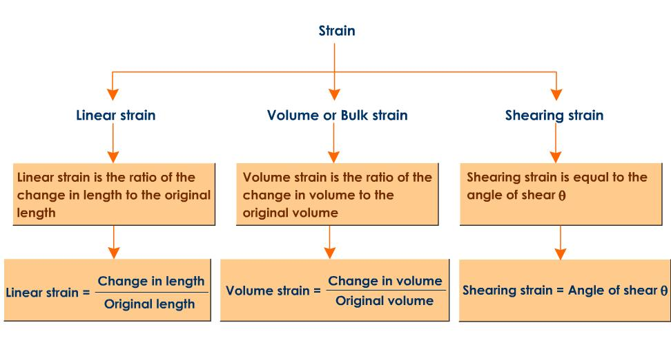**Units of Strain : As strain is a ratio , it has no units and dimensions.**

***YOUNG'S MODULUS OF ELASTICITY***

It is defined as the ratio of normal stress to the longitudinal strain within elastic limit.

$Y=\frac{Normal stress}{Longitudinal Strain}$**= $\frac{F/A}{{∆L}/L}= \frac{FL}{A∆L}$**

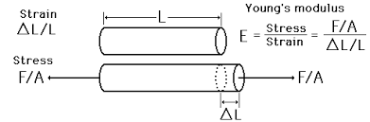

F is the normal force applied at the end of its wire, A is area of  cross section (= pr2),Dl is the extension produced due to normal force, L is the original length of the wire.

## Bulk Modulus of elasticity (K*)*

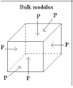

## It is defined as the ratio of normal stress to the volumetric strain within the elastic limit. Thus,

$$K=\frac{Normal Stress}{Volumetric Strain}$$

Consider a spherical solid body of volume V and surface area a, when a force F is applied normally, the volume decreases by 

Volumetric strain = $-\frac{∆V}{V}$

Normal stress = $\frac{F}{a}$

K **= $\frac{F/a}{{-∆V}/V}= \frac{-pV}{∆V}$**

$$compressibility=\frac{1}{K}=\frac{-∆V}{pV}$$

## Modulus of Rigidity

It is defined as the ratio of tangential stress to the shearing strain within the elastic limit.

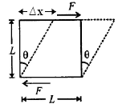

Considering a solid metal cube whose lower face is fixed and its upper face is subjected to a tangential force F. The body suffers a change in its shape but not in its volume. If θ is angle through which upper layer is sheared then,

$$θ= \frac{∆x}{L}$$

Tangential stress = $F/a$

$$η=\frac{Tangential Stress}{Shearing Strain}= \frac{F/a}{{∆x}/L}= \frac{FL}{a∆x}= \frac{F}{θa}$$

**Poisson’s ratio** ()

It is defined as the ratio of lateral strain to the longitudinal strain.

$$σ=\frac{lateral strain}{longitudinal strain}$$

Theoretical value of σ lies between –1 and + $\frac{1}{2}$

The practical value of σlies between 0 and +1/2. If there is no change in the volume of wire on

loading, then its Poisson’s ratio is 0.5.

**ELASTIC POTENTIAL ENERGY STORED PER UNIT VOLUME OF A STRAINED BODY**



## 

## STRESS - STRAIN RELATIONSHIP IN A WIRE

##### stress strain curve

AO = Elastic Range

P = Yield point

OD = Breaking stress or tensile stress

E = Breaking point

OO1= Permanent set

When the stress-strain relationship in a wire is studied, one finds that stress is directly proportional to the strain up to the point A (see the graph). The point 'A' is called the **elastic limit** and AO is called the **elastic range.**

The Hooke's law is valid up till A. Beyond A, if the stress is removed, graph between stress and strain does not follow AO. BO| is followed when stress is zero, strain is not zero or a permanent deformation sets in the material. Therefore, OO| represents the **permanent set**.

Notice that beyond 'A', the stress - strain graph is a curve and that for a small stress, large strain is produced in the material. The material beyond A and upto 'P' is partly elastic and partly plastic in behaviour.

Beyond 'P', the behaviour of the wire is very erratic. There is a large increase in the strain but a very small change in the stress.

At this stage, the wire flows down upto the point C. The point 'P', when the wire yields to the applied stress and begins to flow, is called the **yield point**. The region PC is called the plastic region. Materials used to make sheets or wires must have a longer plastic region and must be ductile.

Beyond C, the graph has a hump at D. Even if the wire is loaded by a little amount, the wire becomes thin at weak portions of the wire and tends to break at E. The stress corresponding to the breaking point is called the **breaking stress**. Brittle substances generally have a small plastic region and the breaking stress lies closer to the elastic limit.

The above graph is useful in classifying materials which serve different purposes.

***ELASTOMERS***

Materials which can be stretched to large values of strains are called elastomers.

* There is no well defined plastic region.
* Elastic region is very large.

***Elastomers***

# *The stress vs strain curve for elastomers*

|  |  |
| --- | --- |
| http://revisionworld.com/sites/revisionworld.com/files/rw_files/strain_33.gif | *stress versus strain* |

# APPLICATIONS OF ELASTICITY

Mechanical properties like strength, stiffness (Rigidity), ductility, malleability and brittleness have to be carefully studied to select a material for a particular job.

* The metallic parts of machines should not be subjected to stress beyond the elastic limit otherwise they will be deformed.
* Beams are the simplest and most common parts of large structures. When beams are

##### elasticity

subjected to stress, the different parts are strained in different way as shown in the above diagram. For this purpose, the beam's cross-section is I in shape, where there is advantage of lightness. The flanges are able to withstand the compression and tension force due to loading.

* The thickness of the metallic rope needed to lift a given load is decided using the knowledge of elastic limit of the material of the rope and the factor of safety.

**PROPERTIES OF FLUIDS**

* Fluids are substances which begin to flow when external force is applied on them. Liquids and gases are fluids. Fluids do not have a definite shape. The branch of physics, dealing with the study of fluids at rest is called hydrostatics.
* When fluids are kept in a container, due to random motion of the molecules (intermolecular forces are less) they constantly collide with the wall of the container and rebound from them. Due to this, they suffer change in momentum and this momentum, transferred to walls per unit time, accounts for the force or thrust on the walls of the container.
* Forces acting on a fluid in equilibrium of rest, are always perpendicular to its surface. This can be seen as follows:

##### fluids

* Consider a force acting along AB. In reaction, a force is executed along BA. On resolving the forces, Fcosq along the horizontal direction, tends to move the liquid as the liquid surface cannot resist the tangential force Fcosq. But since the liquid is at rest, no component of force acts along the horizontal. Therefore, the liquid at rest, exerts a force at B or any point perpendicular to surface of the container

# PRESSURE MECHANICS

There are many situations in which effects of a force are better described in terms of force per unit area i.e. pressure.

$$Pressure=\frac{normal force}{area}$$

## Pressure exerted by a liquid column

##### pressure due to a liquid column

Consider a liquid of density 'r' contained in a cylinder of cross-sectional area 'A'. Let 'h' be the height of the liquid column. The weight of liquid will exert a downward thrust on the bottom surface of the vessel. The weight of liquid inside the vessel = volume x density x g = Ahρg

Thrust or force of liquid on the area = weight of liquid = Ahρg

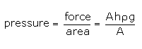

Pressure exerted by a liquid column P = hρg

The above expression tells us why dams are broader at the bottom. The liquid pressure increases with breadth.

With a broader base, the pressure on the walls of the dam are reduced.

Blaise Pascal, a French physicist, discovered that the pressure in a fluid in equilibrium is the same everywhere, if the effect of gravity is neglected.

**PASCAL’S LAW**

The pressure in a fluid at rest is the same at all points if they are at the same height.

Whenever external pressure is applied on any part of a fluid contained in a vessel, it is transmitted undiminished and equally in all directions.

## PASCAL'S LAW-EFFECT OF GRAVITY

Consider a tank containing a liquid (or fluid). Let A and B be two points inside the liquid separated by a distance 'h'. Imagine a cylinder of liquid with axis AB, cross-sectional area A and length h. Let the mass of the liquid in this imaginary cylinder be 'm'.

##### pascal law effect of gravity

Let P1 and P2 be the pressure at A and B. The forces acting on the cylinder are

* F1 = P1 A acting vertically downward
* F2 = P2 A acting upwards on the lower face of the cylinder.
* Weight (mg) = W of the liquid acting downward.

As the liquid is at rest, the net force acting on it should be zero.

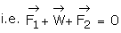









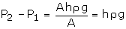



## Note

* If A and B were at the same height

i.e. h=0 then P2 - P1=0 or P1 = P2

i.e., Pressure is same at all points inside a liquid lying on the same horizontal plane.

* If g = 0 at place, then P2 = P1 at any two points inside the liquid (Pascal's law neglecting effect of gravity).

**HYDRAULIC MACHINES**

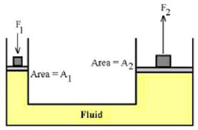

$$\frac{F_{1}}{A_{1}}=\frac{F_{2}}{A_{2}}$$

**VISCOSITY :**

Viscosity is the property of a fluid by virtue of which an internalfrictional force comes into play when the fluid is in motion and opposes the relative motion of its different layers.

Viscous drag *F* acting between two layers of liquid each of area *A*, moving with velocity gradient *d*v*/dx* is given by *F =* η *A d*v*/dx*where h is the coefficient of viscosity of liquid.

SI unit of η is poiseuille of N s m–2 or Pascal-second

# CRITICAL VELOCITY

Critical velocity is the velocity of a liquid flow upto which its flow is streamlined and after which its flow becomes turbulent. Using the methods of dimensions, one can show that $v=\frac{kη}{ρd}$  where k is constant of proportionality called Reynolds number.

# STOKES' LAW

When small spherical bodies move through a viscous medium, the bodies drag the layers of the medium that are in contact with them. This dragging results in relative motion between different layers, which are away from the body. Therefore, a viscous drag comes into play, opposing the motion of the body. It is found that this backward force or viscous drag, increases with increase in velocity of the body.

According to Stoke, the viscous drag 'f'', depends on the coefficient of viscosity 'h' of the medium, the velocity v) of the body and radius (r) of the spherical body.

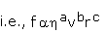

By methods of dimensions, the values of a, b and c are 1,1,1 respectively. Therefore,

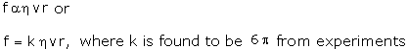

The various forces acting on the body are:

* Weight of the body, acting downwards
* Viscous drag F, acting upwards (opposing motion of the body)
* Upthrust or Buoyant force U of liquids, equal to weight of the displaced liquid.

As the body falls, its velocity and the viscous drag increase due to gravity. There comes a stage, when all the three forces balance each other i.e., the net forces acting on the sphere is zero. When these conditions are achieved, the body starts moving with a constant velocity. This constant velocity is called as the terminal velocity.

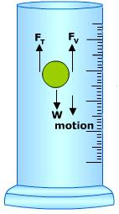**EXPRESSION FOR TERMINAL VELOCITY**

Weight of the body =mg= Vρg

$W=\frac{4}{3}πr^{3}ρg$

where r is the radius of the body, r is density, g is the gravity due to upward viscous drag

$F_{T}= 6πηvr$ (Stokes' law).

where h is coefficient of viscosity, v is the velocity of body, r is radius of the body.

Upthrust or Buoyant force Fv **=** weight of displaced liquid

= Volume of bodyx density of liquid x acceleration due to gravity

$$F_{v}=\frac{4}{3}πr^{3}σg$$

When the body moves with terminal velocity $v=v_{t}$

$$6πηv_{t}r+\frac{4}{3}πr^{3}σg= \frac{4}{3}πr^{3}ρg$$

$$6πηv_{t}r= \frac{4}{3}πr^{3}\left(ρ-σ\right)g$$

$$v_{t}=\frac{2}{9}\frac{r^{2}\left(ρ-σ\right)g}{η}$$

Note that if ρ<σ, the body moves up with constant velocity. For example, gas bubbles rise up through soda water bottle.

# EQUATIONS OF CONTINUITY

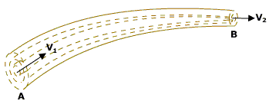

Consider a non-viscous liquid in streamline flow through a tube AB, of varying cross-section. Let A1 and A2 be the area of cross-section at A and B respectively.

The volume of water entering A per second = A1V1

Volume = Area x distance

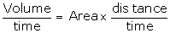



where V1 is the velocity of the flow of liquid at A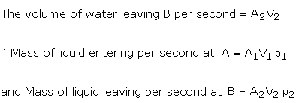

Assuming there is no loss of liquid in tube and for free steady flow,

Mass of liquid entering per second at A

= Mass of liquid leaving per second at B

$A_{1}V_{1}ρ_{1}=A_{2}V_{2}ρ_{2 }$ but $ρ_{1}=ρ_{2 }$

$$henceA_{1}V_{1}=A_{2}V_{2}$$

orAV = constant.

This is the equation of continuity.

# BERNOULLI'S THEOREM

This theorem is a consequence of the principle of conservation of energy, applied to ideal liquids in motion. The theorem states that:

For the streamline flow of an ideal liquid, the total energy (sum of pressure energy, potential energy and kinetic energy) per unit mass remains constant at every cross-section, throughout the flow.

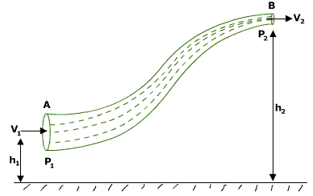

Consider a tube AB of varying cross-section and at different heights. Let an ideal liquid (an ideal liquid is incompressible and non-viscous) flow through it in a streamline. Since the liquid is flowing from A to B, p1 > p2. Now A1V1r = A2V2r = m (according to the equation of continuity)

Here A1 > A2 so V1 < V2



Now, the work done per second on the liquid at section A =A1v1 (v1 is velocity and V1 is volume of liquid per sec) $=ρ_{1}V_{1}$

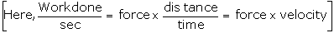

Now, the work done per second on the liquid at section B =A2v2 =

As V1 = V2

Net work done per second on the liquid by the pressure energy in moving from A to B

= p1V - p2V

The net work done per second, in turn, increases the P.E. per second and also increases the K.E. per sec, from A to B. This is in accordance with the law of conservation of energy.

P1V- P2V=(mgh2 – mgh1) +

P1V+ mgh1+ = P2V+ mgh2 +

+ gh1+ = + gh2 +

+ gh+

Pressure energy per unit mass

+ potential energy per unit mass (gh)

+ kinetic energy per unit mass $\frac{v^{2}}{2}$ is constant for

Streamline flow of an ideal liquid

**LIMITATIONS OF THE THEOREM**

Since a velocity gradient exists across the tube, the mean velocity of the liquid is to be considered.

* The viscous drag which comes into play when the liquid is in motion, is not taken into account.
* In above conservation principle, part of K.E. is converted into heat.

**SURFACE TENSION**

Surface tension is a physical property of water.

The Surface tension is defined as: The dragging force observed in the given liquid per unit length. It is given by the formula:

$$T =\frac{F}{L}$$

where, F = Force ,L = Length over which the force acts.

**The Surface tension is expressed in Newton per meter.**

***Impurities present in a liquid affect its surface tension. A highly soluble substance like salt increases the surface tension whereas a sparingly soluble substance like soap decreases the surface tension.***

**SURFACE ENERGY**

Surface energy is the additional energy per unit area of surface or the work done to increase the area of the surface film by unity.

## RELATION BETWEEN SURFACE TENSION AND SURFACE ENERGY

Consider a liquid film to be formed on a rectangular surface ABCD. On forming a film, the surface film contracts (see arrows) due to surface tension i.e., AB is pulled inwards. To keep AB in its original position, a force F is applied in the outward direction, all along its length. If T is force due to surface tension (i.e. T=F/l).

##### surface energy

Then F = T x 2l. Since the film has two free surfaces, the RHS of the equation is multiplied by 2.

If the wire AB is to be pulled by an additional distance dx, then the additional work done W in this case is,

W = Fx( Δ*x*) = Tx (2*l*x Δ*x*) = TxΔA

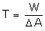

If ΔA = 1 then T = W

i.e. Work done in increasing the surface area by unity, is equal to the surface tension T at constant temperature. Therefore, this work done, is the

## Excess pressure inside a liquid drop

## EXCESS PRESSURE INSIDE A LIQUID DROP AND A BUBBLE

We know that in small drops and bubbles, the effect of gravity is negligible on account of surface tension. Small drops do not collapse due to surface tension. This means that the pressure inside the drop is greater than the pressure outside. Let this excess pressure i.e., pi - po = p. Due to this pressure difference, let the radius increase from R to R + dR.

* Outside force = pressure difference x surface area



Hence, to increase the surface area



Work done by the excess pressure is stored in the form of potential energy.

Increase in P.E. = surface tension x increase in surface area.







dW = increase in P.E.

 

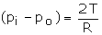

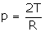



**ANGLE OF CONTACT**

The angle between tangent to the liquid surface at the point of contact and solid surface inside the liquid is termed as angle of contact.

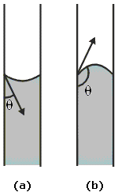

* The figure shows two liquids, one liquid which wets the glass and the other (i.e. diagram 'b') which does not wet the glass.
* In the first case, the force of adhesion (i.e. force of attraction between unlike molecules) is more than the force of cohesion (i.e. force of attraction between like molecules).
* The force of adhesion in the first case, is the force of attraction between glass molecules and water molecules. The force of cohesion is between the molecules of water.
* In the second case, the force of cohesion is more than the force of adhesion.
* In the first case, the angle q is acute and in the second case, it is obtuse.

**CAPILLARY RISE**

When one end of a glass capillary tube that is open at both ends, is dipped in a liquid like water that wets the tube, the liquid level in the tube rises to a certain height above the liquid level in the container, as shown below.

Liquids that don't wet the tube like mercury do not rise in the tube, but fall below its level in the container.

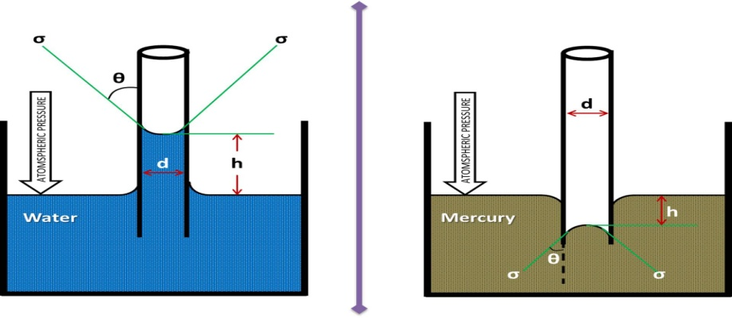

Liquids that don't wet the tube like mercury do not rise in the tube, but fall below its level in the container.

The phenomenon of rise or fall of liquid in a capillary tube is called capillarity.



Consider a vertical capillary tube of circular cross section (radius a) inserted into an open vessel of water.

The contact angle between water and glass is acute. Thus the surface of water in the capillary is concave. This means that there is a pressure difference between the two sides of the top surface. This is given by

$$\left(P_{i}-P_{o}\right)=\frac{2T}{r}=\frac{2TCosθ}{a}$$

The pressure of the water inside the tube, just at the meniscus (air-water interface) is less than the atmospheric pressure.

$\left(P_{i}-P_{o}\right)=hρg∴h=\frac{2TCosθ}{aρg}$

$$h=\frac{2TCosθ}{aρg}$$

## ILLUSTRATIONS OF CAPILLARITY

* Oil rises through a wick due to capillarity. The narrow pores in the threads of a wick act like tiny capillaries, through which oil rises.
* Ink spreads on a blotting paper as the pores in the blotting paper act like tiny capillaries.
* Water rises to the tip of the plants through the tiny fibres in the plant.
* A towel gets soaked with water on account of capillary action.
* Ploughing of fields is essential for preserving moisture in the soil. By ploughing, the fine capillaries in the soil are broken. This ensures that water does not rise to the surface of the soil due to capillary action and evaporate.

**THERMAL PROPERTIES OF MATTER**

**THERMAL EXPANSION AND CALORIMETRY**

* Heat- it is a form of energy, which produce in us the sensation of warmth
* Temperature:- The degree of hotness or coldness of a body is called temperature
* Thermometer- It is a device used to measure the temperature of a body
* Scales of temperature:- There are four scales of temperature. Given below is scales of temp with lower and upper fixed point. Temperature scales Lower fixed point (Melting point office) Upper fixed point (Boiling point of water)

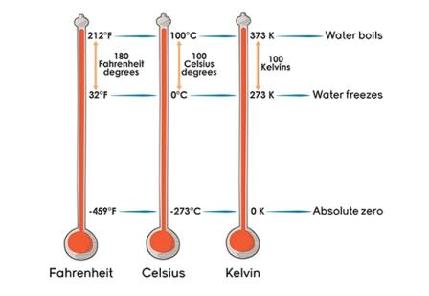

**Relation between the various temperature scales**

$$\frac{C}{5}=\frac{F-32}{9}=\frac{K-273}{5}$$

**IDEAL GAS EQUATION: ABSOLUTE ZERO:**

|  |  |
| --- | --- |
| **Boyle’s law**  According to this law $P∝\frac{1}{V}$ At constant temperature  PV= Constant-------------(1) | **Charles law**  According to this law $V∝T$ At constant temperature $\frac{V}{T}$ = Constant------------------(2) |

From equation (1) and(2)

$\frac{PV}{T}=Constant Or PV=µRT$---------------(3)

**ABSOLUTE ZERO:**

The lowest temperature at which the gas is supposed to have zero volume or zero pressue or at which the molecular motion stops.*A plot of pressure versus temperature andextrapolation of lines for low density gasesindicates the same absolute zerotemperature.*

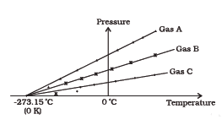

**THERMAL EXPANSION**:-

All solid expands on heating. There are three types of expansion.

(1) Liner expansion- When a solid rod of initial length ‘l’ is heated through a temperature then its new length **L2= L1( 1+αΔT** ) , where α is called coefficient of linear expansion.

(2) Superficial expansion- when a solid of initial surface area A is heated through temperature then its new Area is **A2= A1 (1 + βΔT** )**,** where β is coefficient of superficial expansion.

(3) Cubical expansion- when a solid of initial volume V is heated through a temperature then its new volume is **V2= V1( 1 + γΔT )** ,where ϒ is the coefficient of cubical expansion.

**SI unit of coefficient of expansion is /K**

Relation between **α** ,**β and γ**

**α:β:γ= 1:2:3**

**THERMAL EXPANSION OF WATER:**

Water exhibits an anomalous behavour; itcontracts on heating between 0 °C and 4 °C.

The volume of a given amount of water decreasesas it is cooled from room temperature, until itstemperature reaches 4 °C.

Below4 °C, the volume increases, and therefore the density decreases.

|  |  |
| --- | --- |
| http://www.spiritsd.ca/curr_content/physics20/heat/heat_images/water_graph.gif  Variation of volume of water with temp | Variation of density of water with temp. |

**HEAT CAPACITY**

**A**mount of heat required to increase the temperature by unity i.e 10C. It is expressed as $S=\frac{∆Q}{∆T}$

**SI unit is Joule/Kelvin S=M L2 T-2 K-1**

**SPECIFIC HEAT CAPACITY**

It is defined as the amount of heat per unit mass absorbed or rejected by the substance to change its temperature by one unit. It depends on the nature of the substance and its temperature.

**The SI unit of specific heat capacity is J kg–1 K–1.**

**MOLAR SPECIFIC HEAT CAPACITY**

If the amount of substance is specified in terms of moles μ, instead of mass *m* in kg, we can define heat capacity per mole of the substance by

$$C=\frac{1}{µ}\frac{∆Q}{∆T}$$

* In this case, heat transfer can be achieved by keeping either pressure or volume constant.
* If the gas is held under constant pressure during the heat transfer, then it is called the **molar specific heat capacity atconstant pressure** and is denoted by *C*p.
* If the volume of the gas is maintained during the heat transfer, then the corresponding molar specific heat capacity is called **molar specific heat capacity at constantvolume** and is denoted by *C*v.

**CALORIMETRY**

Calorimetry means measurement of heat. When a body at higher temperature is brought in contact with another body at lower temperature,

***the heat lost by the hot body = the heat gained by the colder body.***

**CHANGE OF STATE**

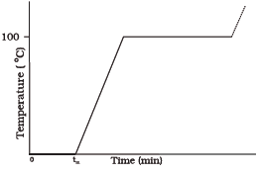

* + The change of state from solid to liquid iscalled **melting**
  + The change of state from liquid to solid iscalled **fusion**
  + The temperatureat which the solid and the liquid states of thesubstance in thermal equilibrium with eachother is called its **melting point**.
  + *Melting point decreases with increase in pressure.*
  + The change of state from liquid to vapour (orgas) is called **vaporisation**.
  + It is observed thatthe temperature remains constant until theentire amount of the liquid is converted intovapour.
  + The temperature at which the liquid and thevapour states of the substance coexist is calledits **boiling point**.
  + *Boiling point decreases with decrease in pressure.*
  + *At high altitudes, atmospheric pressure is lower,reducing the boiling point of water as compared to that at sea level.*
  + *This explains why cooking is difficult on hills.*
  + *On the other hand, boiling point is increased inside a pressure cooker by increasing the pressure. Hence cooking is faster.*

The change from solid state to vapour state without passing through the liquid state is called **sublimation**.

**LATENT HEAT**

The amount of heat per unit mass transferred during change of state of the substance is called latent heat of the substance for the process.

The heat required during a change of state depends upon the heat of transformation and the mass of the substance undergoing a change of state. Thus, if mass *m* of a substance undergoes a change from one state to the other, then the quantity of heat required is given by

*Q = m L* or *L = Q/m*

where*L* is known as latent heat and is a characteristic of the substance.

**Its SI unit is J kg–1.**

**CONDUCTION:**

Conduction is the mechanism of transfer of heat between two adjacent parts of a body because of their temperature difference.

**STEADY STATE:**

At steady state the temperature of different parts of the conductor becomes constant with time.



If Q = Heat flow through a body per unit time (in watts) W,  
A = Surface area of heat flow (perpendicular to the direction of flow) m2,dt = Temperature difference oC or K and  
L = Thickness of body in the direction of flow, m.

$$Q ∝ A \frac{dt}{dx}=Q = -k . A \frac{dt}{dx}$$

The constant of proportionality *K* is called the **thermal conductivity** of the material.

It is defined as the amount of heat conducted across the opposite faces of unit cube maintained at unit temperature difference.

The greater the value of *K* for a material, the more rapidly will it conduct heat.

**The SI unit of *K* is J S–1m–1K–1or W m–1K–1.**

**NEWTON’S LAW OF COOLING**

It states that the rate of heat lost by a body is directly proportional to the difference in temperature between the body and its surroundings.

Let the mass of the body be **m**.

Specific heat heat capacity be **s**

Initial temp. of the body be **T2**

Temp. of the surrounding be**T1**

According to Newton’s law of cooling, the rate of loss of heat, – d*Q*/d*t*of the body is directly proportional to the difference of temperature

Δ*T* = (*T*2*–T*1) of the body and the surroundings, - $\frac{dQ}{dt}=k(T_{2}-T_{1})$

d*Q*= *ms*d*T*2

Rate of loss of heat

$$\frac{dQ}{dt}=ms\frac{dT_{2}}{dt}$$

$$k\left(T_{2}-T_{1}\right)=-ms\frac{dT_{2}}{dt}$$

$$\frac{dT_{2}}{T_{2}-T_{1}}=-\frac{k}{ms}dt=-Kdt where K=\frac{k}{ms}$$

On integrating $\log\left(T_{2}-T_{1}\right)=-Kt+c$

|  |  |
| --- | --- |
| Cooling of hot water with temperature | Verification of Newtons Law |

***REFLECTANCE:***

It is defined as the ratio of amount of thermal energy reflected by a body in a certain time to the total amount of thermal energy falling upon the body in the same time.

$$r=\frac{R}{Q}$$

***ABSORPTANCE***

It is defined as the ratio of amount of thermal energy absorbed by a body in a certain time to the total amount of thermal energy incident upon the body in the same time.

$$a= \frac{A}{Q}$$

***TRANSIMITTANCE***

It is defined as the ratio of amount of thermal energy transmitted by a body in a certain time to the total amount of thermal radiation incident upon the body in the same time.

$$t= \frac{T}{Q}$$

The reflectance, transmittance and absorptance of a body depends upon

1) Nature of the surface of the body

2) Wavelength of incident radiation

**ABSORPTIVE POWER**

Absorptive power of a body for a given wavelength is defined as the ratio of amount of heat energy absorbed in certain time to the total heat energy incident on it in the same time within a unit wavelength range around the wavelength. It is a dimensionless quantity

**EMISSIVE POWER**

Emissive Power of a body at a given temperature and for a given wavelength is defined as the amount of radiant energy emitted per unit time per unit surface area of the body with in a unit wavelength range around the wavelength.

**EMISSIVITY**

It is defined as the ratio of the heat energy radiated per unit time per unit area by the given body to the amount of heat energy radiated per unit time per unit area by a perfect black body at the same temperature

**BLACK BODY**

Black body is one which neither reflects nor transmits but absorbs whole of the heat radiation incident on it. The absorptive power of a perfect black body is unity.

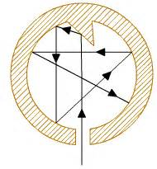

**WIEN'S DISPLACEMENT LAW**

It states that the [black body radiation](https://en.wikipedia.org/wiki/Black_body_radiation) curve for different temperatures peaks at a [wavelength](https://en.wikipedia.org/wiki/Wavelength) inversely proportional to the temperature.

$$λ_{max. }= \frac{b}{T}$$

where *T* is the absolute temperature in [kelvin](https://en.wikipedia.org/wiki/Kelvin). *b* is a [constant of proportionality](https://en.wikipedia.org/wiki/Proportionality_constant) called *Wien's displacement constant*, equal to2.9×10−3 m K.

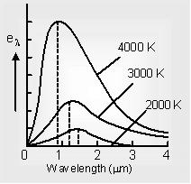

***CONCLUSIONS DRAWN FROM BLACK BODY SPECTRUM***

i) At each temperature, a black body emits continuous heat radiation spectrum. The energy is not distributed uniformly amongst all wavelengths.

ii) The energy associated with a particular wavelength increases with increase in temperature.

iii) As wavelength increases, the energy emitted increases, reaches a maximum for a particular wavelength and then increases.

iv) The wavelength of maximum emission shifts towards the lower wavelength side as the temperature of the black body increases.

v) Area under a curve represents the total energy E emitted by a perfectly black body per second per unit area over the complete range at that temperature. This area is found to increase with fourth power of absolute temperature. This area is found to increase with fourth power of absolute temperature

**STEFAN- BOLTZMANN LAW**

This law states that the total heat energy emitted by a perfect black body per second per unit area is directly proportional to the fourth power of the absolute temperature of its surface. Thus

4  or E =T4.

**QUESTIONS (1 MARKS)**

1. What is the value of bulk modulus for an incompressible liquid?

Ans. $K=\frac{Stress}{Strain}= ∞$

1. Draw stress – strain curve for elastomers (elastic tissue of Aorta)

Ans.

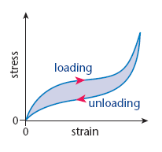

1. Define Poisson’s ratio? Does it have any unit?

Ans. Poisson’s ratio is the ratio of lateral strain to the longitudinal strain. It has no units.

1. For solids with elastic modulus of rigidity, the shearing force is proportional to shear strain. On what factor does it depend in case of fluids?

Ans. Rate of Shear Strain.

1. Why machine parts get jammed in winter?

Ans. In winter i.e. at low temperature the viscosity of lubricants increases.

1. Why do paints and lubricants have low surface tension?

Ans. Low surface tension makes paints and lubricants to spread more effectively.

1. What will be the effect of increasing temperature on (i) angle of contact(ii) surface tension.

Ans. Angle of contact increases with increase of temperature while surface tension generally decreases with increase of temperature

1. How does rise in temperature affect (i) viscosity of gases (ii) viscosity of liquids.

Ans. Viscosity of gases increases while viscosity of liquid decreases.

1. Explain why detergents should have small angle of contact?

Ans. Detergents should have small angle of contact so that they have low surface tension and greater ability to wet a surface.

1. Obtain a relation between SI unit and cgs unit of coefficient of viscosity.

Ans. CGS unit of η= poise

S.I Unit of η= poiseuille or deca poise

1 poise = 1 g cm–1 s–2 = 10–1 kg m–1 s–1 = 0.1 poiseuille

1. How the use of parachute helps a person jumping from an airplane?

Ans. Viscous force on the parachute is large as F =6πη rv, F α r , so its terminal velocity becomes small so the person hits the ground with this small velocity and does not get injured.

1. What happens when a capillary tube of insufficient length is dipped in a liquid?

Ans. When a capillary tube of insufficient length is dipped in a liquid, the radius of curvature of the mensicus increase so that hr = constant. That is pressure on concave side becomes equal to pressure exerted by liquid column so liquid does not overflow.

1. Give a plot of Fahrenheit temperature versus celsius temperature

Ans.



1. Why we cannot remove a filter paper from a funnel by blowing air into narrow end.

Ans. When air is blown into the narrow end its velocity in the region between filter paper and glass increases. This decreases the pressure. The filter paper gets more firmly held with the wall of the tunnel.

15. The plots of intensity versus wavelength for three blackbodies at temperature T1, T2 and T3 respectively are shown.

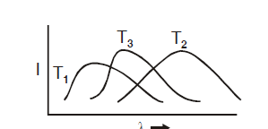

Ans. $λ_{m}^{1}<λ_{m}^{3}<λ_{m}^{2}$ from Wein displacement law

T1 > T3 > T2

16. The coolant used in chemical or in a nuclear plant should have high specific heat. Why?

Ans. As it absorbs more heat with comparatively small change in temperature and extracts large amount of heat.

17. The earth without its atmosphere would be inhospitably cold. Why?

Ans. Due to green house effect, the presence of atmosphere prevents heat radiations received by earth to go back. In the absence of atmosphere radiation will go back at night making the temperature very low and

inhospitable.

18. If Kelvin temperature of an ideal black body is doubled, what will be the effect on energy radiated by it?

Ans. E =T4

19. A brass disc fits snugly in a hole in a steel plate. Should we heat or cool the system to loosen the disc from the hole.

Ans. The temp. coefficient of linear expansion for brass is greater than that for steel. On cooling the disc shrinks to a greater extent than the hole, and hence brass disc gets loosened.

20. Plot a graph of temperature versus time showing the change in the state of ice on heating.

Ans.



**QUESTIONS (2/3 MARKS)**

1. State Hooke’s law. Deduce expression for young’s modulus of material of a wire of length ‘*l*’, radius of cross section ‘r’ loaded with a body of mass M producing an extension Δ*l* in it.

Ans. It is defined as the ratio of normal stress to the longitudinal strain within elastic limit.

$Y=\frac{Normal stress}{Longitudinal Strain}$**= $\frac{F/A}{{∆L}/L}= \frac{FL}{A∆L}=\frac{FL}{πr^{2}∆L}$**



1. Define the term bulk modulus. Express it mathematically. Give its SI unit. Give the relation between bulk modulus and compressibility.

## Ans. It is defined as the ratio of normal stress to the volumetric strain within the elastic limit. Thus,

$$K=\frac{Normal Stress}{Volumetric Strain}$$

Its SI Unit is N/m2 or Pascal

Consider a spherical solid body of volume V and surface area a, when a force F is applied normally, the volume decreases by 

Volumetric strain = $-\frac{∆V}{V}$

Normal stress = $\frac{F}{a}$

K **= $\frac{F/a}{{-∆V}/V}= \frac{-pV}{∆V}$**

$$compressibility=\frac{1}{K}=\frac{-∆V}{pV}$$

1. Define shear modulus. With the help of a diagram explain how shearmodulus can be calculated.

Ans. It is defined as the ratio of tangential stress to the shearing strain within the elastic limit.



Considering a solid metal cube whose lower face is fixed and its upper face is subjected to a tangential force F. The body suffers a change in its shape but not in its volume. If θ is angle through which upper layer is sheared then,

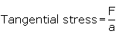

4. A wire of length *l* area of crossection A and young’s modulus Y is stretchedby an amount x. What is the work done?

Ans: Restoring force in extension *x* = F = $\frac{AYx}{l}$

Work done in stretching it by *dx = dw = f.dx*

Work done in stretching it from zero to *x = W =*

5. Prove that the elastic potential energy per unit volume is equal to $\frac{1}{2} × stress and strain?$

Ans: Energy density= $\frac{energy}{volume}$

$$=\frac{1}{2}\frac{AYx^{2}}{l}\frac{1}{Al}=\frac{1}{2}\frac{F}{A}\frac{x}{l}$$

= $\frac{1}{2}$ Stress x Strain

6. Which is more elastic steel or rubber? Explain.

Ans:

$$Y_{s}=\frac{F}{A}\frac{l}{∆l_{s}}$$

$$Y_{r}=\frac{F}{A}\frac{l}{∆l_{r}}$$

For same force applied to wires made of steel & rubber of same length and same area of cross section

$$∆l_{s}<∆l_{r}$$

*Hence steel is more elastic than rubber.*

7. Two wires P and Q of same diameter are loaded as shown in the figure. The length of wire P is L m and its young’s modulus is $YN/m^{2}$ while lengthof wire a is twice that of P and its material has young’s modulus half that of P. Compute the ratio of their elongation.

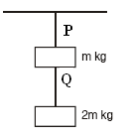

Ans:

8. Stress strain curve for two wires of material A and B are as shown in Fig.



* 1. Which material in more ductile?
  2. Which material has greater value of young modulus?
  3. Which of the two is stronger material?
  4. Which material is more brittle?

Ans: (*a*) Wire with larger plastic region is more ductile material A

(*b*) Young’s modulus is $\frac{stress}{ strain}$

YA >YB

(*c*) For given strain, larger stress is required for A than that for B.

9. In a hydraulic lift air exerts a force F on a small piston of radius 5cm. The pressure is transmitted to the second piston of radius 15 cm. If a car of mass 1350 kg is to be lifted, calculate force F that is to be applied.

Ans.

**F1 = 1470N**

10. A manometer reads the pressure of a gas in an enclosure as shown in the fig (a) when some of the gas is removed by a pump, the manometer reads as in fig (b) The liquid used in manometer is mercury and the atmospheric pressure is 76 cm of mercury. (i) Give absolute and gauge pressure of the gas in the enclosure for cases(a) and (b).



Ans. In case (*a*) Pressure head, h = + 20 cm of Hg

Absolute pressure = P + h = 76 + 20 = 96 cm of Hg.

Gauge Pressure = h = 20 cm of Hg.

In case (b) Pressure Head h = –18 cm of Hg

Absolute Pressure = 76 – 18 = 58 cm of Hg

Gauge Pressure = h = – 18 cm of Hg

10. How would the levels change in (b) if 13.6 cm of water (immiscible with mercury) are poured into the right limb of the manometer in the above numerical?

Ans: as h1ρ1 g = h2ρ2 g

h1 × 13.6 × g = 13.6 × 1 × g

h1 = 1 cm

12. The terminal velocity of a tiny droplet is ${ v}_{t}$.N number of such identical droplets combine together forming a bigger drop. Find the terminal velocity of the bigger drop.

Ans. Terminal velocity is given by

$$v_{t}=\frac{2}{9}\frac{r^{2}\left(ρ-σ\right)g}{η}$$

$$v_{t}∝r^{2}$$

If N drops coalesce, then

Volume of one big drop = volume of N droplets

$$\frac{4}{3}πR^{3}=N\frac{4}{3}πr^{3}$$

$$R=N^{1/3}r$$

Terminal velocity of bigger drop=

13. Derive relation between coefficient of linear and cubical expansion. The coefficient of volume expansion of glycerin is 49x10-5 C-1. What is fractional change in density for 30o C rise in temperature?

Ans: Coefficient of cubical expansion β = $\frac{∆V}{V∆t}=\frac{\left[{\left(l+∆l\right)}^{3}-l^{3}\right]}{l^{3}∆t}= \frac{\left(l^{3}+3l^{2}∆l+ 3l{\left(∆l\right)}^{2}+{\left(∆l\right)}^{3}-l^{3}\right)}{l^{3}∆t}$

Neglecting terms containing *Δl2and Δl3*

**Hence β=3α**

Fractional change in density

14. Calculate heat required to covert 3kg of water at 0°C to steam at 100°C Given specific heat capacity of water is 4186J kg–1 k–1 and latent heat of steam = 2.256 × 106 J/kg.

Ans. Heat required to convert H2O at 0° to H2O at 100° = m1c1 t

Q1= 3 × 4186 × 100

= 1255800 J

Heat required to convert H2O at 100°C to steam at 100°C is = mL

Q2= 3 × 2.256 × 106

= 6768000J

**Total heat Q=Q1 + Q2 = 8023800 J**

1. A body at temperature 94°C cools to 86°C in 2 min. What time will it take to cool from 82°C to 78°C. The temperature of surrounding is 20°C.

Ans.

$$\frac{\left(θ_{1}-θ_{2}\right)}{t}∝\frac{\left(θ_{1}+θ_{2}\right)}{2}-θ_{0}$$

$$\frac{94-96}{2}=k\left[\frac{94+86}{2}-20\right]$$

$4=70k$--------------- (1)

$$\frac{82-78}{t^{'}}=k\left[\frac{82+78}{2}-20\right]$$

$\frac{4}{t^{'}}=60k$---------------------------- (2)

From eq. (1) & (2)

**t’ = 1.16mins**

16. A iron ring of diameter 5.231 m is to be fixed on a wooden rim of diameter 5.243 m both initially at 27°C. To what temperature should the iron ring be heated so as to fit the rim (Coefficient of linear expansion of iron is 1.2 ×105 k–1?

Ans.

5.243 = 5.231[1+1.2x 10-5(T-20)]

**T = 491k=2180C**

1. Ratan noticed that his grandfather was suffering from fever. He took him to the doctor The doctor gave him some pills .When the pills were used he sweated much, after some time became normal. Rahim enquired the Doctor about how his grandfather became normal.

(a)According to you what values are possessed by Ratan?

(b) A child running a temperature of 101°F is given an Antipyria which causes an increase in the rate of evaporation from the body. If the fever is brought down to 98°F in 20 mins, what is the amount of heat lost by the body? The mass of the child is 30 kg.

Ans: (a) Ratan is responsible and he has concern for others, inquisitiveness in gaining the knowledge

(b) Heat lost by the body = msΔt = 30kg X 1000cal/kg/°C X 1.67 °C = 50100cal

[(where loss in tem = (101- 98) °C =3 x 5/9 °F = 1.67°C.]

1. (a) Savita was surprised to see oil spreading on the surface of water and asked her mother to explain why oil spreads on the surface of water. Her mother explained her daughter the reason behind it. By going through the explanation she thought of learning more about the other scientific phenomenon also. What qualities do you can find in Savita?

(b) Oil spreads over the surface of water whereas water does not spread over the surface of oil. Why?

Ans: (a) She has inquisitiveness; she wants know the scientific reason behind the phenomena, determined.

(b)The surface tension of the water is more than that of oil, therefore when oil is poured over water, the greater value of surface tension of water, pulls the oil in all directions. On the other hand, when water is poured over oil, it does not spread over it because surface tension of oil is less than that of water.

19. Construction for metro line was carried out day and night. One night, when the work was in full swing, suddenly chain of the crane, lifting a heavy concrete block, snapped and it fell down. Immediately, people from nearby area came for help. They lifted the concrete and saved many lives. Injured were transferred to hospital without waiting for police to arrive.

1. What values of locals helped in saving lives?
2. A crane having steel ropes is used to lift heavy loads upto 104 kg. The elastic limit for steel is 3x108 Nm-2. What should be the radius r of the steel rope used?
3. Which is more elastic- rubber or steel?

Ans: i. Presence of mind, care for others, helping nature.

ii. Elastic limit = $\frac{mg}{πr^{2}}$

$r= \sqrt{\frac{10×{10}^{4}}{3.14×3×{10}^{8}}}$ = 1.03cm

1. Steel is more elastic as for a given stress; the strain in steel is less than that of rubber. Youngs modulus of steel is more than that of rubber.

20. Radha was studying when she noticed her 2 year old younger brother was leaning towards kitchen where her mother had kept the boiling water. Radha ran towards him and caught him just as he was about to touch the boiling water. She moved him to the side and fell on the fioor but she was happy that she saved her brother from getting burnt.

(i) What values of Radha are appreciable?

(ii) At atmospheric pressure, 2 g of water having volume of 2.00cm3 becomes 3342cm3 of steam when boiled. The latent heat of vaporization of water is 539cal/g at 1atm. What is the amount of heat added to the system?

(iii) Why does steam causes more severe burn than boiling water?

Ans. (i) Radha is very kind hearted and brave girl. Her presence of mind saved his brother

(ii)amount of heat added=m L=2x539=1078cal.

(iii) The steam at 1000C carries 22.6x105J/kg which is greater than heat carried by water at 1000C. So the burns of steam are more severe.

**NUMERICALS FOR PRACTICE**

1. A force of 5 × 103 N is applied tangentially to the upper face of a cubical block of steel of side 30 cm. Find the displacement of the upper face relative to the lower one, and the angle of shear. The shear modulus of steel is 8.3 × 1010 pa.
2. Calculate the pressure at a depth of 10 m in an Ocean. The density of sea water is 1030 kg/m3. The atmospheric pressure is 1.01 × 105 pa.
3. Calculate excess pressure in an air bubble of radius 6mm. Surface tension of liquid is 0.58 N/m.
4. Calculate the velocity with which a liquid emerges from a small hole in the side of a tank of large cross-sectional area if the hole is 0.2m below the surface liquid (g = 10 ms–2).
5. A soap bubble of radius 1 cm expands into a bubble of radius 2cm. Calculate the increase in surface energy if the surface tension for soap is 25 dyne/cm.
6. Water rises to a height of 9 cm in a certain capillary tube. If in the same tube, level of Hg is depressed by 3 cm, compare the surface tension of water and mercury. Specific gravity of Hg is 13.6 and the angle of contact for Hg is 135°.
7. A metal piece of 50 g specific heat 0.6 cal/g°C initially at 120°C is dropped in 1.6 kg of water at 25°C. Find the final temperature or mixture.
8. 100g of ice at 0°C is mixed with 100 g of water at 80°C. The resulting temperature is 6°C. Calculate heat of fusion of ice.
9. Calculate the heat required to convert 3 kg of ice at –12 °C kept in a calorimeter to steam at 100 °C at atmospheric pressure. Given specific heat capacity of ice = 2100 J kg–1 K–1, specific heat capacity of water = 4186 J kg– 1 K–1, latent heat of fusion of ice = 3.35 105 J kg–1 and latent heat of steam = 2.256 106J kg–1.
10. A pan filled with hot food cools from 94 °C to 86 °C in 2 minutes when the room temperature is at 20 °C. How long will it take to cool from 71 °C to 69 °C?
11. A ‘thermacole’ icebox is a cheap and efficient method for storing small quantities of cooked food in summer in particular. A cubical icebox of side 30 cm has a thickness of 5.0 cm. If 4.0 kg of ice is put in the box, estimate the amount of ice remaining after 6 h. The outside temperature is 45 °C, and co-efficient of thermal conductivity of thermacole is 0.01 J s–1 m–1 K–1. [Heat of fusion of water = 335x 103J kg–1]
12. The triple points of neon and carbon dioxide are 24.57 K and 216.55 K respectively. Express these temperatures on the Celsius and Fahrenheit scales.
13. A hydraulic automobile lift is designed to lift cars with a maximum mass of 3000kg. The area of cross-section of the piston carrying the load is 425 cm2. What maximum pressure would the smaller piston have to bear?
14. The cylindrical tube of a spray pump has a cross-section of 8.0 cm2 one end of which has 40 fine holes each of diameter 1.0 mm. If the liquid flow inside the tube is 1.5 m/min–1, what is the speed of ejection of the liquid through the holes ?
15. Compute the fractional change in volume of a glass slab, when subjected to a hydraulic pressure of 10 atm.

Given bulk modulus of glass is 37x109N/m2

**QUESTIONS (5 MARKS)**

1. Draw and discuss stress versus strain graph, explaining clearly the terms elastic limit, permanent set, proportionality limit, breaking stress, tensile strength.

2. Show that pressure difference exists between the two sides of a curved surface of a liquid. Derive the expression for excess pressure inside a liquid drop.Why the droplets of mercury when brought in contact pulled together to form a bigger drop?

3. State Pascal’s law. Two syringes of different cross sections (without needles) filled with water are connected with a tightly fitted rubber tube filled with water. Diameters of the smaller piston and larger piston are 1.0 cm and 3.0 cm respectively. (a) Find the force exerted on the larger piston when a force of 10 N is applied to the smaller piston. (b) If the smaller piston is pushed in through 6.0 cm, how much does the larger piston move out?

4. State and prove Bernoullis theorem. Give its limitation. Name any two application of the principle.

5. Define terminal velocity. Obtain an expression for terminal velocity of a sphere falling through a viscous liquid. Use the formula to explain the observed rise of air bubbles in a liquid.

6. (a) Why does water rises in a capillary tube placed in it? Derive the expression for height to which a liquid rises in capillary tube.

(b) Water rises to certain height in capillary tube, what is the effect on height

(i) when detergent is added to water?

(ii) on increasing temperature of water?

(iii) if the tube makes an angle 300 with the vertical?

Justify your answer in each case.

7. State Newton’s law of cooling. Express it mathematically. Represent Newton’s law of cooling graphically.

8. On what factors does the rate of heat conduction in a metallic rod in the steady state depend? Write the necessary expression and hence define the coefficient of thermal conductivity. Write its unit and dimensions.

9. What is meant by a block body? Explain how a black body may be achieved in practice. State and explain Stefan’s law?

10. Discuss energy distribution of a block body radiation spectrum and explain Wien’s displacement law of radiation and Stefan’s law of heat radiation.

|  |  |  |
| --- | --- | --- |
| **IMPORTANT FORMULAS** | | |
| **S.No** | **QUANTITY** | **FORMULA** |
| 1 | Stress | $$Stress = \frac{DeformingForce}{Area of cross section}$$ |
| 2 | Strain | $$Strain =\frac{Change in dimension }{original dimension}$$ |
| 3. | Young's modulus of elasticity | $Y=\frac{Normal stress}{Longitudinal Strain}$**= $\frac{F/A}{{∆L}/L}= \frac{FL}{A∆L}$** |
| 4. | Bulk modulus of elasticity | K = $\frac{F/a}{{-∆V}/V}= \frac{-pV}{∆V}$ |
| 5. | Compressibility | $$compressibility=\frac{1}{K}=\frac{-∆V}{pV}$$ |
| 6. | Modulus of rigidity | $$η=\frac{Tangential Stress}{Shearing Strain}= \frac{F/a}{{∆x}/L}= \frac{FL}{a∆x}= \frac{F}{θa}$$ |
| 7. | Poisson’s ratio () | $$σ=\frac{lateral strain}{longitudinal strain}$$ |
| 8. | Elastic potential energy | $$U=\frac{1}{2}×stress×strain ×volume of wire$$ |
| 9. | Elastic potential energy per unit volume | $$u=\frac{1}{2}×stress×strain$$ |
| 10. |  | $$Pressure=\frac{normal force}{area}$$ |
| 11. | Pascal’s law | $$\frac{F_{1}}{A_{1}}=\frac{F_{2}}{A_{2}}$$ |
| 12. | Viscosity | *F =* η *A d*v*/dx* |
| 13. | Critical velocity | $$v=\frac{kη}{ρd}$$ |
| 14. | Stoke’s law | $$F=6πηav$$ |
| 15. | Terminal velocity | $$v_{t}=\frac{2}{9}\frac{r^{2}\left(ρ-σ\right)g}{η}$$ |
| 16. | Equations of continuity | $$A_{1}V_{1}=A_{2}V_{2}$$ |
| 17 | Bernoulli's theorem | http://images.tutorvista.com/contentimages/physics_11/content/us/class11physics/chapter07/images/img181.gif |
| 18. | Surface tension | $$T =\frac{F}{L}$$ |
| 19. | Excess pressure inside a liquid drop | http://images.tutorvista.com/contentimages/physics_11/content/us/class11physics/chapter07/images/img219.gif |
| 20. | Excess pressure inside a liquid bubble | $$P=\frac{4T}{R}$$ |
| 21. | Capillary rise | $$h=\frac{2TCosθ}{aρg}$$ |
| 22. | Relation between the various temperature scales | $$\frac{C}{5}=\frac{F-32}{9}=\frac{K-273}{5}$$ |
| 23. | Linear expansion | L2= L1( 1+αΔT ) |
| 24. | Coefficient of linear expansion | $$∝=\frac{∆l}{l∆t}$$ |
| 25. | Superficial expansion | A2= A1 (1 + βΔT ) |
| 26. | Coefficient of superficial expansion | $$β=\frac{∆A}{A∆t}$$ |
| 27. | Cubical expansion | V2= V1 ( 1 + γΔT ) |
| 28. | Coefficient of cubical expansion | $$γ=\frac{∆V}{V∆t}$$ |
| 29. | Relation between α and β | β=2α |
| 30. | Relation between α and γ | γ=3α |
| 31. | Heat capacity | $$S=\frac{∆Q}{∆T}$$ |
| 32. | Specific heat capacity | $$s=\frac{1}{m}\frac{∆Q}{∆T}$$ |
| 33. | Heat | $$Q=ms∆t$$ |
| 34. | Molar specific heat capacity | $$C=\frac{1}{µ}\frac{∆Q}{∆T}$$ |
| 35. | Conduction of heat | $$Q=-KA\frac{dt}{dx}=Q$$ |

**THERMODYNAMICS**

**KEY CONCEPTS**

 If temperature of a body of mass *m* rises by *T*, then *Q = mc*  *T* where *c* is *specific heat* of the material of the body, When the state of body of mass m changes at its melting point/boiling

point, then *Q = m L*, where *L* is *latent heat* of the body.

 **Principle of calorimetry :** When two substances at different temperatures are mixed together, they exchange heat. If we assume that no heat is lost to the surroundings, then according to principle of calorimetry. Heat loss  Heat gained

 **Specific heat of gases :** Specific heat of a gas is the amount of heat required to raise the temperature of one gram of gas through 1°C.

*Principal specific heat of a gas* :

(*i*) Specific heat at constant volume (*cv*)

(*ii*) Specific heat at constant pressure (*cp*)

 **Newton's Law of Cooling :** It states that the rate of loss of heat of a liquid is directly proportional to difference in temperatures of the liquid and the surroundings provided the temperature difference is small (= 30°C).

 When the temperature difference between body and surroundings is large, then Stefan's law for cooling of body is obeyed

**Wien's Displacement Law :** The wavelength max at which the maximum amount of energy is radiated decreases with the increase of temperature and is such that maxT = *a* constant where T is the temperature of black body in Kelvin.

 **Thermodynamical system :** An assembly of extremely large number of gas molecules is called a thermodynamical system. The pressure *P*, volume *V,* temperature *T* and heat cotent *Q* are called *Thermodynamical parameters*

*.*

 **Zeroth Law of Thermodynamics :** (Concept of temperature) According to this law, when thermodynamic systems *A* and *B* are separately in thermal equilibrium with a third thermodynamic system *C*, then the systems *A* and *B* are in thermal equilibrium with each other also.

 **Internal Energy of a Gas** is the sum of kinetic energy and the potential energy of the molecules of the gas. internal energy of an ideal gas is wholly kinetic.

 **First Law of Thermodynamics** (principle of conservation of energy)

According to this law *dQ* = *dU* + *dW* where *dQ* is the small amount of heat energy exchange with a system, *dU* is small change in internal energy of the system and *dW* is the small external work done by or on the system.

 *Sign conventions* used in thermodynamics.

(a) Heat *absorbed* by the system = *positive* and heat rejected by the system = *negative*.

(b) When temperature of the system rises, its internal energy increases *U* = *positive*.

When temperature of the system falls, its internal energy decreases, *U* = *negative*.

(c) When a gas expands, work is done by the system. It is taken as positive. When a gas is compressed, work is done *on* the system. It is taken as negative.

 **Second Law of Thermodynamics :** It is impossible for self acting machine, unaided by an external agency to convey heat from the body at lower temperature to another at higher temperature. This statement of the law was made by **Clausius.**

According to **Kelvin,** it is impossible to derive a continuous supply of work by cooling a body to a temperature lower than that of the coldest of its surroundings.

**Heat Engines :** A heat engine is a device which converts heat energy into mechanical energy. Efficiency of a heat engine is the ratio of work done (*W*) by the engine per cycle to the energy absorbed from the source (*Q*1) per cycle.

 **Carnot Engine :** is an ideal heat engine which is based on Carnot's reversible cycle. Its working consists of four steps. (Isothermal expansion, Adiabatic expansion isothermal compression and adiabatic compression).

**A Refrigerator** absorbs heat Q2 from a sink (substance to be cooled) at lower temperature TK. Electric energy W has to be supplied for this purpose *Q*1 = *Q*2 + *W*

**QUESTIONS**

1. Why spark is produced when two substances are struck hard against each other?

2. What is the specific heat of a gas in an isothermal process.

3. On what factors, does the efficiency of Carnot engine depend?

4. What are two essential features of Carnot's ideal heat engine.

5. Refrigerator transfers heat from cold body to a hot body. Does this violate the second law of thermodynamics.

6. What is heat pump?

7. Give two example of heat pump?

8. What is heat engine?

9. Why a gas is cooled when expanded?

10. Can the temperature of an isolated system change?

11. Which one a solid, a liquid or a gas of the same mass and at the same temperature has the greatest internal energy.

12. Under what ideal condition the efficiency of a Carnot engine be 100%.

13. Which thermodynamic variable is defined by the first law of thermodynamics?

14. Give an example where heat be added to a system without increasing its temperature.

15. What is the efficiency of carnot engine working between ice point and steam point?

16. Two blocks of the same metal having masses 5g and 10g collide against a target with the same velocity. If the total energy used in heating the balls which will attain higher temperature?

17. What is the specific heat of a gas in an adiabatic process.

**SHORT ANSWER (1 MARK)**

1. Work is converted into heat.
2. Infinite

     = 1 – T2/T1

4. (i) Source and sink have infinite heat capacities.

(ii) Each process of the engine's cycle is fully reversible

1. No, External work is done

6 A heat pump is a device which uses mechanical work to remove heat.

7 Refrigerator, Air Conditioner.

8. Heat engine is a device which convert heat energy into mechanical energy.

9 Decrease in internal energy.

10. Yes in an adiabatic process

11. Gas has greatest internal energy and solid has least internal energy.

1. If the temperature of sink is OK.
2. Internal energy.

14. Melting.

  = 1 – T2/T1 = 1 – 273/373 = 26.8%

16. Both the balls will undergo the same rise in temperature.

17. Zero.

**SHORT ANSWER TYPE QUESTION (2 MARKS)**

1. A thermos bottle containing tea is vigorously shaken. What will be the effect on the temperature of tea.

2. Write two limitation of the first law of thermodynamics.

3. No real engine can have an efficiency greater that of a carnot engine working between the same tow temperatures. Why?

4. Why water at the base of a waterfall is slightly warmer than at the top?

5. When ice melts, the change in internal energy is greater than the heat supplied. Why?

6. Explain why two isothermal curves never intersect.

7. Can a room be cooled by opening the door of refrigerator in a closed room?

8. Explain what is meant by isothermal and adiabatic operations.

9. Two bodies at different temperatures T1 and T2, if brought in thermal contact do not necessarily settle to the mean temperature (T1 + T2)/2 Explain?

**SHORT ANSWERS (2 MARKS)**

1. Temperature of tea will rise.

2. (i) It does not give the direction of flow of heat.

(ii) It does not explain why heat cannot be spontaneously converted into work.

3. In carnot engine.

(i) There is absolutely no friction between the wall of cylinder and piston.

(ii) Working substance is an ideal gas In real engine these condition cannot be fulfilled.

4. Potential energy converted in to kinetic energy, some part of kinetic energy is converted in to heat.

5. dq = du + dw

du = dq – pdv

When ice melt change in volume is negative.

6. PV

7. No, It a voilets seconds law.

8. Adiabatic a Process – Pressure, volume and temperature of the system changes but there is no exchange of heat. Isothermal Process – Pressure, volume changes temperature remain constant.

9. Heat flows from higher temperature to lower temperature until the temperature become equal only where the thermal capacities of two bodies are equal.

**SHORT ANSWER TYPE QUESTIONS (3 MARKS)**

1. Obtain an expression for work done in an isothermal process.

2. Two samples of gas initially at the same temperature and pressure are compressed from volume V to V/2 one sample is compressed isothermally and the other adiabatically in which case the pressure will be higher? Explain?

3. Explain briefly the principle of a heat pump. What is meant by coefficient of performance?

4. When you blow on the back of your hand with your mouth wide open your breath feels warm about if you partially close your mouth form an ''O'' and then blow on your hand breath fells cool. Why?

5. Is it a violation of the second law of thermodynamics to convert

(a) Work completely in to heat

(b) Heat completely in to work

Why or why not?

6. State first law of thermodynamics on its basis establish the relation between two molar specific heat for a gas.

7. Explain briefly the working principle of a refrigerator and obtain an expression for its coefficient of performance.

8. State zeroth law of thermodynamics. How does it lead to the concept of temperature? process is numerically equal to the area of the loop representing the cycle.

**LONG ANSWER TYPE QUESTIONS (5 MARKS)**

1. Describe briefly carnot engine and obtain an expression for its efficiency.

2. Define adiabatic process. Derive an expression for work done during adiabatic process.

3. Why a gas has two principle specific heat capacities? What is the significance of Cp – C and Cp/C where symbols have usual meaning.

**NUMERICALS**

**1.**2 mole of helium is contained in a container at S.T.P. How much heat energy is needed to double the pressure of the gas, keeping the volume constant? Heat capacity of gas is 3 J g–1 K–1.

2. The volume of steam produced by 1g of water at 100°c is 1650 cm3. Calculate the change in internal energy during the change of state given J = 4.2 × 107 erg cal–1 g = 98 J cm/s2 latent heat of steam = 540 cal/g

3. What is the coefficient of performance () of a carnot refrigerator working between 30°C and 0°C?

4. Calculate the fall in temperature when a gas initially at 72°C is expanded suddenly to eight times its original volume. ( = 5/3)

5. A steam engine intake steam at 200°C and after doing work exhausts it directly in air at 100°C calculate the percentage of heat used for doing work. Assume the engine to be an ideal engine?

6. A perfect carnot engine utilizes an ideal gas the source temperature is 500K and sink temperature is 375K. If the engine takes 600k cal per cycle from the source, calculate

(i) The efficiency of engine

(ii) Work done per cycle

(iii) Heat rejected to sink per cycle.

7. Two carnot engines A and B are operated in series. The first one A receives heat at 900 K and reject to a reservoir at temperature T K. The second engine B receives the heat rejected by the first engine and in turn rejects to a heat reservoir at 400 K calculate the temperature T when

(i) The efficiencies of the two engines are equal

(ii) The work output of the two engines are equal

8. Ten mole of hydrogen at NTP is compressed adiabatically so that its temperature become 400°C How much work is done on the gas? what is the increase in the internal energy of the gas

R = 8.4 J mol–1K–1  = 1.4

9. The temperature T1 and T2 of the two heat reservoirs in an ideal carnot engine be 1500°C and 500°C respectively. which of these increasing T1 by 100°C or decreasing T2 by 100°C would result in a greater improvement in the efficiency of the engine.

**ANSWERS**

1. 1638 J
2. 21.01 × 109 erg.
3. 9.1
4. 86.25 k
5. 21%
6. 25%, 450 k cal
7. 8.4 × 104 J
8. 58.73%, 2 > 1

**KINETIC THEORY OF GASES**

